
RACK CABINETS & DATA CENTER CONTAINMENT

K1-6042 42U K1 server cabinet
  - Exact model: K1-6042
PRODUCT IMAGES
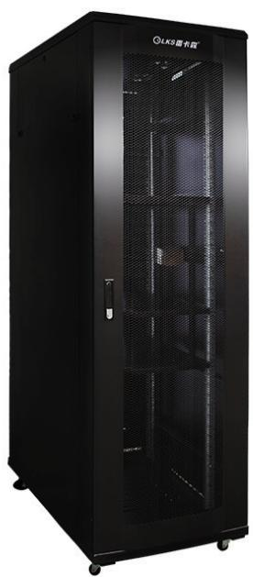 | 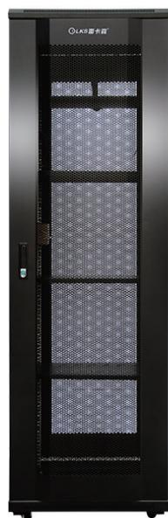 | 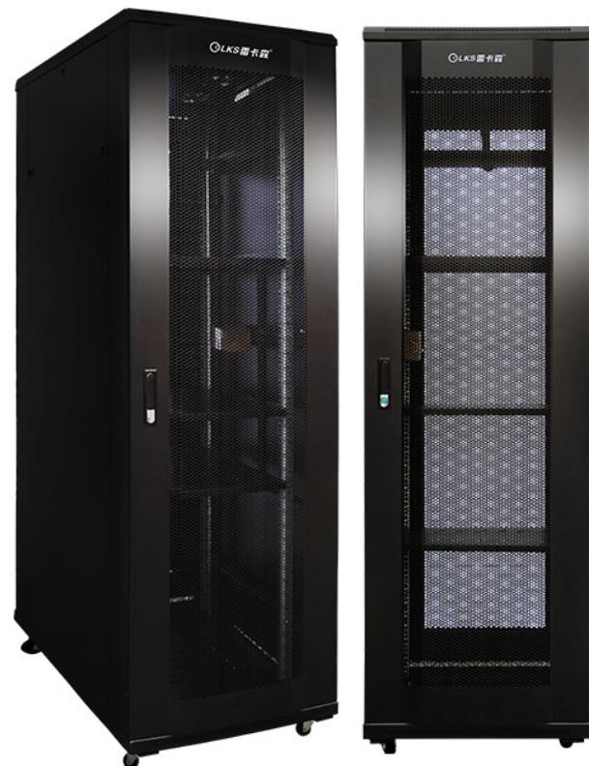 | 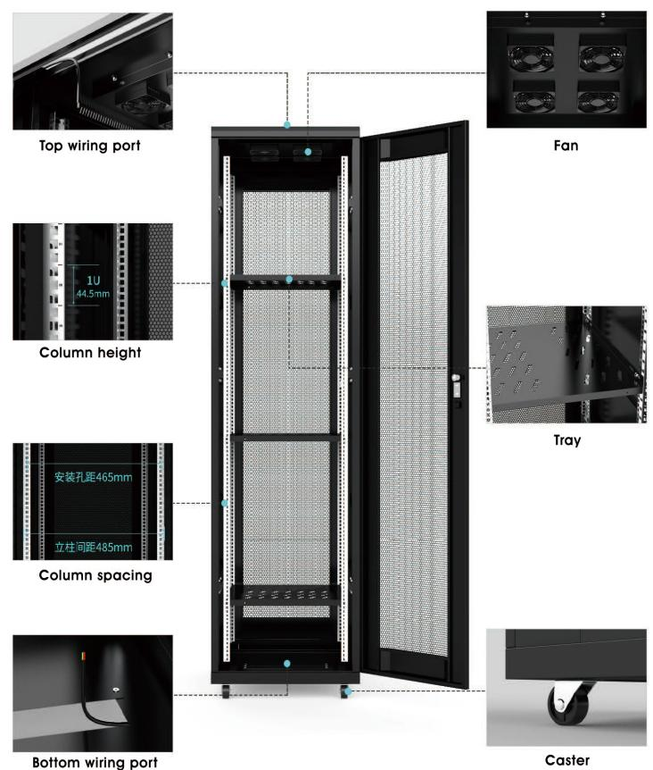
K1-6042 · Primary | K1-6042 · Gallery | K1-6042 · Gallery | K1-6042 · Diagram · Series Reference View

PRODUCT OVERVIEW
19-inch network and server cabinets for standard IT, networking and security equipment.
Product line | Rack Cabinets & Data Center Containment
Series / family | k1
Exact model | K1-6042
Applications | Wall-mount network cabinets, CCTV and ELV equipment racks, Small server rooms
MODEL IDENTIFICATION
Exact model | Product / variant | Type | Dimensions | Height
K1-6042 | K1-6042 42U K1 server cabinet | Server cabinet | 600 × 1000 × 2000 mm | 42U
TECHNICAL SPECIFICATIONS
Parameter | Specification
Type | Server cabinet
Dimensions | 600 × 1000 × 2000 mm
Height | 42U
Mounting Rail Spacing | 485 mm (19-inch standard)
Sheet Thickness | mounting rails 2.0 mm; other / main load-bearing beam approx. 1.1±0.1 mm
Material / Finish | SPCC cold-rolled steel, degreased and powder-coated
Series Load Capacity | K1 series catalog load rating: ≤600 kg
Standard Configuration | PDU × 1、cage nuts and screws × 20、M12leveling feet × 4、42Umounting rails × 4、front and rear mesh doors × 1、side panels × 2、fans × 2、shelves × 3、casters × 4
Recommended Equipment Depth | <850 mm
Product series | K1 Network & Server Cabinet Series
Product category | Data Center Cabinet
APPLICATIONS & RFQ CONFIRMATION
Typical applications | Confirm in the project RFQ
Wall-mount network cabinets  CCTV and ELV equipment racks  Small server rooms | Confirm the application, rack or room position, destination-market interface and mounting requirement.  Confirm electrical, network, accessory or protection scope from the product family and project drawings.  Confirm quantity, labeling, packing and required documents before purchase order.
Project supply: MOQ — Confirm by model and project quantity · Lead time — Confirm after configuration review · FOB port — Confirm in project quotation · OEM/ODM — To be confirmed
PROJECT CONFIGURATION CHECKLIST
Exact model | K1-6042
Application and site conditions | Confirm installation environment and operating requirements.
Quantity and model mix | Confirm forecast quantity, phase plan and required variants.
Interfaces and accessories | Confirm compatible interfaces, accessories and system integration scope.
Finish, branding and packing | Confirm only when project customization is required.
Documentation and destination | Confirm drawings, datasheets, packing documents and destination country or port.

