
RACK PDU & POWER DISTRIBUTION

IEC C13/C19 Locking PDU Series
  - Models: SP5IEC139 | SPSIEC196
PRODUCT IMAGES
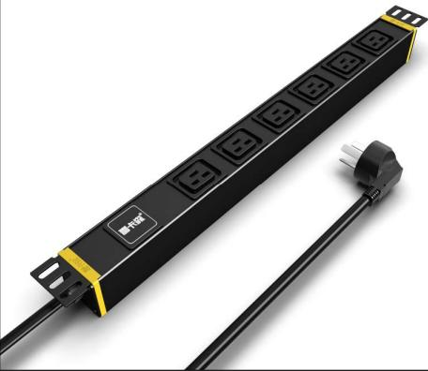 | 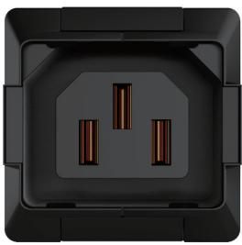 |  | 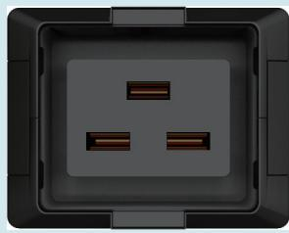
SP5IEC139 · Primary | SP5IEC139 · Gallery | SPSIEC196 · Primary | SPSIEC196 · Gallery

PRODUCT OVERVIEW
Rack PDU with IEC C13 or C19 locking outlets for IT and data-center equipment.
Product line | Rack PDU & Power Distribution
Series / family | pdu-iec
Exact model | SP5IEC139 | SPSIEC196
Applications | IEC equipment racks, Server cabinets, Locking-outlet power distribution
MODEL COMPARISON
Exact model | Product / variant | Input Current | Input Cable | Input Plug
SP5IEC139 | SP5IEC139 9-Outlet IEC C13 Locking PDU | 16 A | 3 m, 2.5 mm² | 16A Chinese-standard plug
SPSIEC196 | SPSIEC196 9-Outlet IEC C19 Locking PDU | 16 A | 3 m, 2.5 mm² | 16A Chinese-standard plug
TECHNICAL SPECIFICATIONS
Parameter | SP5IEC139 | SPSIEC196
Input Current | 16 A | 16 A
Input Cable | 3 m, 2.5 mm² | 3 m, 2.5 mm²
Input Plug | 16A Chinese-standard plug | 16A Chinese-standard plug
Function Module | Not specified in the catalog | Not specified in the catalog
Output | 9 × IEC 60320 C13 locking outlets | 9 × IEC 60320 C19 locking outlets
Rated Load | 4000 W | 4000 W
Dimensions | 485 × 44.5 × 44.5 mm | 485 × 44.5 × 44.5 mm
Product series | IEC C13/C19 Locking PDU Series | IEC C13/C19 Locking PDU Series
Product category | PDU | PDU
APPLICATIONS & RFQ CONFIRMATION
Typical applications | Confirm in the project RFQ
IEC equipment racks  Server cabinets  Locking-outlet power distribution | Confirm the application, rack or room position, destination-market interface and mounting requirement.  Confirm electrical, network, accessory or protection scope from the product family and project drawings.  Confirm quantity, labeling, packing and required documents before purchase order.
Project supply: MOQ — Confirm by model and project quantity · Lead time — Confirm after configuration review · FOB port — Confirm in project quotation · OEM/ODM — To be confirmed
PROJECT CONFIGURATION CHECKLIST
Exact model | SP5IEC139
Application and site conditions | Confirm installation environment and operating requirements.
Quantity and model mix | Confirm forecast quantity, phase plan and required variants.
Interfaces and accessories | Confirm compatible interfaces, accessories and system integration scope.
Finish, branding and packing | Confirm only when project customization is required.
Documentation and destination | Confirm drawings, datasheets, packing documents and destination country or port.

