
RACK PDU & POWER DISTRIBUTION

Metered PDU Series
  - Models: SP5086 | SP5186
PRODUCT IMAGES
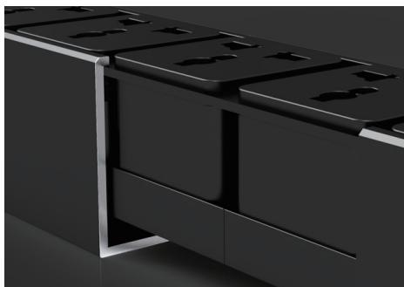 | 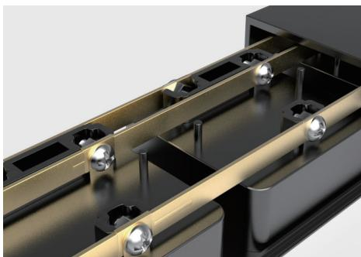 | 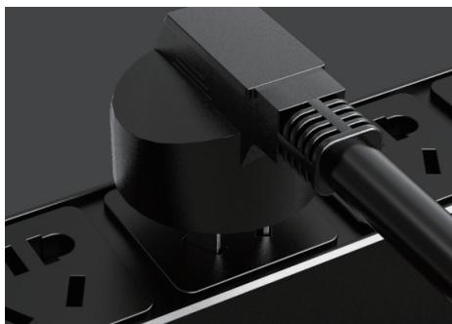 | 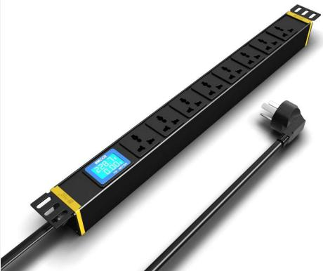
SP5086 · Structural Detail · Series Reference View | SP5086 · Structural Detail · Series Reference View | SP5086 · Structural Detail · Series Reference View | SP5186 · Primary

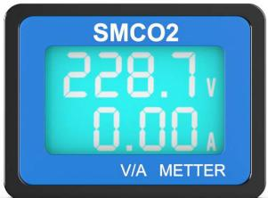
SP5186 · Gallery

PRODUCT OVERVIEW
Rack PDU with local voltage and current display for basic load monitoring.
Product line | Rack PDU & Power Distribution
Series / family | pdu-metered
Exact model | SP5086 | SP5186
Applications | Server racks, Network rooms, Load monitoring projects
MODEL COMPARISON
Exact model | Product / variant | Input Current | Cable Specification | Rated Load
SP5086 | SP5086 16Ametered PDU | 16 A | 3 × 2.5 mm² | 4000 W
SP5186 | SP5186 16Ametered PDU | 16 A | Not provided | Not provided
TECHNICAL SPECIFICATIONS
Parameter | SP5086 | SP5186
Cable Specification | 3 × 2.5 mm² | Not provided
Input Current | 16 A | 16 A
Rated Load — Key Specifications | 4000 W | Not provided
Input Plug — Source Technical Data | 16A Chinese-standard plug | Not provided
Function Module | Current and voltage display | Current and voltage display
Output | 8 × 16 A Chinese-standard outlets | 8 × 10 A universal outlets
Dimensions | 485 × 44.5 × 44.5 mm | 485 × 44.5 × 44.5 mm
Product series | Metered PDU Series | Metered PDU Series
Product category | PDU | PDU
Input Cable | Not provided | 3 m, 2.5 mm²
Input Plug — Key Specifications | Not provided | 16A Chinese-standard plug
Rated Load — Source Technical Data | Not provided | 4000 W
APPLICATIONS & RFQ CONFIRMATION
Typical applications | Confirm in the project RFQ
Server racks  Network rooms  Load monitoring projects | Confirm the application, rack or room position, destination-market interface and mounting requirement.  Confirm electrical, network, accessory or protection scope from the product family and project drawings.  Confirm quantity, labeling, packing and required documents before purchase order.
Project supply: MOQ — Confirm by model and project quantity · Lead time — Confirm after configuration review · FOB port — Confirm in project quotation · OEM/ODM — To be confirmed
PROJECT CONFIGURATION CHECKLIST
Exact model | SP5086
Application and site conditions | Confirm installation environment and operating requirements.
Quantity and model mix | Confirm forecast quantity, phase plan and required variants.
Interfaces and accessories | Confirm compatible interfaces, accessories and system integration scope.
Finish, branding and packing | Confirm only when project customization is required.
Documentation and destination | Confirm drawings, datasheets, packing documents and destination country or port.

