
RACK PDU & POWER DISTRIBUTION

Surge-Protected Rack PDU Series
  - Models: SP1182-2 | SP3182 | SP5082 | SP5087 | SP5182 | SP61202
PRODUCT IMAGES
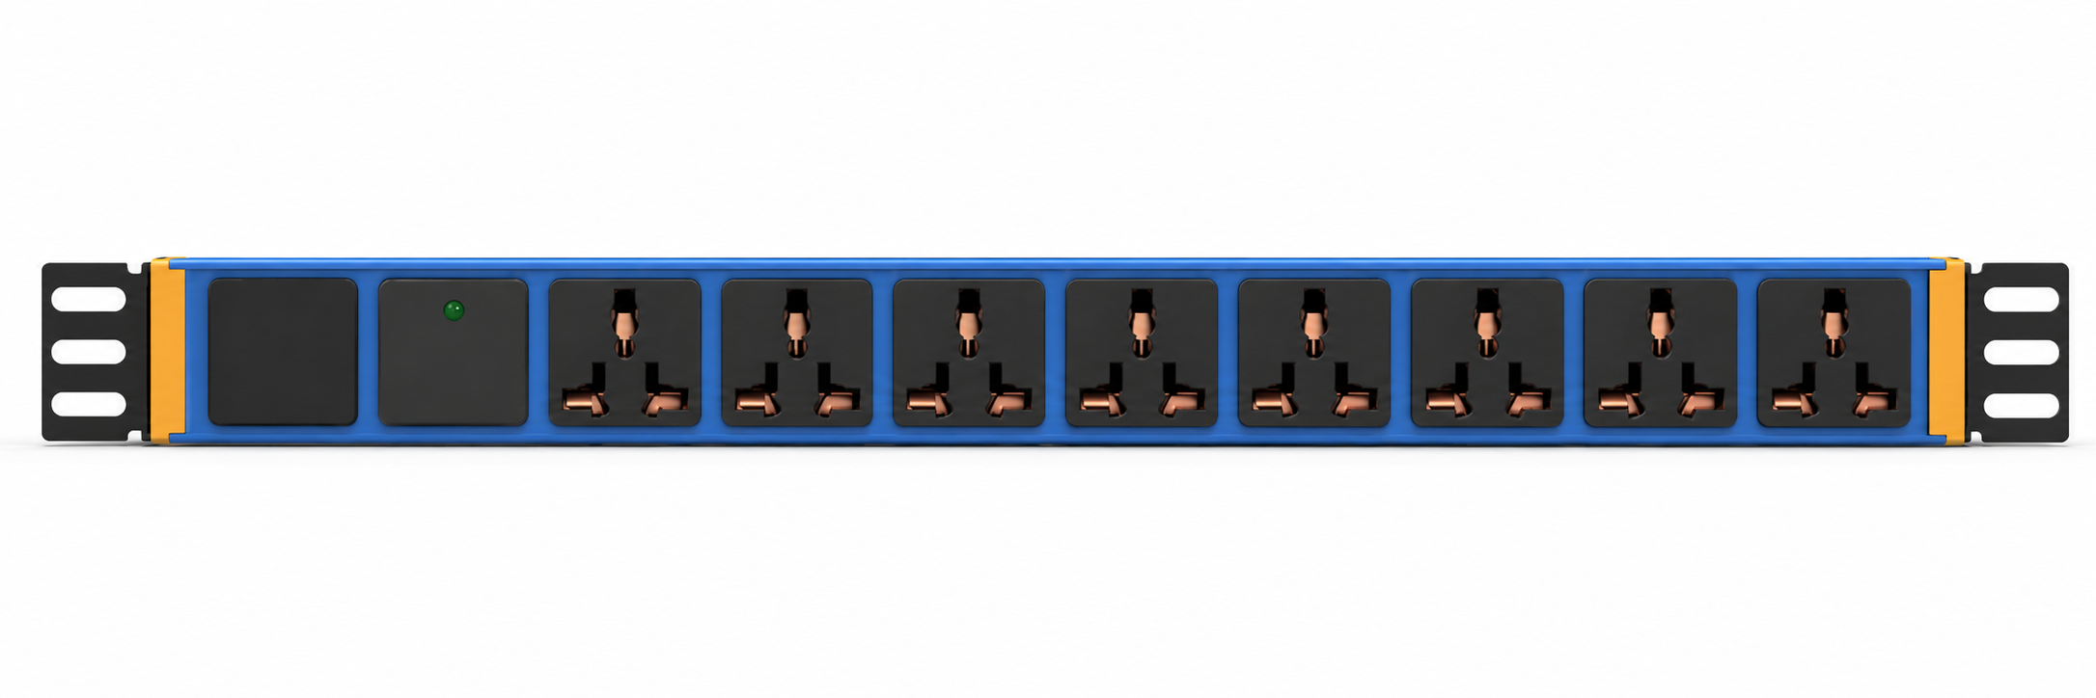 | 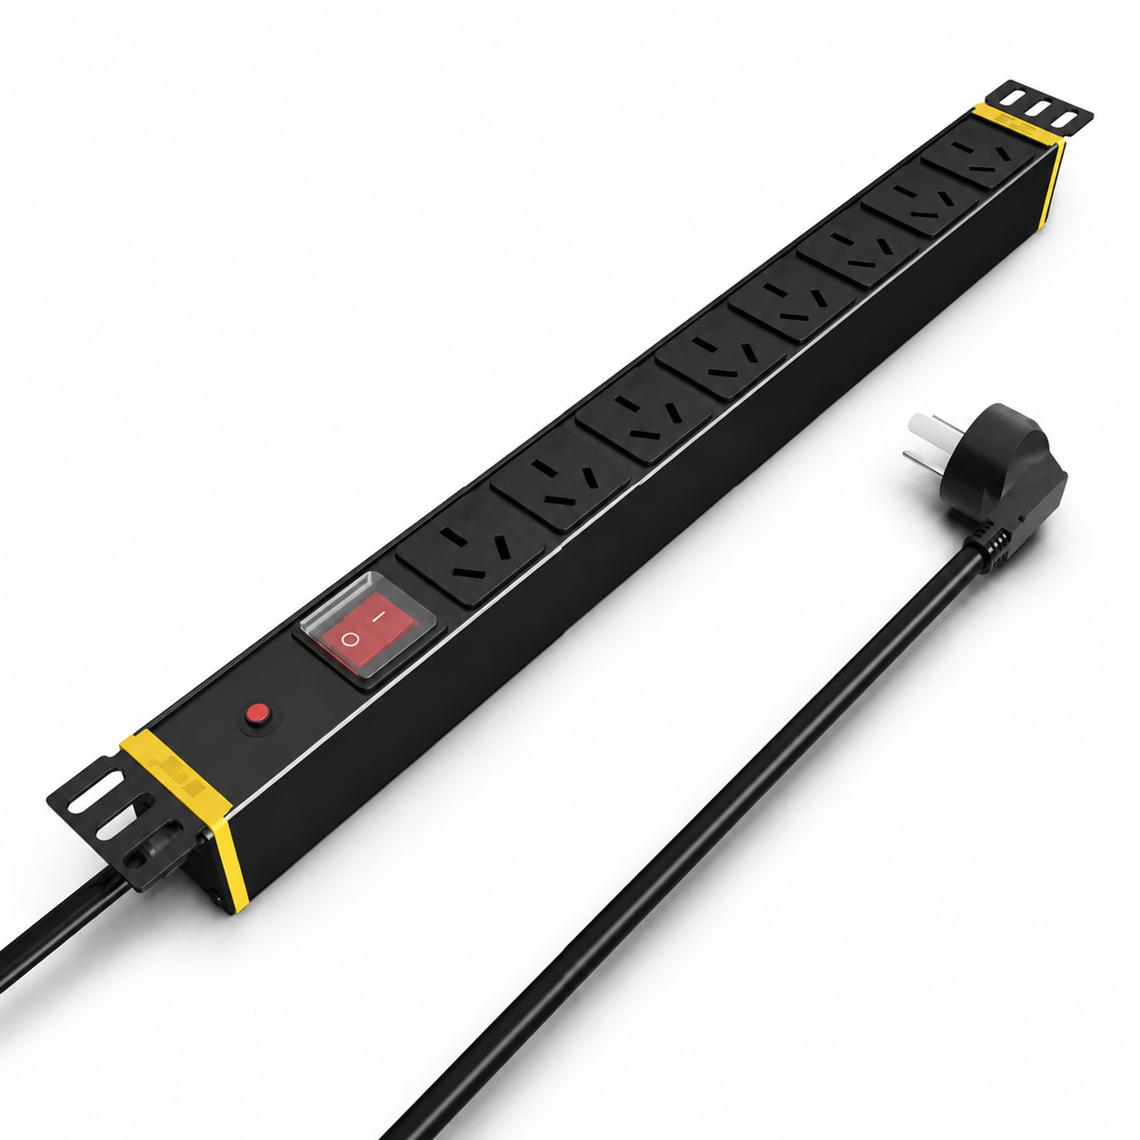 | 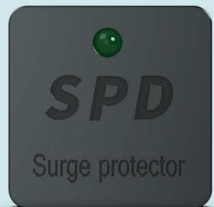 | 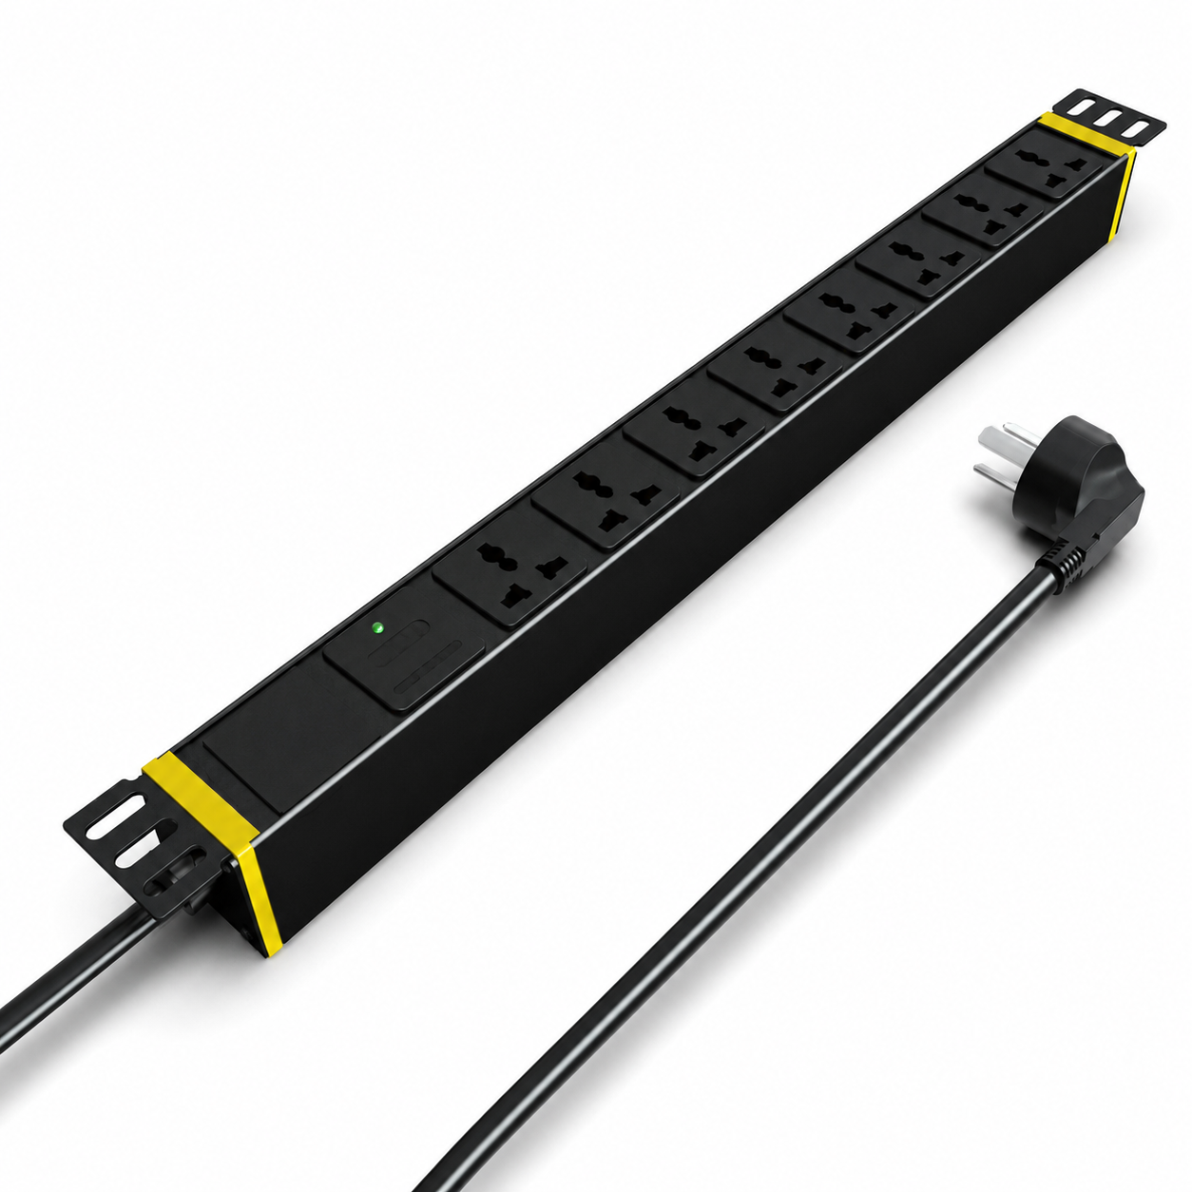
SP1182-2 · Primary | SP3182 · Primary | SP3182 · Gallery | SP5082 · Primary

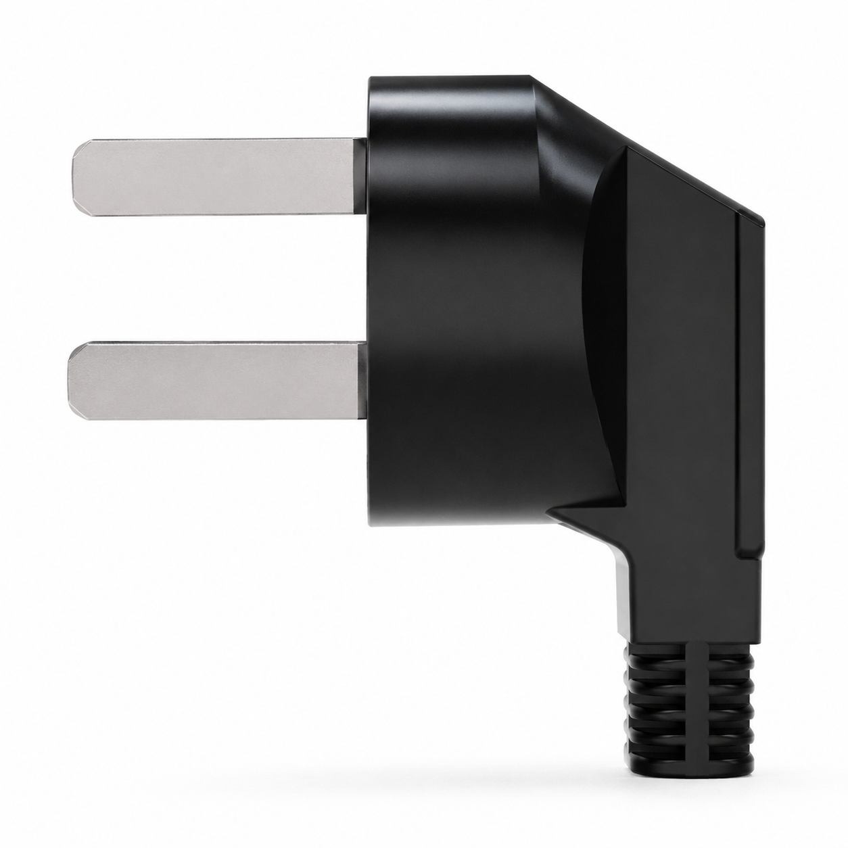 | 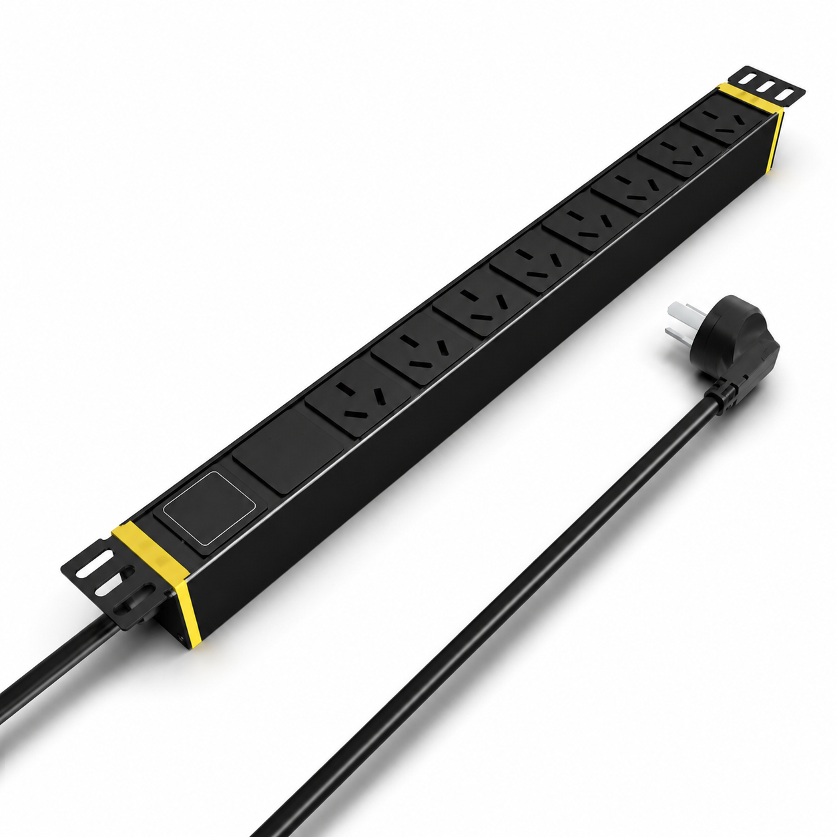 | 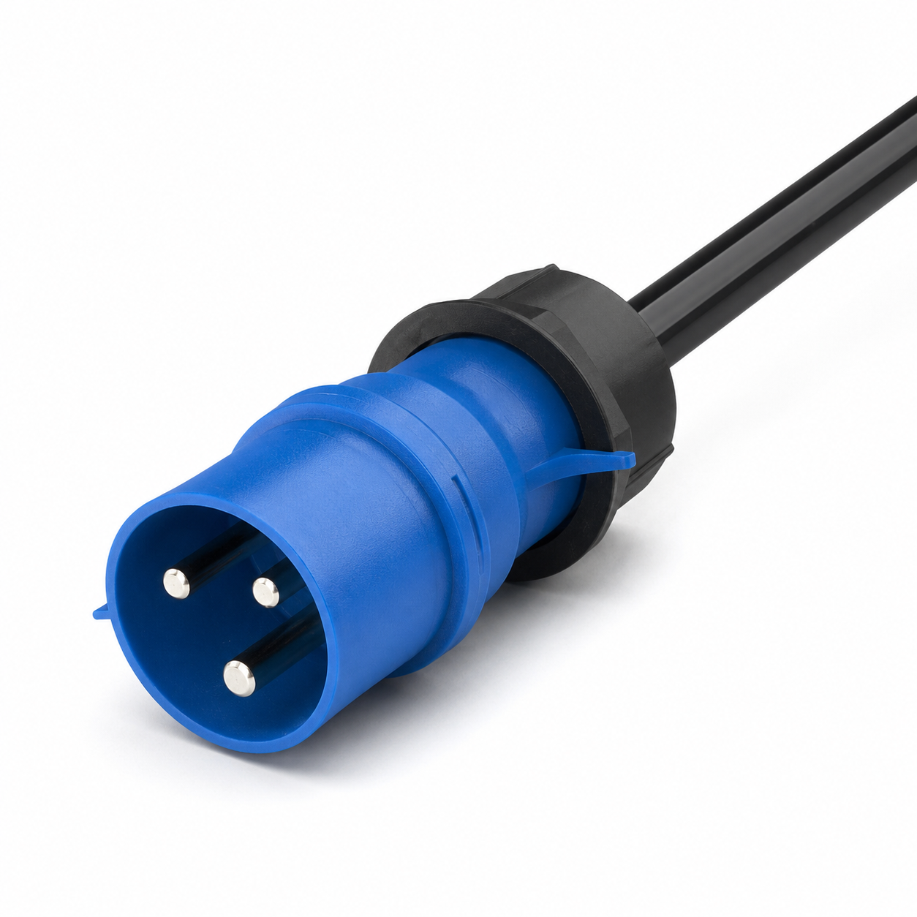 | 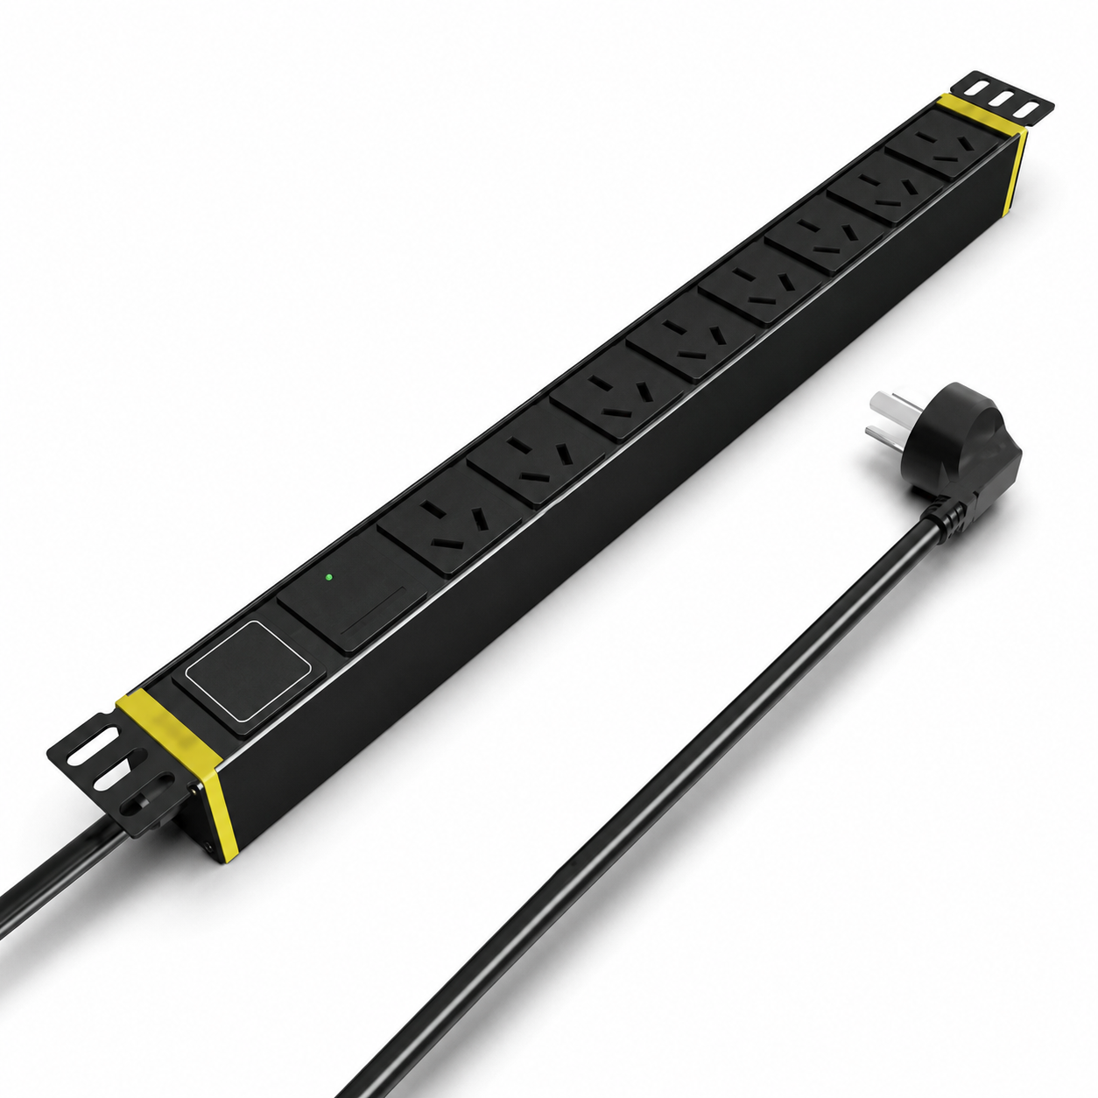
SP5082 · Gallery | SP5082 · Gallery | SP5082 · Gallery | SP5087 · Primary

PRODUCT OVERVIEW
Rack power distribution with integrated surge protection for 10 A, 16 A and 32 A input configurations.
Product line | Rack PDU & Power Distribution
Series / family | pdu-spd
Exact model | SP1182-2 | SP3182 | SP5082 | SP5087 | SP5182 | SP61202
Applications | Network racks, Security cabinets, Surge-protected equipment distribution
MODEL COMPARISON
Exact model | Product / variant | Input Current | Input Cable | Input Plug
SP1182-2 | SP1182-2 Single-Row 1U High-Power PDU | 32 A | Not provided | Not provided
SP3182 | SP3182 10 A SPDsurge-protected PDU | 10 A | 3 m, 1.5 mm² | 10A Chinese-standard plug
SP5082 | SP5082 Surge-Protected Rack PDU | 16 A | 3 m, 2.5 mm² | Not provided
SP5087 | SP5087 16 A Switched Surge-Protected PDU | 16 A | 3 m, 2.5 mm² | 16A Chinese-standard plug
SP5182 | SP5182 10 A SPDsurge-protected PDU | 10 A | Not provided | Not provided
SP61202 | SP61202 20-Outlet Long-Form High-Power Surge-Protected PDU | 32 A | Not provided | Not provided
TECHNICAL SPECIFICATIONS
Models: SP1182-2 | SP3182 | SP5082 | SP5087
Parameter | SP1182-2 | SP3182 | SP5082 | SP5087
Input Current | 32 A | 10 A | 16 A | 16 A
Function Module — Key Specifications | catalog states “hot plug lighting protection” | Not provided | Not provided | Not provided
Output — Key Specifications | 8 × 10 A universal outlets | Not provided | Not provided | Not provided
Rated Load | 8000 W | 2500 W | 4000 W | 4000 W
Dimensions | 485 × 44.5 × 44.5 mm | 485 × 44.5 × 44.5 mm | 485 × 44.5 × 44.5 mm | 485 × 44.5 × 44.5 mm
Product series | Surge-Protected Rack PDU Series | Surge-Protected Rack PDU Series | Surge-Protected Rack PDU Series | Surge-Protected Rack PDU Series
Product category | PDU | PDU | Not provided | PDU
Input Cable | Not provided | 3 m, 1.5 mm² | 3 m, 2.5 mm² | 3 m, 2.5 mm²
Input Plug — Key Specifications | Not provided | 10A Chinese-standard plug | Not provided | 16A Chinese-standard plug
Function Module — Source Technical Data | Not provided | SPD protection | SPD surge protection | Switch + surge protection
Output — Source Technical Data | Not provided | 8 × 10 A universal outlets | 8 × 16 A Chinese-standard outlets | 8 × 16 A Chinese-standard outlets
Configurations | Not provided | Not provided | 2 | Not provided
Input Plug — Source Technical Data | Not provided | Not provided | 16A Chinese-standard plug | Not provided
Entity type | Not provided | Not provided | Product group with selectable configurations | Not provided
Models: SP5182 | SP61202
Parameter | SP5182 | SP61202
Cable Specification | 3 × 1.5 mm² | 3 × 6 mm²
Input Current | 10 A | 32 A
Rated Load | 2500 W | 8000 W
Input Plug | 10A Chinese-standard plug | 32A industrial plug
Function Module | SPD surge protection | SPD surge protection
Output | 8 × 10 A universal outlets | 20 × 10 A universal outlets
Dimensions | 485 × 44.5 × 44.5 mm | 990 × 62 × 44.5 mm
Product series | Surge-Protected Rack PDU Series | Surge-Protected Rack PDU Series
Product category | PDU | PDU
APPLICATIONS & RFQ CONFIRMATION
Typical applications | Confirm in the project RFQ
Network racks  Security cabinets  Surge-protected equipment distribution | Confirm the application, rack or room position, destination-market interface and mounting requirement.  Confirm electrical, network, accessory or protection scope from the product family and project drawings.  Confirm quantity, labeling, packing and required documents before purchase order.
Project supply: MOQ — Confirm by model and project quantity · Lead time — Confirm after configuration review · FOB port — Confirm in project quotation · OEM/ODM — To be confirmed
PROJECT CONFIGURATION CHECKLIST
Exact model | SP1182-2
Application and site conditions | Confirm installation environment and operating requirements.
Quantity and model mix | Confirm forecast quantity, phase plan and required variants.
Interfaces and accessories | Confirm compatible interfaces, accessories and system integration scope.
Finish, branding and packing | Confirm only when project customization is required.
Documentation and destination | Confirm drawings, datasheets, packing documents and destination country or port.

