
RACK PDU & POWER DISTRIBUTION

Basic Switched Rack PDU Series
  - Models: LS8113 | SP5181 | SP81097S
PRODUCT IMAGES
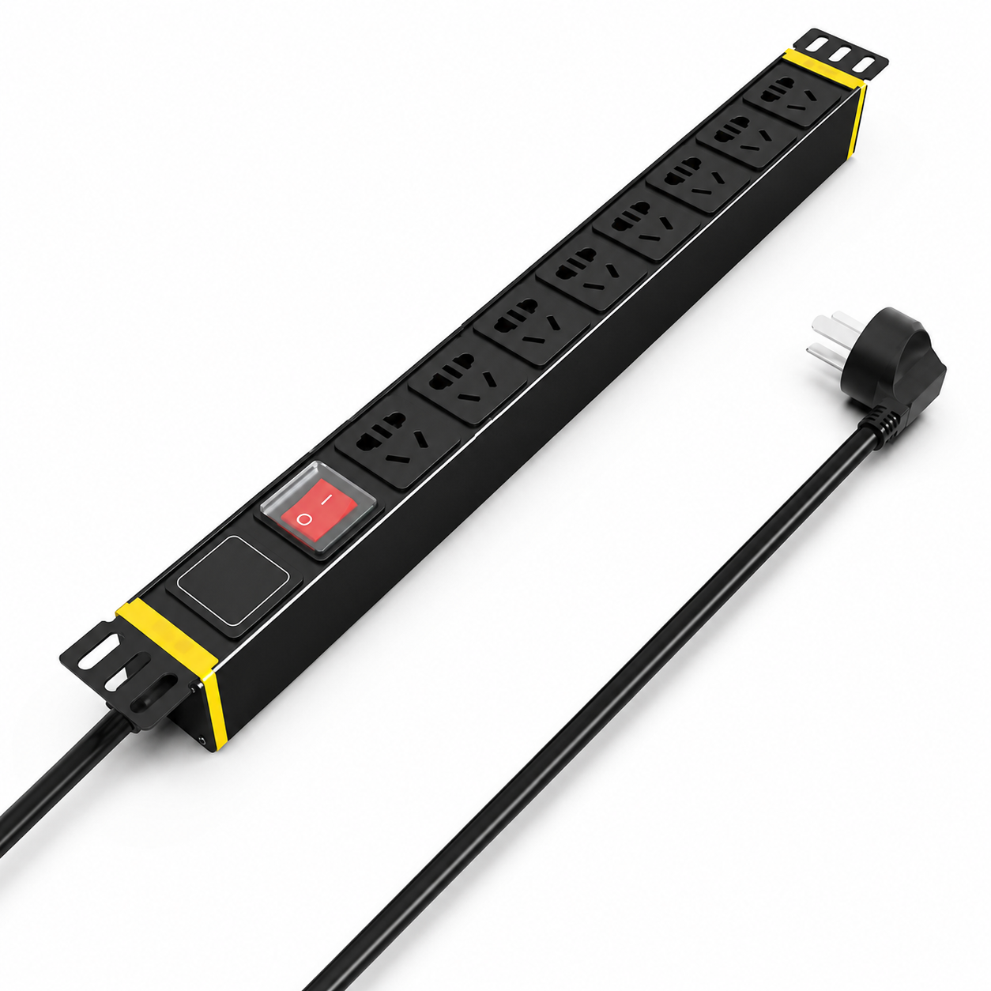 | 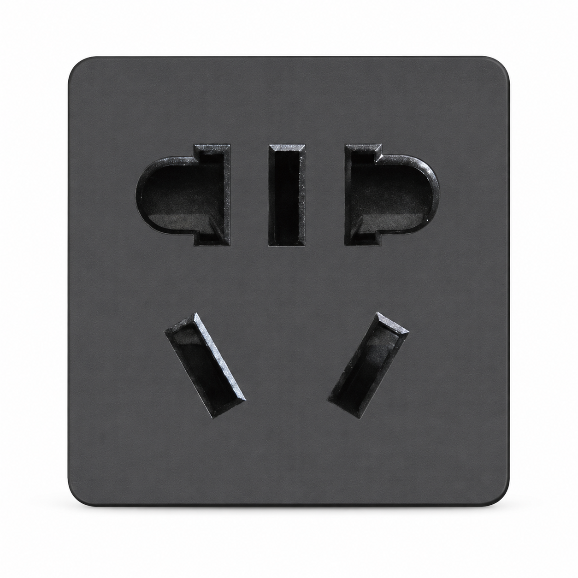 | 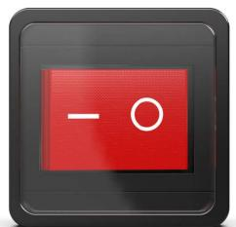 | 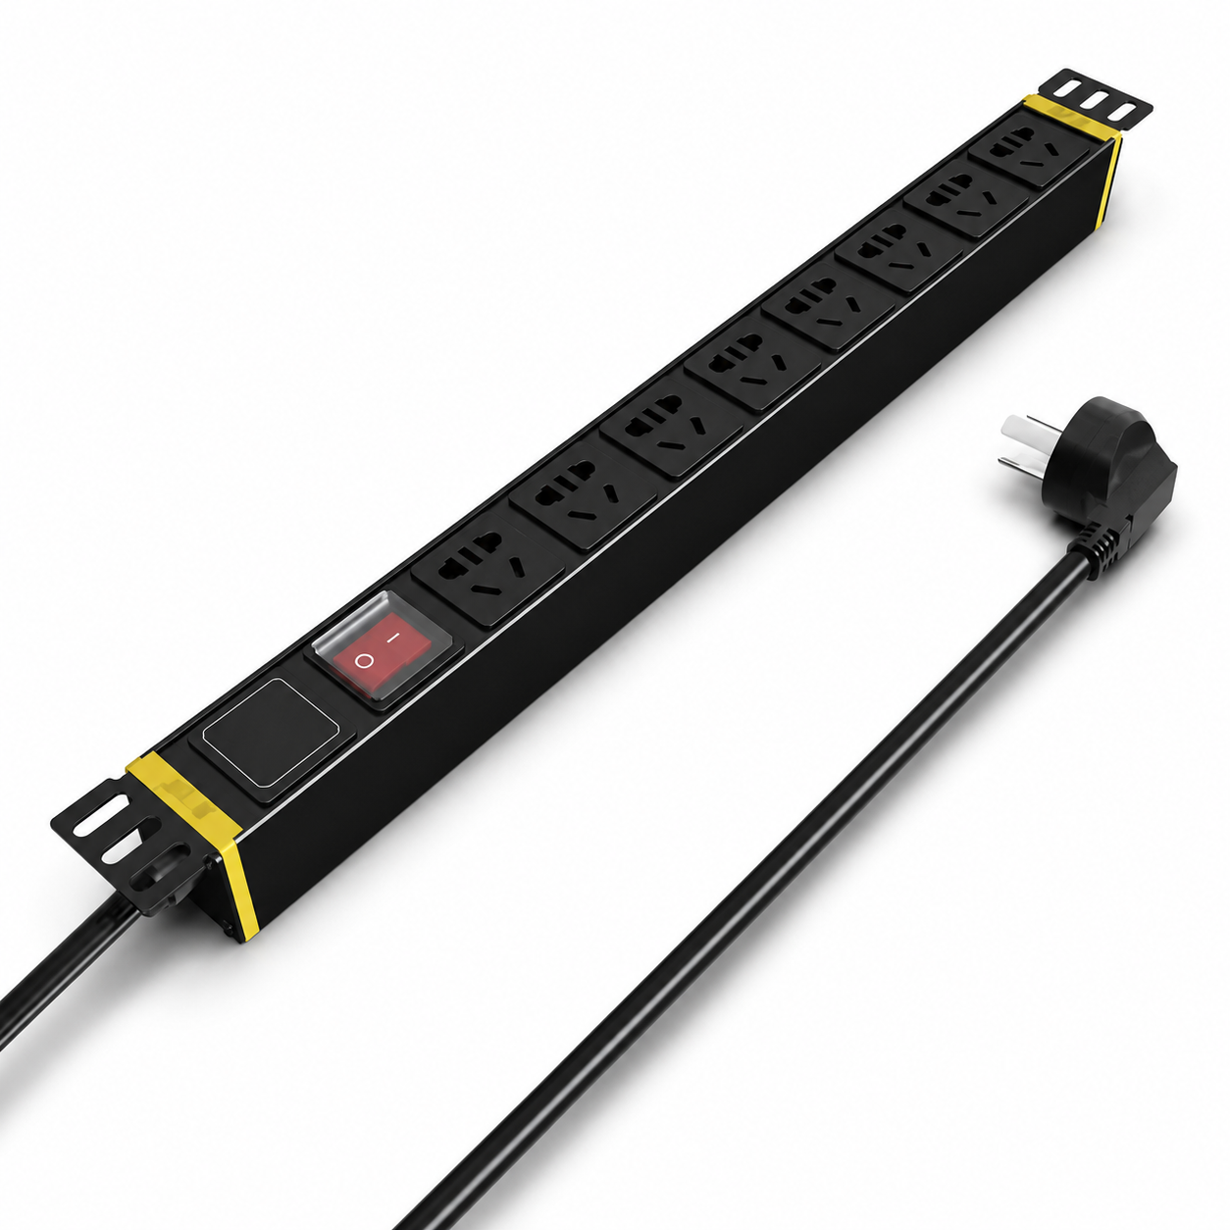
LS8113 · Primary | LS8113 · Gallery | LS8113 · Gallery | SP5181 · Primary

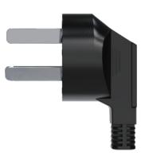 | 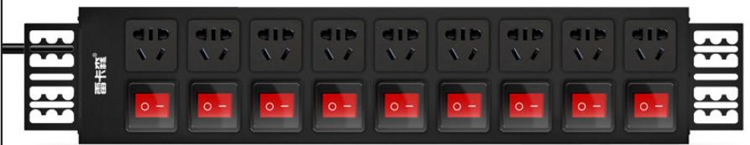
SP5181 · Gallery | SP81097S · Primary

PRODUCT OVERVIEW
2 documented configurations are consolidated on this product-group page so buyers can compare specifications without duplicate catalog cards.
Product line | Rack PDU & Power Distribution
Series / family | pdu-basic
Exact model | LS8113 | SP5181 | SP81097S
Applications | Network racks, Security equipment cabinets, IT equipment distribution
MODEL COMPARISON
Exact model | Product / variant | Input Current | Input Cable | Input Plug
LS8113 | LS8113 Basic Switched Rack PDU | 10 A | Not provided | Not provided
SP5181 | SP5181 10 A basic switched rack PDU | 10 A | 3 m, conductor cross-section 1.5 mm² | 10 A Chinese-standard plug
SP81097S | SP81097S dual-row independently switched PDU | 10 A | 3 m, 1.5 mm² | 10A Chinese-standard plug
TECHNICAL SPECIFICATIONS
Parameter | LS8113 | SP5181 | SP81097S
Configurations | 2 | Not provided | Not provided
Input Current | 10 A | 10 A | 10 A
Conductor Cross-Section | 2.5 mm² (catalog unit normalized for website display) | Not provided | Not provided
Input Plug — Source Technical Data | 10A Chinese-standard plug | Not provided | Not provided
Function Module | Switch protection | Master switch protection | Switch protection
Output | 8 × 10 A new Chinese-standard outlets | 8 × 10 A universal outlets | 8 × 10 A universal outlets
Rated Load | 2500 W | 2500 W | 2500 W
Dimensions | 485 × 44.5 × 44.5 mm | 485 × 44.5 × 44.5 mm (approx. 1U) | 485 × 44.5 × 44.5 mm
Product series | Basic Switched Rack PDU Series | Basic Switched Rack PDU Series | Basic Switched Rack PDU Series
Entity type | Product group with selectable configurations | Not provided | Not provided
Input Cable | Not provided | 3 m, conductor cross-section 1.5 mm² | 3 m, 1.5 mm²
Input Plug — Key Specifications | Not provided | 10 A Chinese-standard plug | 10A Chinese-standard plug
Product category | Not provided | PDU | PDU
APPLICATIONS & RFQ CONFIRMATION
Typical applications | Confirm in the project RFQ
Network racks  Security equipment cabinets  IT equipment distribution | Confirm the application, rack or room position, destination-market interface and mounting requirement.  Confirm electrical, network, accessory or protection scope from the product family and project drawings.  Confirm quantity, labeling, packing and required documents before purchase order.
Project supply: MOQ — Confirm by model and project quantity · Lead time — Confirm after configuration review · FOB port — Confirm in project quotation · OEM/ODM — To be confirmed
PROJECT CONFIGURATION CHECKLIST
Exact model | LS8113
Application and site conditions | Confirm installation environment and operating requirements.
Quantity and model mix | Confirm forecast quantity, phase plan and required variants.
Interfaces and accessories | Confirm compatible interfaces, accessories and system integration scope.
Finish, branding and packing | Confirm only when project customization is required.
Documentation and destination | Confirm drawings, datasheets, packing documents and destination country or port.

