
RACK PDU & POWER DISTRIBUTION

Circuit Breaker & Overload Protection PDU Series
  - Models: DT7188 | SP5071 | SP51103 | SP5188 | SP6081
PRODUCT IMAGES
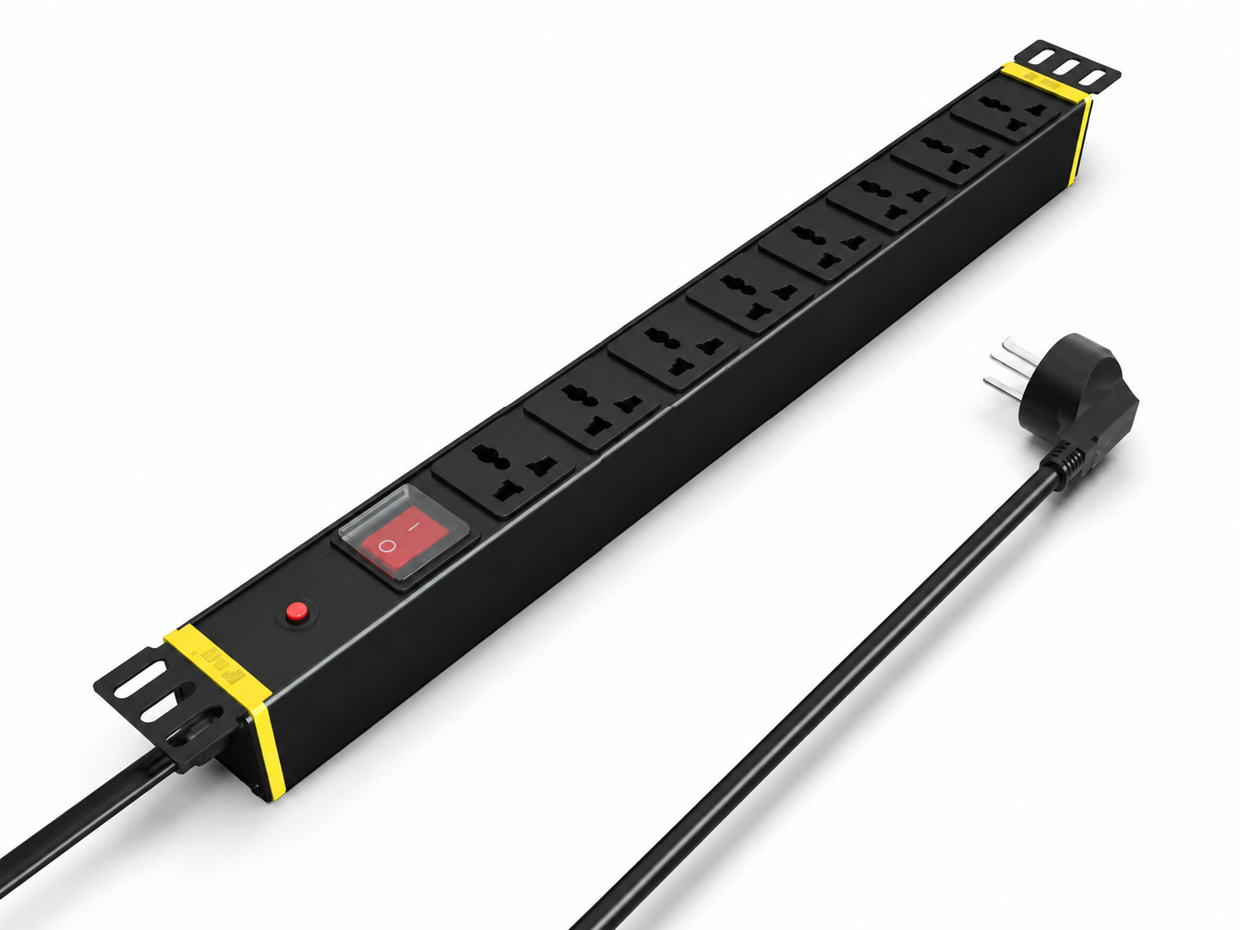 |  | 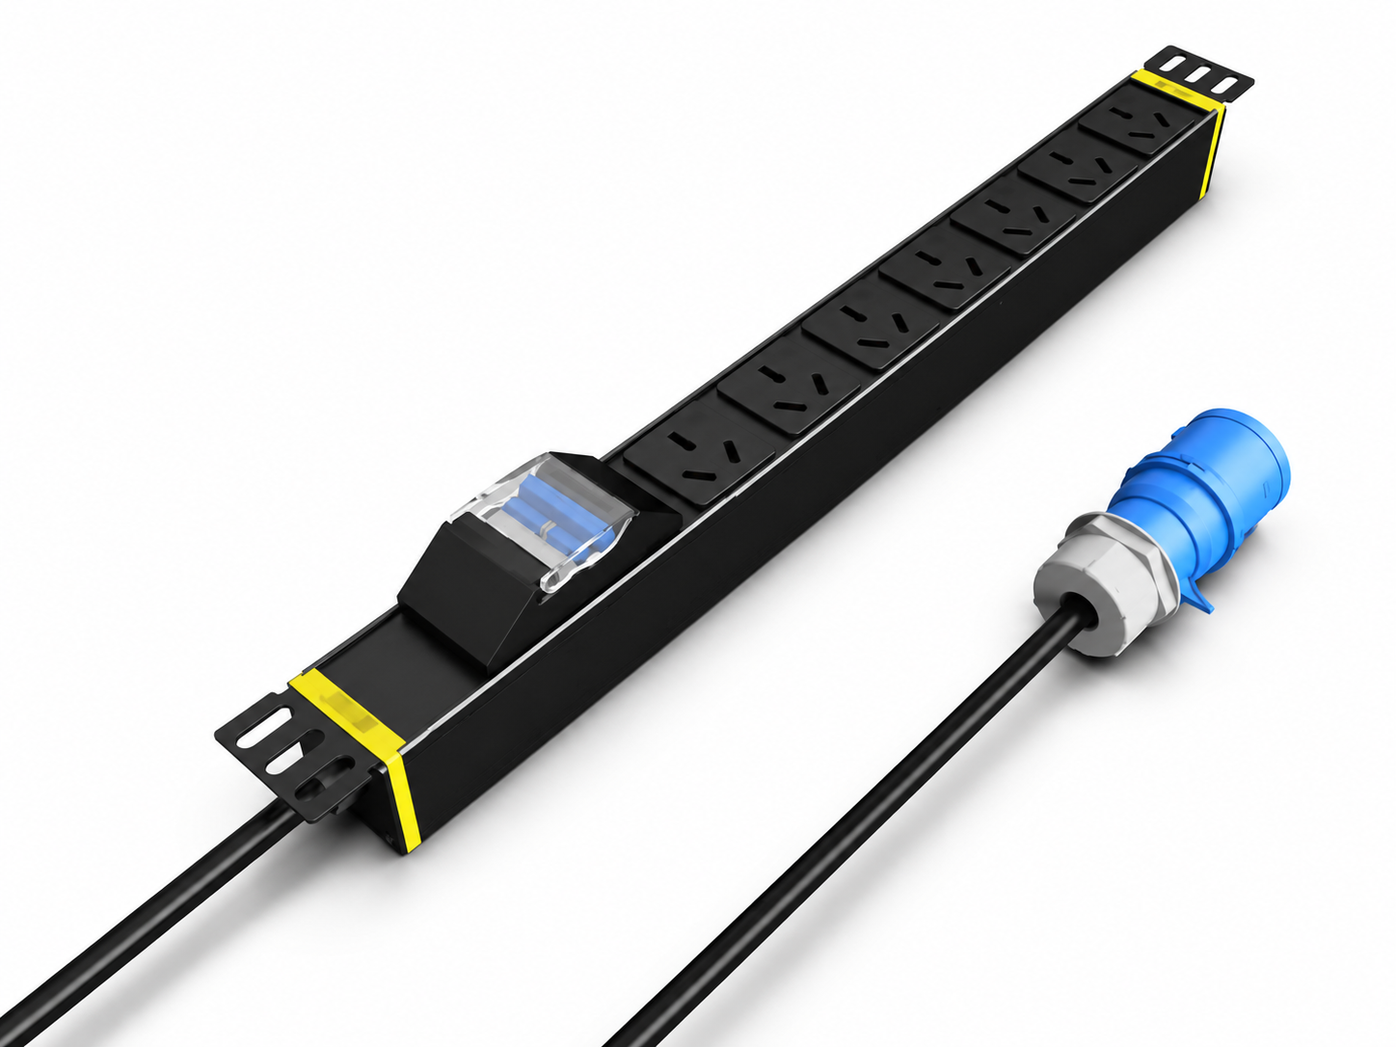 | 
DT7188 · Primary | DT7188 · Gallery | SP5071 · Primary | SP5071 · Gallery

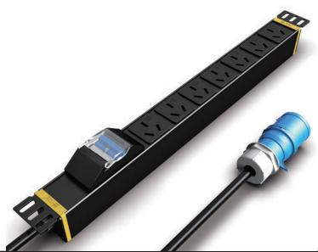 | 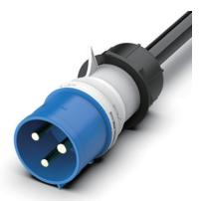 | 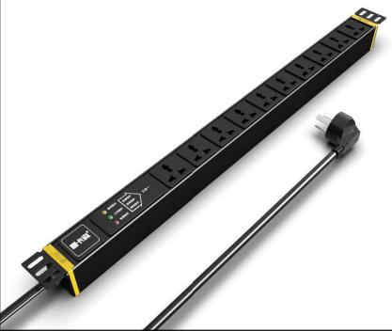 | 
SP5071 · Gallery | SP5071 · Gallery | SP51103 · Primary | SP51103 · Gallery

PRODUCT OVERVIEW
Rack power distribution with circuit-breaker or overload-protection modules for enhanced overcurrent protection.
Product line | Rack PDU & Power Distribution
Series / family | pdu-breaker
Exact model | DT7188 | SP5071 | SP51103 | SP5188 | SP6081
Applications | Server and network racks, Equipment cabinets, Overload-protected distribution
MODEL COMPARISON
Exact model | Product / variant | Input Current | Input Cable | Input Plug
DT7188 | DT7188 10 A Switched Overload-Protected PDU | 10 A | 3 m, 1.5 mm² | 10A Chinese-standard plug
SP5071 | SP5071 Circuit Breaker & Overload Protection PDU | 16 A | 3 m, 2.5 mm² | Not provided
SP51103 | SP51103 10-Outlet 3-in-1 Protection PDU | 16 A | 3 m, 2.5 mm² | 16A Chinese-standard plug
SP5188 | SP5188 16 A Switched Overload-Protected PDU | 16 A | 3 m, 2.5 mm² | 16A Chinese-standard plug
SP6081 | SP6081 32 A High-Power Circuit-Breaker PDU | 32 A | Not provided | Not provided
TECHNICAL SPECIFICATIONS
Models: DT7188 | SP5071 | SP51103 | SP5188
Parameter | DT7188 | SP5071 | SP51103 | SP5188
Input Current | 10 A | 16 A | 16 A | 16 A
Input Cable | 3 m, 1.5 mm² | 3 m, 2.5 mm² | 3 m, 2.5 mm² | 3 m, 2.5 mm²
Input Plug — Key Specifications | 10A Chinese-standard plug | Not provided | 16A Chinese-standard plug | 16A Chinese-standard plug
Function Module | Switch + overload protection | Circuit breaker | 3-in-1 protection | Switch + overload protection
Output | 8 × 10 A universal outlets | 7 × 16 A Chinese-standard outlets | 10 × 10 A universal outlets | 8 × 10 A universal outlets
Rated Load | 2500 W | 4000 W | 4000 W | 4000 W
Dimensions | 485 × 44.5 × 44.5 mm | 485 × 44.5 × 44.5 mm | 485 × 44.5 × 44.5 mm | 485 × 44.5 × 44.5 mm
Product series | Circuit Breaker & Overload Protection PDU Series | Circuit Breaker & Overload Protection PDU Series | Circuit Breaker & Overload Protection PDU Series | Circuit Breaker & Overload Protection PDU Series
Product category | PDU | Not provided | PDU | PDU
Configurations | Not provided | 2 | Not provided | Not provided
Input Plug — Source Technical Data | Not provided | 16A Chinese-standard plug | Not provided | Not provided
Entity type | Not provided | Product group with selectable configurations | Not provided | Not provided
Models: SP6081
Parameter | Specification
Cable Specification | 3 × 4 mm²
Input Current | 32 A
Rated Load | 6000 W
Input Plug | 32A industrial plug
Function Module | Circuit breaker
Output | 8 × 16 A Chinese-standard outlets
Dimensions | 485 × 44.5 × 44.5 mm
Product series | Circuit Breaker & Overload Protection PDU Series
Product category | PDU
APPLICATIONS & RFQ CONFIRMATION
Typical applications | Confirm in the project RFQ
Server and network racks  Equipment cabinets  Overload-protected distribution | Confirm the application, rack or room position, destination-market interface and mounting requirement.  Confirm electrical, network, accessory or protection scope from the product family and project drawings.  Confirm quantity, labeling, packing and required documents before purchase order.
Project supply: MOQ — Confirm by model and project quantity · Lead time — Confirm after configuration review · FOB port — Confirm in project quotation · OEM/ODM — To be confirmed
PROJECT CONFIGURATION CHECKLIST
Exact model | DT7188
Application and site conditions | Confirm installation environment and operating requirements.
Quantity and model mix | Confirm forecast quantity, phase plan and required variants.
Interfaces and accessories | Confirm compatible interfaces, accessories and system integration scope.
Finish, branding and packing | Confirm only when project customization is required.
Documentation and destination | Confirm drawings, datasheets, packing documents and destination country or port.

