
RACK PDU & POWER DISTRIBUTION

High-Power & Special I/O PDU Series
  - Models: DS8118 | SP51104 | SP5281 | SP9041S
PRODUCT IMAGES
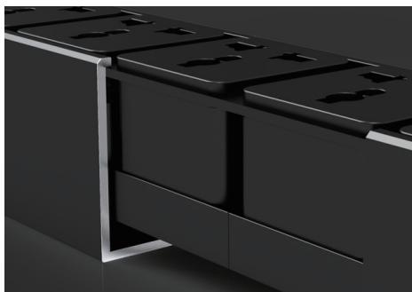 | 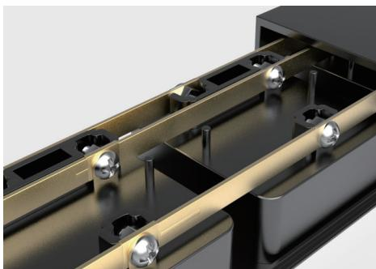 | 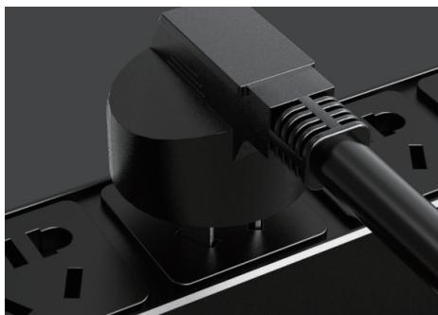 | 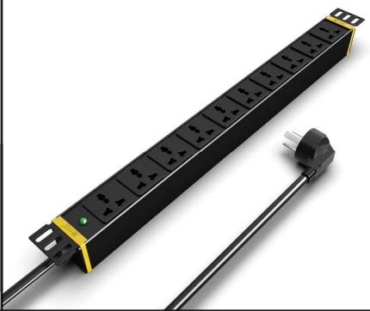
DS8118 · Structural Detail · Series Reference View | DS8118 · Structural Detail · Series Reference View | DS8118 · Structural Detail · Series Reference View | SP51104 · Primary

 | 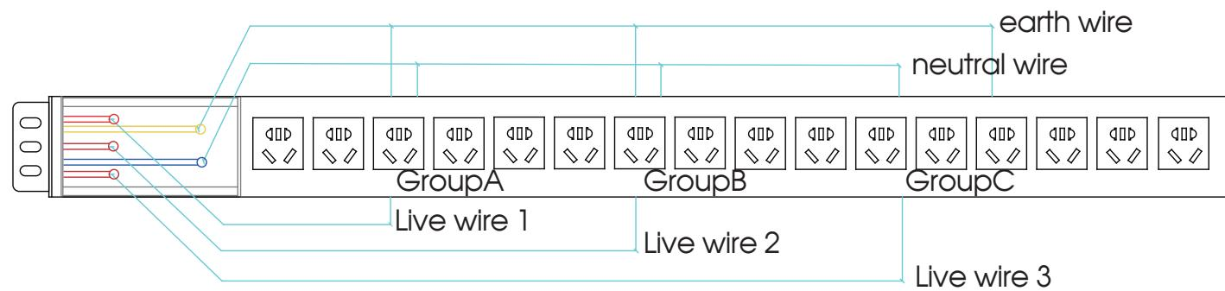 | 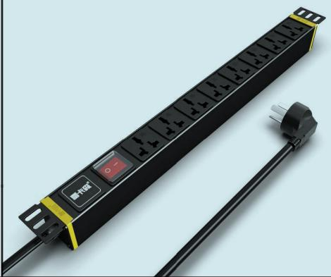 | 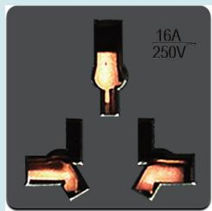
SP51104 · Gallery | SP51104 · Input Wiring | SP5281 · Primary | SP5281 · Gallery

PRODUCT OVERVIEW
High-power and special-input/output rack PDU configurations for project-specific power distribution.
Product line | Rack PDU & Power Distribution
Series / family | pdu-special
Exact model | DS8118 | SP51104 | SP5281 | SP9041S
Applications | Special-input equipment racks, High-load cabinets, Project-configured power distribution
MODEL COMPARISON
Exact model | Product / variant | Input Current | Input Cable | Input Method
DS8118 | DS8118 Hardwired 8-Outlet New Chinese-Standard PDU | 16 A | Not provided | No input cable; terminal-block / hardwired input
SP51104 | SP51104 High-Power & Special I/O PDU | 16 A | 3 m, 2.5 mm² | Not provided
SP5281 | SP5281 16 A Universal-Outlet PDU | 16 A | 3 m, 2.5 mm² | Not provided
SP9041S | SP9041S 4-Outlet 16 A High-Power Terminal-Block PDU | 32 A | Not provided | Not provided
TECHNICAL SPECIFICATIONS
Parameter | DS8118 | SP51104 | SP5281 | SP9041S
Input Method | No input cable; terminal-block / hardwired input | Not provided | Not provided | Not provided
Input Current | 16 A | 16 A | 16 A | 32 A
Rated Load — Key Specifications | 4000 W | Not provided | Not provided | Not provided
Function Module — Source Technical Data | Switch protection | Power indicator | Switch protection | Not provided
Output — Source Technical Data | 8 × 10 A new Chinese-standard outlets | 10 × 10 A universal outlets | 8 × 16 A universal outlets | Not provided
Dimensions | 485 × 44.5 × 44.5 mm | 485 × 44.5 × 44.5 mm | 485 × 44.5 × 44.5 mm | 485 × 44.5 × 44.5 mm
Product series | High-Power & Special I/O PDU Series | High-Power & Special I/O PDU Series | High-Power & Special I/O PDU Series | High-Power & Special I/O PDU Series
Product category | PDU | Not provided | PDU | PDU
Configurations | Not provided | 2 | Not provided | Not provided
Input Cable | Not provided | 3 m, 2.5 mm² | 3 m, 2.5 mm² | Not provided
Input Plug — Source Technical Data | Not provided | 16A Chinese-standard plug | Not provided | Not provided
Rated Load — Source Technical Data | Not provided | 4000 W | 4000 W | 8000 W
Entity type | Not provided | Product group with selectable configurations | Not provided | Not provided
Input Plug — Key Specifications | Not provided | Not provided | 16A Chinese-standard plug | Not provided
Function Module — Key Specifications | Not provided | Not provided | Not provided | Junction box / terminal block
Output — Key Specifications | Not provided | Not provided | Not provided | 4 × 16 A Chinese-standard outlets
APPLICATIONS & RFQ CONFIRMATION
Typical applications | Confirm in the project RFQ
Special-input equipment racks  High-load cabinets  Project-configured power distribution | Confirm the application, rack or room position, destination-market interface and mounting requirement.  Confirm electrical, network, accessory or protection scope from the product family and project drawings.  Confirm quantity, labeling, packing and required documents before purchase order.
Project supply: MOQ — Confirm by model and project quantity · Lead time — Confirm after configuration review · FOB port — Confirm in project quotation · OEM/ODM — To be confirmed
PROJECT CONFIGURATION CHECKLIST
Exact model | DS8118
Application and site conditions | Confirm installation environment and operating requirements.
Quantity and model mix | Confirm forecast quantity, phase plan and required variants.
Interfaces and accessories | Confirm compatible interfaces, accessories and system integration scope.
Finish, branding and packing | Confirm only when project customization is required.
Documentation and destination | Confirm drawings, datasheets, packing documents and destination country or port.

