
RACK PDU & POWER DISTRIBUTION

SP9041S 4-Outlet 16 A High-Power Terminal-Block PDU
  - Exact model: SP9041S
PRODUCT IMAGES
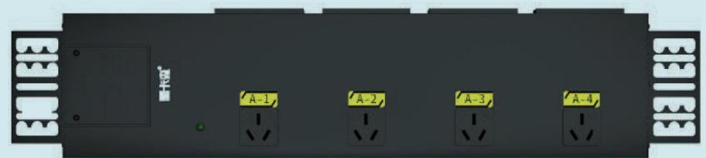
SP9041S · Primary

PRODUCT OVERVIEW
High-power and special-input/output rack PDU configurations for project-specific power distribution.
Product line | Rack PDU & Power Distribution
Series / family | pdu-special
Exact model | SP9041S
Applications | Special-input equipment racks, High-load cabinets, Project-configured power distribution
MODEL IDENTIFICATION
Exact model | Product / variant | Input Current | Function Module | Output
SP9041S | SP9041S 4-Outlet 16 A High-Power Terminal-Block PDU | 32 A | Junction box / terminal block | 4 × 16 A Chinese-standard outlets
TECHNICAL SPECIFICATIONS
Parameter | Specification
Input Current | 32 A
Function Module | Junction box / terminal block
Output | 4 × 16 A Chinese-standard outlets
Rated Load | 8000 W
Dimensions | 485 × 44.5 × 44.5 mm
Product series | High-Power & Special I/O PDU Series
Product category | PDU
APPLICATIONS & RFQ CONFIRMATION
Typical applications | Confirm in the project RFQ
Special-input equipment racks  High-load cabinets  Project-configured power distribution | Confirm the application, rack or room position, destination-market interface and mounting requirement.  Confirm electrical, network, accessory or protection scope from the product family and project drawings.  Confirm quantity, labeling, packing and required documents before purchase order.
Project supply: MOQ — Confirm by model and project quantity · Lead time — Confirm after configuration review · FOB port — Confirm in project quotation · OEM/ODM — To be confirmed
PROJECT CONFIGURATION CHECKLIST
Exact model | SP9041S
Application and site conditions | Confirm installation environment and operating requirements.
Quantity and model mix | Confirm forecast quantity, phase plan and required variants.
Interfaces and accessories | Confirm compatible interfaces, accessories and system integration scope.
Finish, branding and packing | Confirm only when project customization is required.
Documentation and destination | Confirm drawings, datasheets, packing documents and destination country or port.

