
RACK PDU & POWER DISTRIBUTION

SP61202 20-Outlet Long-Form High-Power Surge-Protected PDU
  - Exact model: SP61202
PRODUCT IMAGES
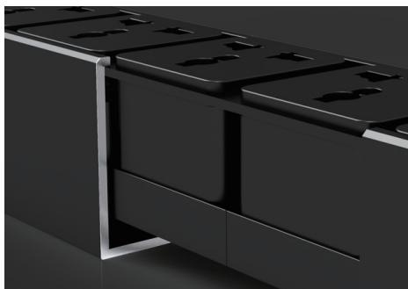 | 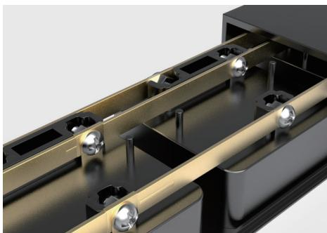 | 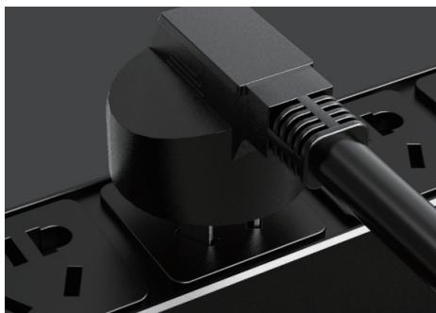
SP61202 · Structural Detail · Series Reference View | SP61202 · Structural Detail · Series Reference View | SP61202 · Structural Detail · Series Reference View

PRODUCT OVERVIEW
Rack power distribution with integrated surge protection for 10 A, 16 A and 32 A input configurations.
Product line | Rack PDU & Power Distribution
Series / family | pdu-spd
Exact model | SP61202
Applications | Network racks, Security cabinets, Surge-protected equipment distribution
MODEL IDENTIFICATION
Exact model | Product / variant | Cable Specification | Input Current | Rated Load
SP61202 | SP61202 20-Outlet Long-Form High-Power Surge-Protected PDU | 3 × 6 mm² | 32 A | 8000 W
TECHNICAL SPECIFICATIONS
Parameter | Specification
Cable Specification | 3 × 6 mm²
Input Current | 32 A
Rated Load | 8000 W
Input Plug | 32A industrial plug
Function Module | SPD surge protection
Output | 20 × 10 A universal outlets
Dimensions | 990 × 62 × 44.5 mm
Product series | Surge-Protected Rack PDU Series
Product category | PDU
APPLICATIONS & RFQ CONFIRMATION
Typical applications | Confirm in the project RFQ
Network racks  Security cabinets  Surge-protected equipment distribution | Confirm the application, rack or room position, destination-market interface and mounting requirement.  Confirm electrical, network, accessory or protection scope from the product family and project drawings.  Confirm quantity, labeling, packing and required documents before purchase order.
Project supply: MOQ — Confirm by model and project quantity · Lead time — Confirm after configuration review · FOB port — Confirm in project quotation · OEM/ODM — To be confirmed
PROJECT CONFIGURATION CHECKLIST
Exact model | SP61202
Application and site conditions | Confirm installation environment and operating requirements.
Quantity and model mix | Confirm forecast quantity, phase plan and required variants.
Interfaces and accessories | Confirm compatible interfaces, accessories and system integration scope.
Finish, branding and packing | Confirm only when project customization is required.
Documentation and destination | Confirm drawings, datasheets, packing documents and destination country or port.

