
RACK PDU & POWER DISTRIBUTION

SP6081 32 A High-Power Circuit-Breaker PDU
  - Exact model: SP6081
PRODUCT IMAGES
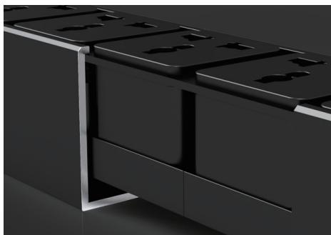 | 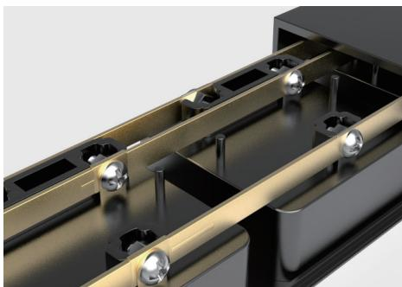 | 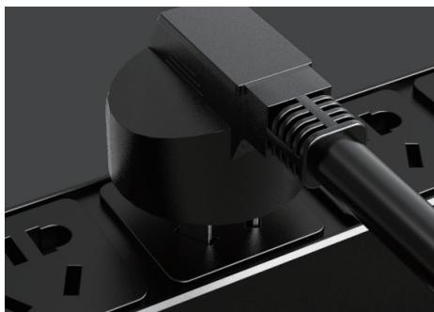
SP6081 · Structural Detail · Series Reference View | SP6081 · Structural Detail · Series Reference View | SP6081 · Structural Detail · Series Reference View

PRODUCT OVERVIEW
Rack power distribution with circuit-breaker or overload-protection modules for enhanced overcurrent protection.
Product line | Rack PDU & Power Distribution
Series / family | pdu-breaker
Exact model | SP6081
Applications | Server and network racks, Equipment cabinets, Overload-protected distribution
MODEL IDENTIFICATION
Exact model | Product / variant | Cable Specification | Input Current | Rated Load
SP6081 | SP6081 32 A High-Power Circuit-Breaker PDU | 3 × 4 mm² | 32 A | 6000 W
TECHNICAL SPECIFICATIONS
Parameter | Specification
Cable Specification | 3 × 4 mm²
Input Current | 32 A
Rated Load | 6000 W
Input Plug | 32A industrial plug
Function Module | Circuit breaker
Output | 8 × 16 A Chinese-standard outlets
Dimensions | 485 × 44.5 × 44.5 mm
Product series | Circuit Breaker & Overload Protection PDU Series
Product category | PDU
APPLICATIONS & RFQ CONFIRMATION
Typical applications | Confirm in the project RFQ
Server and network racks  Equipment cabinets  Overload-protected distribution | Confirm the application, rack or room position, destination-market interface and mounting requirement.  Confirm electrical, network, accessory or protection scope from the product family and project drawings.  Confirm quantity, labeling, packing and required documents before purchase order.
Project supply: MOQ — Confirm by model and project quantity · Lead time — Confirm after configuration review · FOB port — Confirm in project quotation · OEM/ODM — To be confirmed
PROJECT CONFIGURATION CHECKLIST
Exact model | SP6081
Application and site conditions | Confirm installation environment and operating requirements.
Quantity and model mix | Confirm forecast quantity, phase plan and required variants.
Interfaces and accessories | Confirm compatible interfaces, accessories and system integration scope.
Finish, branding and packing | Confirm only when project customization is required.
Documentation and destination | Confirm drawings, datasheets, packing documents and destination country or port.

