
RACK PDU & POWER DISTRIBUTION

SP5188 16 A Switched Overload-Protected PDU
  - Exact model: SP5188
PRODUCT IMAGES
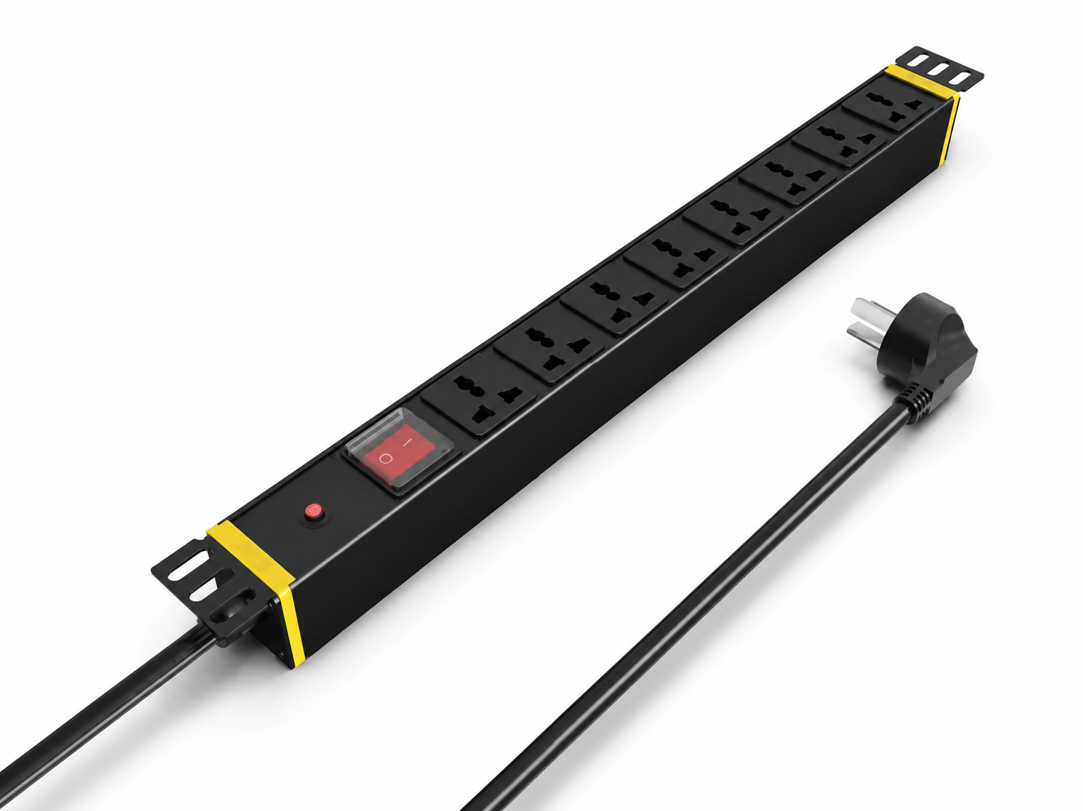 | 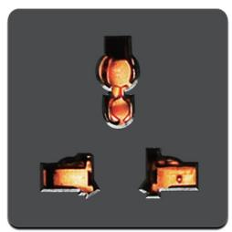
SP5188 · Primary | SP5188 · Gallery

PRODUCT OVERVIEW
Rack power distribution with circuit-breaker or overload-protection modules for enhanced overcurrent protection.
Product line | Rack PDU & Power Distribution
Series / family | pdu-breaker
Exact model | SP5188
Applications | Server and network racks, Equipment cabinets, Overload-protected distribution
MODEL IDENTIFICATION
Exact model | Product / variant | Input Current | Input Cable | Input Plug
SP5188 | SP5188 16 A Switched Overload-Protected PDU | 16 A | 3 m, 2.5 mm² | 16A Chinese-standard plug
TECHNICAL SPECIFICATIONS
Parameter | Specification
Input Current | 16 A
Input Cable | 3 m, 2.5 mm²
Input Plug | 16A Chinese-standard plug
Function Module | Switch + overload protection
Output | 8 × 10 A universal outlets
Rated Load | 4000 W
Dimensions | 485 × 44.5 × 44.5 mm
Product series | Circuit Breaker & Overload Protection PDU Series
Product category | PDU
APPLICATIONS & RFQ CONFIRMATION
Typical applications | Confirm in the project RFQ
Server and network racks  Equipment cabinets  Overload-protected distribution | Confirm the application, rack or room position, destination-market interface and mounting requirement.  Confirm electrical, network, accessory or protection scope from the product family and project drawings.  Confirm quantity, labeling, packing and required documents before purchase order.
Project supply: MOQ — Confirm by model and project quantity · Lead time — Confirm after configuration review · FOB port — Confirm in project quotation · OEM/ODM — To be confirmed
PROJECT CONFIGURATION CHECKLIST
Exact model | SP5188
Application and site conditions | Confirm installation environment and operating requirements.
Quantity and model mix | Confirm forecast quantity, phase plan and required variants.
Interfaces and accessories | Confirm compatible interfaces, accessories and system integration scope.
Finish, branding and packing | Confirm only when project customization is required.
Documentation and destination | Confirm drawings, datasheets, packing documents and destination country or port.

