
RACK PDU & POWER DISTRIBUTION

SP5186 16Ametered PDU
  - Exact model: SP5186
PRODUCT IMAGES
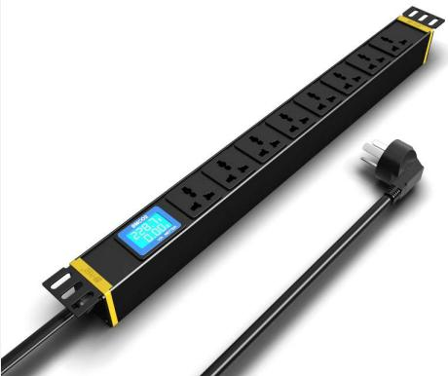 | 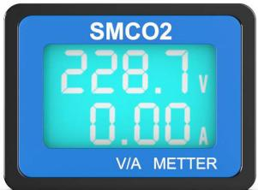
SP5186 · Primary | SP5186 · Gallery

PRODUCT OVERVIEW
Rack PDU with local voltage and current display for basic load monitoring.
Product line | Rack PDU & Power Distribution
Series / family | pdu-metered
Exact model | SP5186
Applications | Server racks, Network rooms, Load monitoring projects
MODEL IDENTIFICATION
Exact model | Product / variant | Input Current | Input Cable | Input Plug
SP5186 | SP5186 16Ametered PDU | 16 A | 3 m, 2.5 mm² | 16A Chinese-standard plug
TECHNICAL SPECIFICATIONS
Parameter | Specification
Input Current | 16 A
Input Cable | 3 m, 2.5 mm²
Input Plug | 16A Chinese-standard plug
Function Module | Current and voltage display
Output | 8 × 10 A universal outlets
Rated Load | 4000 W
Dimensions | 485 × 44.5 × 44.5 mm
Product series | Metered PDU Series
Product category | PDU
APPLICATIONS & RFQ CONFIRMATION
Typical applications | Confirm in the project RFQ
Server racks  Network rooms  Load monitoring projects | Confirm the application, rack or room position, destination-market interface and mounting requirement.  Confirm electrical, network, accessory or protection scope from the product family and project drawings.  Confirm quantity, labeling, packing and required documents before purchase order.
Project supply: MOQ — Confirm by model and project quantity · Lead time — Confirm after configuration review · FOB port — Confirm in project quotation · OEM/ODM — To be confirmed
PROJECT CONFIGURATION CHECKLIST
Exact model | SP5186
Application and site conditions | Confirm installation environment and operating requirements.
Quantity and model mix | Confirm forecast quantity, phase plan and required variants.
Interfaces and accessories | Confirm compatible interfaces, accessories and system integration scope.
Finish, branding and packing | Confirm only when project customization is required.
Documentation and destination | Confirm drawings, datasheets, packing documents and destination country or port.

