
RACK PDU & POWER DISTRIBUTION

SP5181 10 A basic switched rack PDU
  - Exact model: SP5181
PRODUCT IMAGES
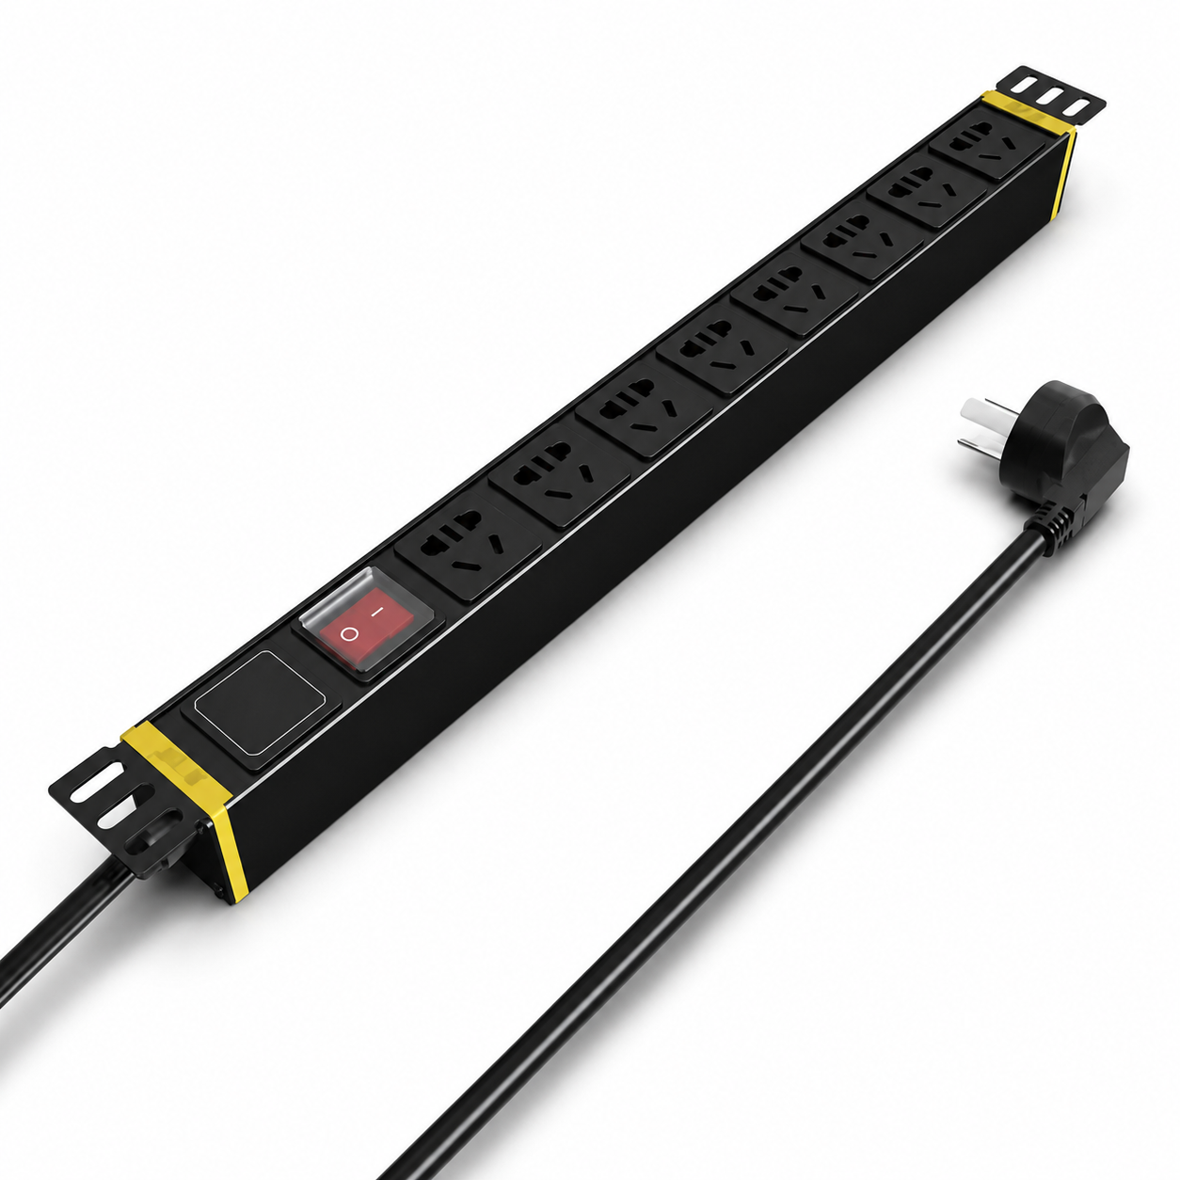 | 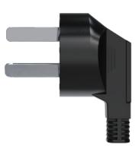
SP5181 · Primary | SP5181 · Gallery

PRODUCT OVERVIEW
Centralized rack power distribution with master or independent switch control for network, security and IT equipment.
Product line | Rack PDU & Power Distribution
Series / family | pdu-basic
Exact model | SP5181
Applications | Network racks, Security equipment cabinets, IT equipment distribution
MODEL IDENTIFICATION
Exact model | Product / variant | Input Current | Input Cable | Input Plug
SP5181 | SP5181 10 A basic switched rack PDU | 10 A | 3 m, conductor cross-section 1.5 mm² | 10 A Chinese-standard plug
TECHNICAL SPECIFICATIONS
Parameter | Specification
Input Current | 10 A
Input Cable | 3 m, conductor cross-section 1.5 mm²
Input Plug | 10 A Chinese-standard plug
Function Module | Master switch protection
Output | 8 × 10 A universal outlets
Rated Load | 2500 W
Dimensions | 485 × 44.5 × 44.5 mm (approx. 1U)
Product series | Basic Switched Rack PDU Series
Product category | PDU
APPLICATIONS & RFQ CONFIRMATION
Typical applications | Confirm in the project RFQ
Network racks  Security equipment cabinets  IT equipment distribution | Confirm the application, rack or room position, destination-market interface and mounting requirement.  Confirm electrical, network, accessory or protection scope from the product family and project drawings.  Confirm quantity, labeling, packing and required documents before purchase order.
Project supply: MOQ — Confirm by model and project quantity · Lead time — Confirm after configuration review · FOB port — Confirm in project quotation · OEM/ODM — To be confirmed
PROJECT CONFIGURATION CHECKLIST
Exact model | SP5181
Application and site conditions | Confirm installation environment and operating requirements.
Quantity and model mix | Confirm forecast quantity, phase plan and required variants.
Interfaces and accessories | Confirm compatible interfaces, accessories and system integration scope.
Finish, branding and packing | Confirm only when project customization is required.
Documentation and destination | Confirm drawings, datasheets, packing documents and destination country or port.

