
RACK PDU & POWER DISTRIBUTION

SP51104 High-Power & Special I/O PDU
  - Exact model: SP51104
PRODUCT IMAGES
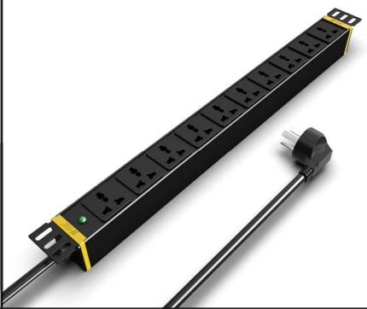 | 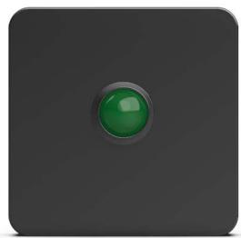 | 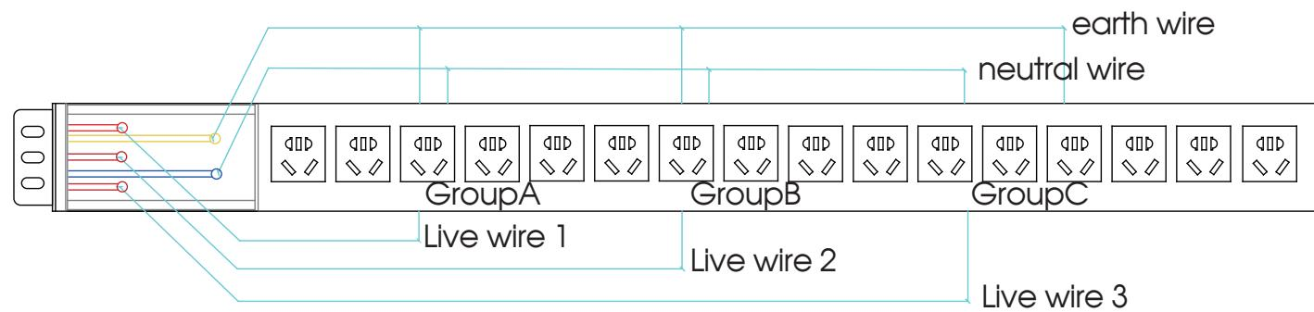
SP51104 · Primary | SP51104 · Gallery | SP51104 · Input Wiring

PRODUCT OVERVIEW
2 documented configurations are consolidated on this product-group page so buyers can compare specifications without duplicate catalog cards.
Product line | Rack PDU & Power Distribution
Series / family | pdu-special
Exact model | SP51104
Applications | Special-input equipment racks, High-load cabinets, Project-configured power distribution
MODEL IDENTIFICATION
Exact model | Product / variant | Configurations | Input Current | Input Cable
SP51104 | SP51104 High-Power & Special I/O PDU | 2 | 16 A | 3 m, 2.5 mm²
TECHNICAL SPECIFICATIONS
Parameter | Specification
Configurations | 2
Input Current | 16 A
Input Cable | 3 m, 2.5 mm²
Input Plug | 16A Chinese-standard plug
Function Module | Power indicator
Output | 10 × 10 A universal outlets
Rated Load | 4000 W
Dimensions | 485 × 44.5 × 44.5 mm
Product series | High-Power & Special I/O PDU Series
Entity type | Product group with selectable configurations
APPLICATIONS & RFQ CONFIRMATION
Typical applications | Confirm in the project RFQ
Special-input equipment racks  High-load cabinets  Project-configured power distribution | Confirm the application, rack or room position, destination-market interface and mounting requirement.  Confirm electrical, network, accessory or protection scope from the product family and project drawings.  Confirm quantity, labeling, packing and required documents before purchase order.
Project supply: MOQ — Confirm by model and project quantity · Lead time — Confirm after configuration review · FOB port — Confirm in project quotation · OEM/ODM — To be confirmed
PROJECT CONFIGURATION CHECKLIST
Exact model | SP51104
Application and site conditions | Confirm installation environment and operating requirements.
Quantity and model mix | Confirm forecast quantity, phase plan and required variants.
Interfaces and accessories | Confirm compatible interfaces, accessories and system integration scope.
Finish, branding and packing | Confirm only when project customization is required.
Documentation and destination | Confirm drawings, datasheets, packing documents and destination country or port.

