
RACK PDU & POWER DISTRIBUTION

SP5087 16 A Switched Surge-Protected PDU
  - Exact model: SP5087
PRODUCT IMAGES
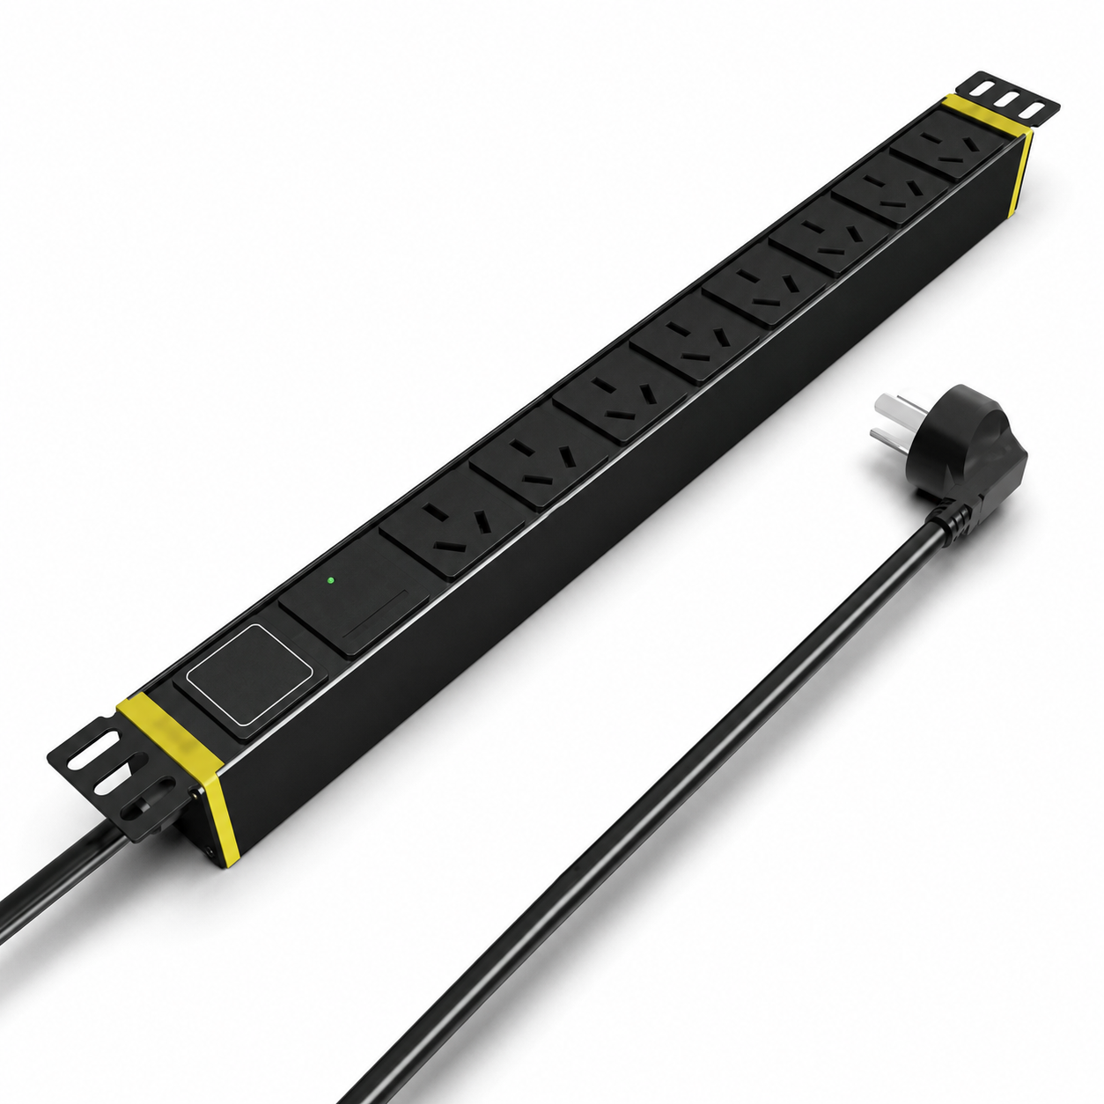 | 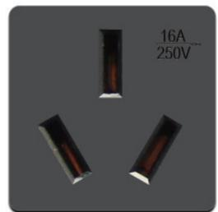
SP5087 · Primary | SP5087 · Gallery

PRODUCT OVERVIEW
Rack power distribution with integrated surge protection for 10 A, 16 A and 32 A input configurations.
Product line | Rack PDU & Power Distribution
Series / family | pdu-spd
Exact model | SP5087
Applications | Network racks, Security cabinets, Surge-protected equipment distribution
MODEL IDENTIFICATION
Exact model | Product / variant | Input Current | Input Cable | Input Plug
SP5087 | SP5087 16 A Switched Surge-Protected PDU | 16 A | 3 m, 2.5 mm² | 16A Chinese-standard plug
TECHNICAL SPECIFICATIONS
Parameter | Specification
Input Current | 16 A
Input Cable | 3 m, 2.5 mm²
Input Plug | 16A Chinese-standard plug
Function Module | Switch + surge protection
Output | 8 × 16 A Chinese-standard outlets
Rated Load | 4000 W
Dimensions | 485 × 44.5 × 44.5 mm
Product series | Surge-Protected Rack PDU Series
Product category | PDU
APPLICATIONS & RFQ CONFIRMATION
Typical applications | Confirm in the project RFQ
Network racks  Security cabinets  Surge-protected equipment distribution | Confirm the application, rack or room position, destination-market interface and mounting requirement.  Confirm electrical, network, accessory or protection scope from the product family and project drawings.  Confirm quantity, labeling, packing and required documents before purchase order.
Project supply: MOQ — Confirm by model and project quantity · Lead time — Confirm after configuration review · FOB port — Confirm in project quotation · OEM/ODM — To be confirmed
PROJECT CONFIGURATION CHECKLIST
Exact model | SP5087
Application and site conditions | Confirm installation environment and operating requirements.
Quantity and model mix | Confirm forecast quantity, phase plan and required variants.
Interfaces and accessories | Confirm compatible interfaces, accessories and system integration scope.
Finish, branding and packing | Confirm only when project customization is required.
Documentation and destination | Confirm drawings, datasheets, packing documents and destination country or port.

