
RACK PDU & POWER DISTRIBUTION

SP5082 Surge-Protected Rack PDU
  - Exact model: SP5082
PRODUCT IMAGES
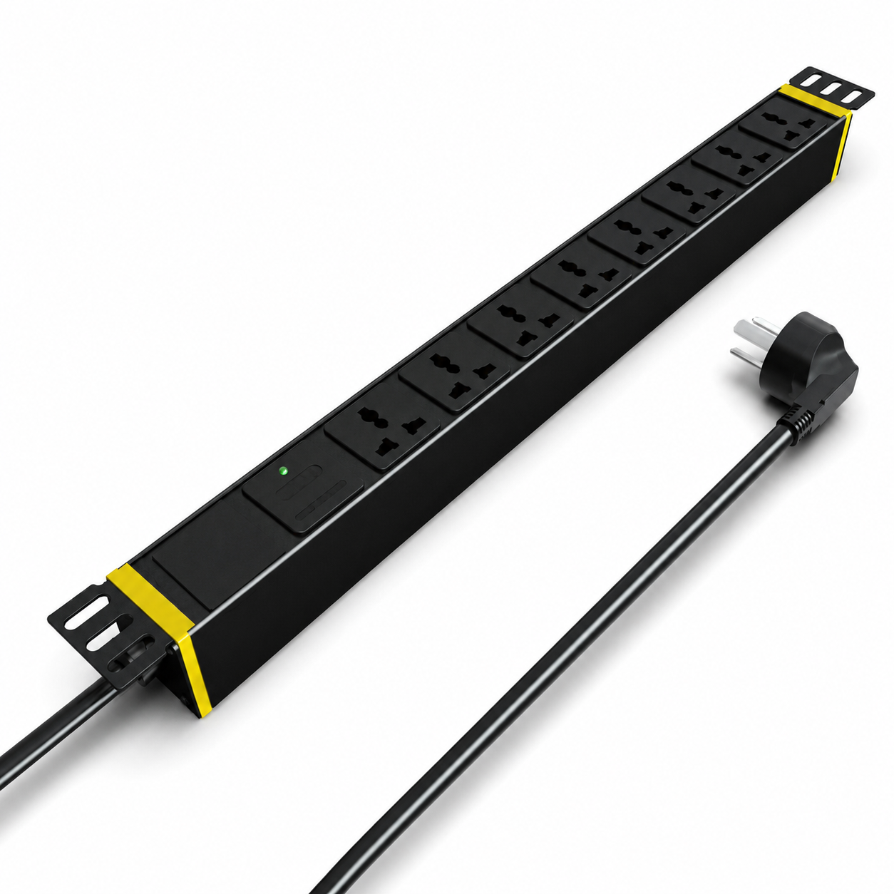 | 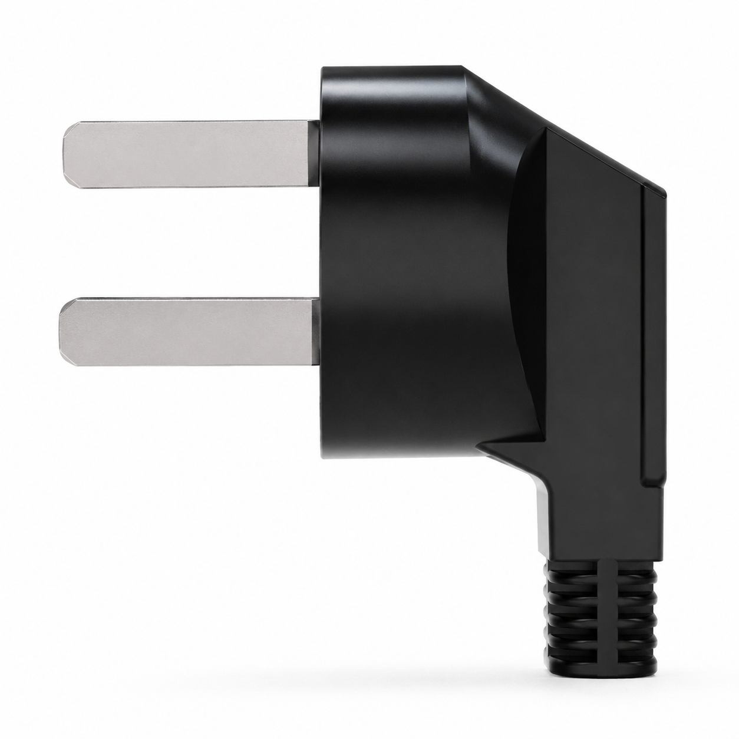 | 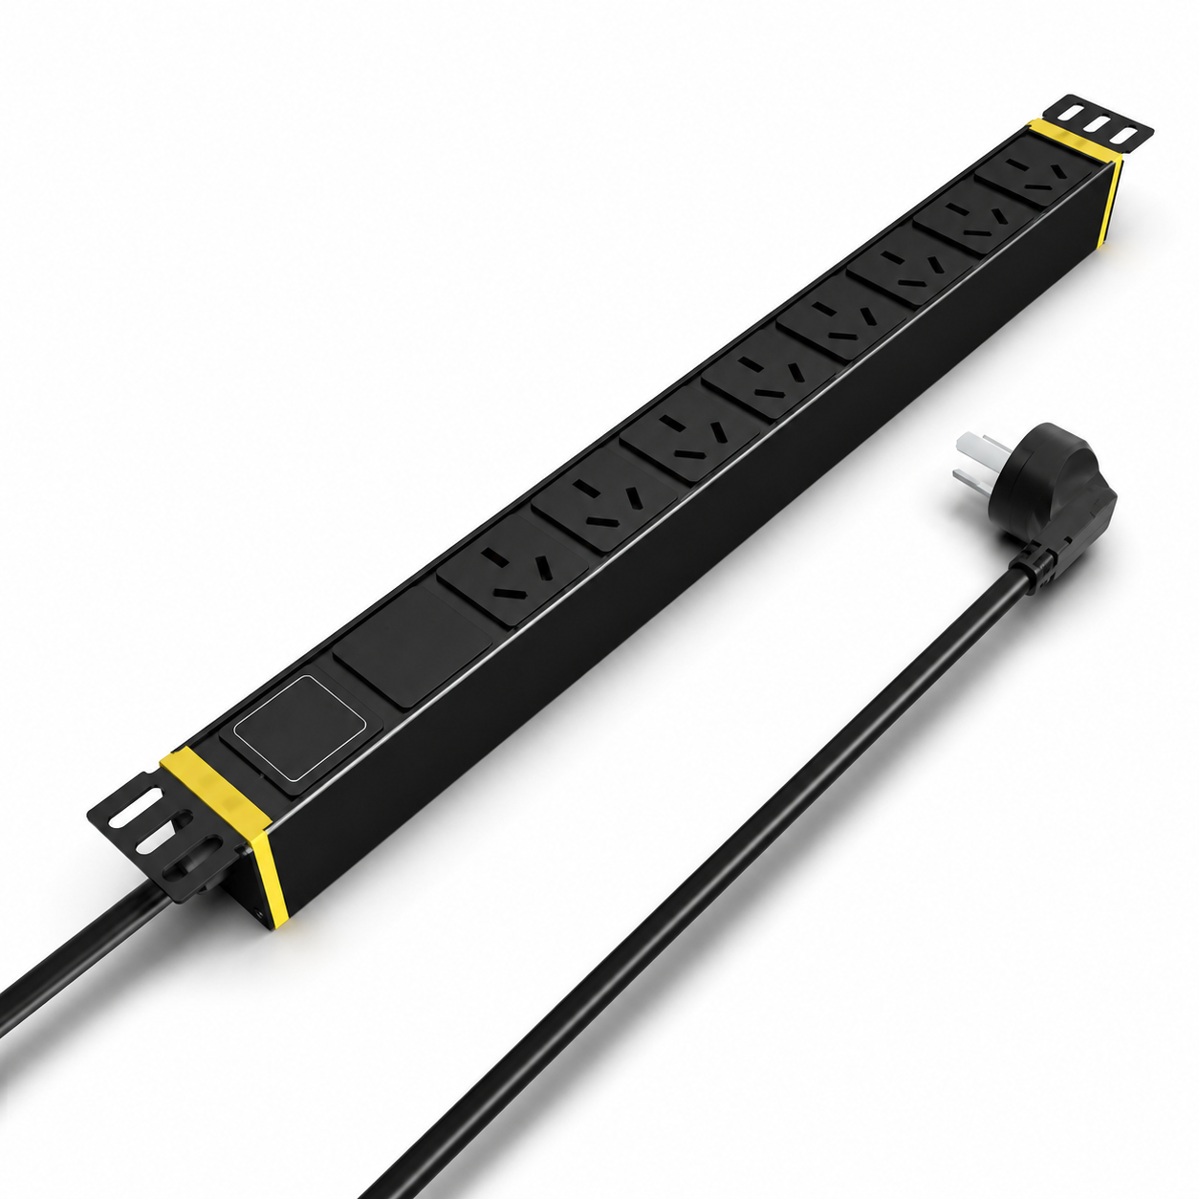 | 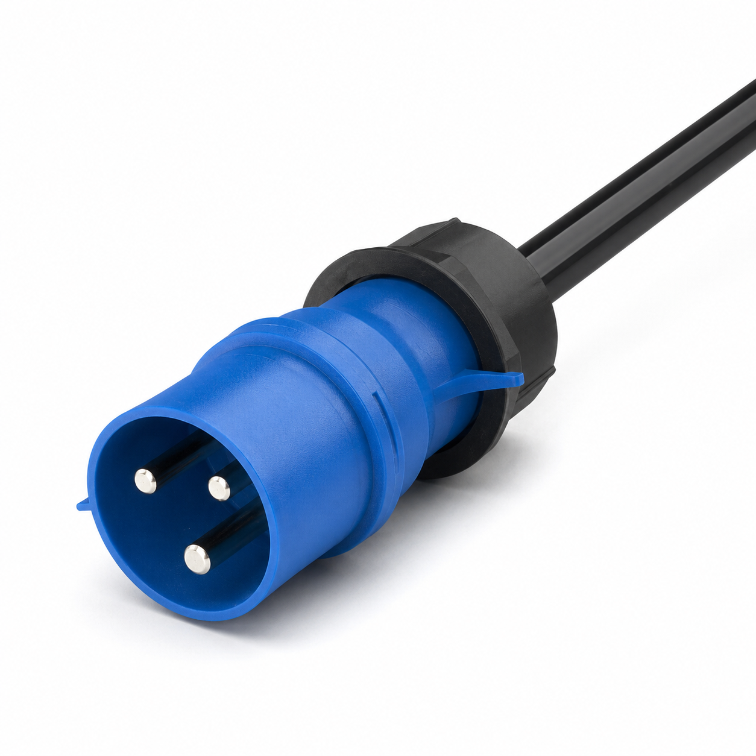
SP5082 · Primary | SP5082 · Gallery | SP5082 · Gallery | SP5082 · Gallery

PRODUCT OVERVIEW
2 documented configurations are consolidated on this product-group page so buyers can compare specifications without duplicate catalog cards.
Product line | Rack PDU & Power Distribution
Series / family | pdu-spd
Exact model | SP5082
Applications | Network racks, Security cabinets, Surge-protected equipment distribution
MODEL IDENTIFICATION
Exact model | Product / variant | Configurations | Input Current | Input Cable
SP5082 | SP5082 Surge-Protected Rack PDU | 2 | 16 A | 3 m, 2.5 mm²
TECHNICAL SPECIFICATIONS
Parameter | Specification
Configurations | 2
Input Current | 16 A
Input Cable | 3 m, 2.5 mm²
Input Plug | 16A Chinese-standard plug
Function Module | SPD surge protection
Output | 8 × 16 A Chinese-standard outlets
Rated Load | 4000 W
Dimensions | 485 × 44.5 × 44.5 mm
Product series | Surge-Protected Rack PDU Series
Entity type | Product group with selectable configurations
APPLICATIONS & RFQ CONFIRMATION
Typical applications | Confirm in the project RFQ
Network racks  Security cabinets  Surge-protected equipment distribution | Confirm the application, rack or room position, destination-market interface and mounting requirement.  Confirm electrical, network, accessory or protection scope from the product family and project drawings.  Confirm quantity, labeling, packing and required documents before purchase order.
Project supply: MOQ — Confirm by model and project quantity · Lead time — Confirm after configuration review · FOB port — Confirm in project quotation · OEM/ODM — To be confirmed
PROJECT CONFIGURATION CHECKLIST
Exact model | SP5082
Application and site conditions | Confirm installation environment and operating requirements.
Quantity and model mix | Confirm forecast quantity, phase plan and required variants.
Interfaces and accessories | Confirm compatible interfaces, accessories and system integration scope.
Finish, branding and packing | Confirm only when project customization is required.
Documentation and destination | Confirm drawings, datasheets, packing documents and destination country or port.

