
RACK PDU & POWER DISTRIBUTION

SP5071 Circuit Breaker & Overload Protection PDU
  - Exact model: SP5071
PRODUCT IMAGES
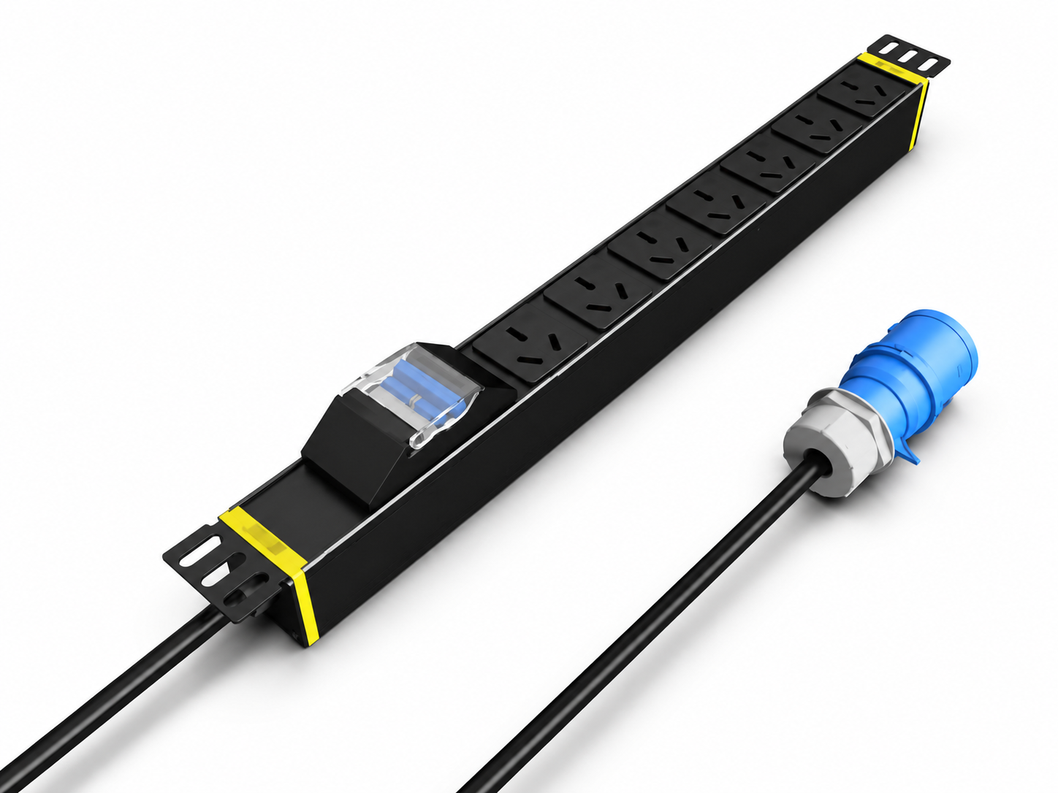 | 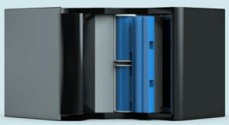 | 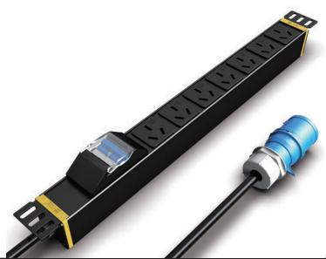 | 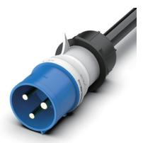
SP5071 · Primary | SP5071 · Gallery | SP5071 · Gallery | SP5071 · Gallery

PRODUCT OVERVIEW
2 documented configurations are consolidated on this product-group page so buyers can compare specifications without duplicate catalog cards.
Product line | Rack PDU & Power Distribution
Series / family | pdu-breaker
Exact model | SP5071
Applications | Server and network racks, Equipment cabinets, Overload-protected distribution
MODEL IDENTIFICATION
Exact model | Product / variant | Configurations | Input Current | Input Cable
SP5071 | SP5071 Circuit Breaker & Overload Protection PDU | 2 | 16 A | 3 m, 2.5 mm²
TECHNICAL SPECIFICATIONS
Parameter | Specification
Configurations | 2
Input Current | 16 A
Input Cable | 3 m, 2.5 mm²
Function Module | Circuit breaker
Output | 7 × 16 A Chinese-standard outlets
Rated Load | 4000 W
Dimensions | 485 × 44.5 × 44.5 mm
Input Plug | 16A Chinese-standard plug
Product series | Circuit Breaker & Overload Protection PDU Series
Entity type | Product group with selectable configurations
APPLICATIONS & RFQ CONFIRMATION
Typical applications | Confirm in the project RFQ
Server and network racks  Equipment cabinets  Overload-protected distribution | Confirm the application, rack or room position, destination-market interface and mounting requirement.  Confirm electrical, network, accessory or protection scope from the product family and project drawings.  Confirm quantity, labeling, packing and required documents before purchase order.
Project supply: MOQ — Confirm by model and project quantity · Lead time — Confirm after configuration review · FOB port — Confirm in project quotation · OEM/ODM — To be confirmed
PROJECT CONFIGURATION CHECKLIST
Exact model | SP5071
Application and site conditions | Confirm installation environment and operating requirements.
Quantity and model mix | Confirm forecast quantity, phase plan and required variants.
Interfaces and accessories | Confirm compatible interfaces, accessories and system integration scope.
Finish, branding and packing | Confirm only when project customization is required.
Documentation and destination | Confirm drawings, datasheets, packing documents and destination country or port.

