
RACK PDU & POWER DISTRIBUTION

Custom Intelligent PDU Series / Manufacturer Model Not Provided
  - Exact model: PDU-SMART-CUSTOM
PRODUCT IMAGES
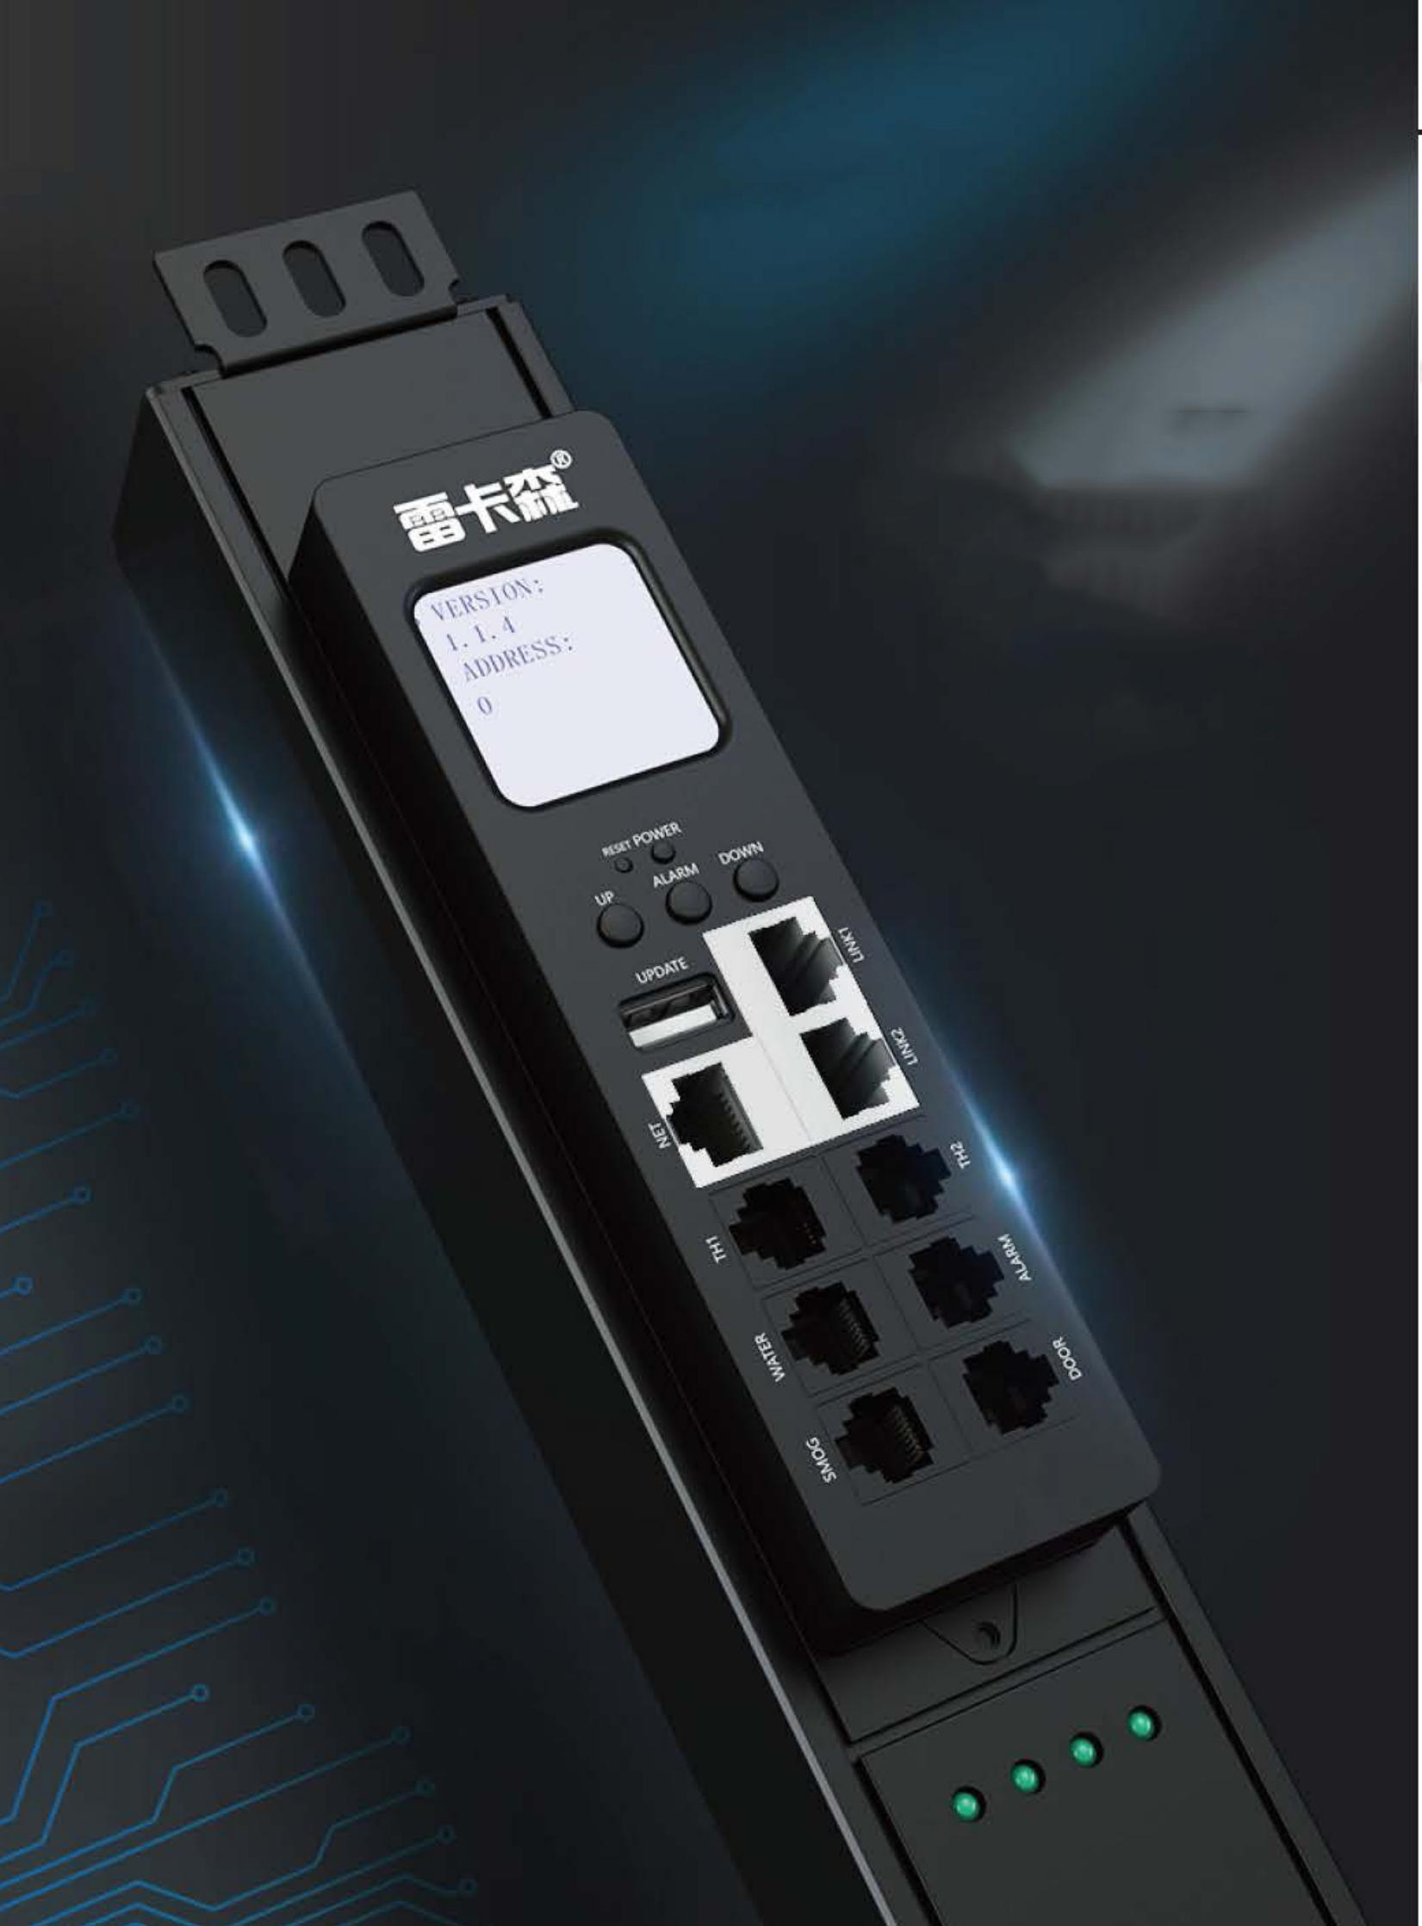 | 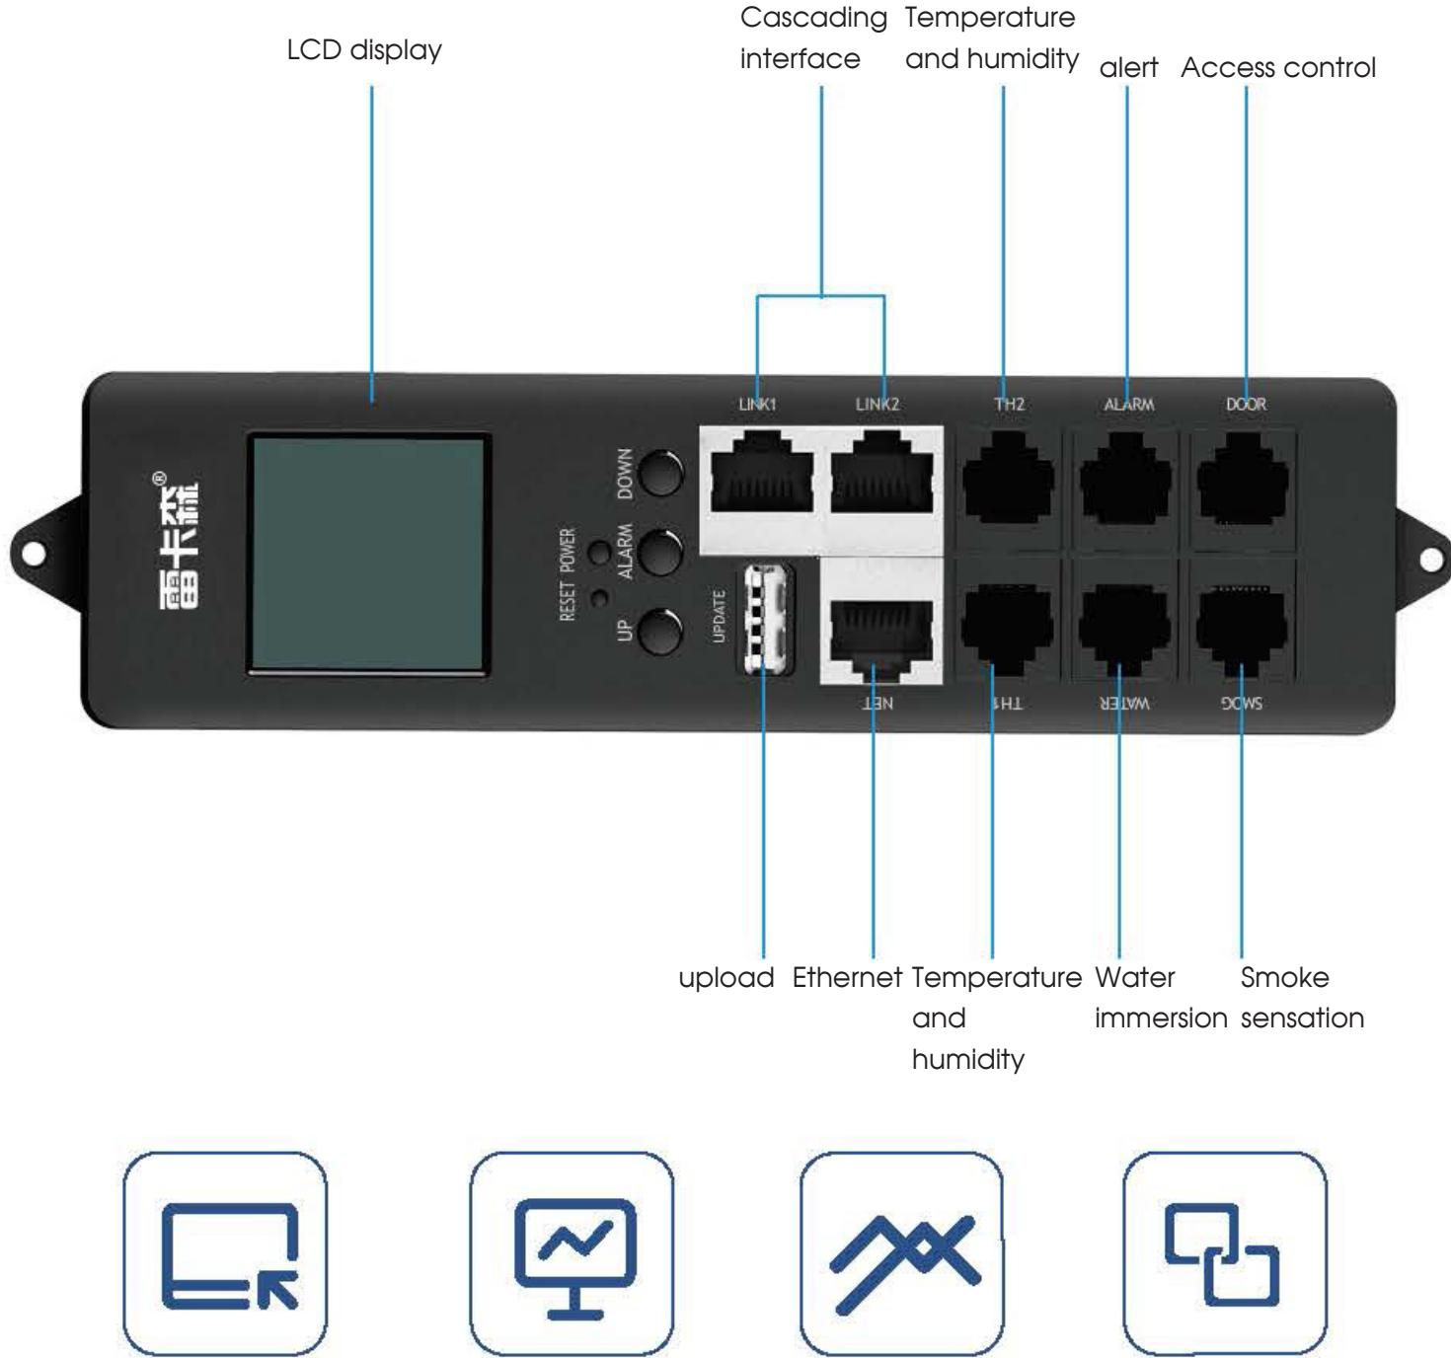
PDU-SMART-CUSTOM · Primary · Series Reference View | PDU-SMART-CUSTOM · Gallery

PRODUCT OVERVIEW
Intelligent rack power distribution with remote monitoring, control and environmental sensor expansion.
Product line | Rack PDU & Power Distribution
Series / family | pdu-smart
Exact model | PDU-SMART-CUSTOM
Applications | Monitored server racks, Remote power management, Data-room environmental monitoring
MODEL IDENTIFICATION
Exact model | Product / variant | Local Interface | Communication / Expansion | Environmental Monitoring
PDU-SMART-CUSTOM | Custom Intelligent PDU Series / Manufacturer Model Not Provided | LCD display | Ethernet uplink and cascading interface | Temperature/humidity alarm, water leakage and smoke detection
TECHNICAL SPECIFICATIONS
Parameter | Specification
Local Interface | LCD display
Communication / Expansion | Ethernet uplink and cascading interface
Environmental Monitoring | Temperature/humidity alarm, water leakage and smoke detection
Security Expansion | Access control
Core Functions | Remote control, real-time monitoring, data acquisition and cascading
Product series | Intelligent PDU Series
Product category | PDU
APPLICATIONS & RFQ CONFIRMATION
Typical applications | Confirm in the project RFQ
Monitored server racks  Remote power management  Data-room environmental monitoring | Confirm the application, rack or room position, destination-market interface and mounting requirement.  Confirm electrical, network, accessory or protection scope from the product family and project drawings.  Confirm quantity, labeling, packing and required documents before purchase order.
Project supply: MOQ — Confirm by model and project quantity · Lead time — Confirm after configuration review · FOB port — Confirm in project quotation · OEM/ODM — To be confirmed
PROJECT CONFIGURATION CHECKLIST
Exact model | PDU-SMART-CUSTOM
Application and site conditions | Confirm installation environment and operating requirements.
Quantity and model mix | Confirm forecast quantity, phase plan and required variants.
Interfaces and accessories | Confirm compatible interfaces, accessories and system integration scope.
Finish, branding and packing | Confirm only when project customization is required.
Documentation and destination | Confirm drawings, datasheets, packing documents and destination country or port.

