
RACK PDU & POWER DISTRIBUTION

LS8113 Basic Switched Rack PDU
  - Exact model: LS8113
PRODUCT IMAGES
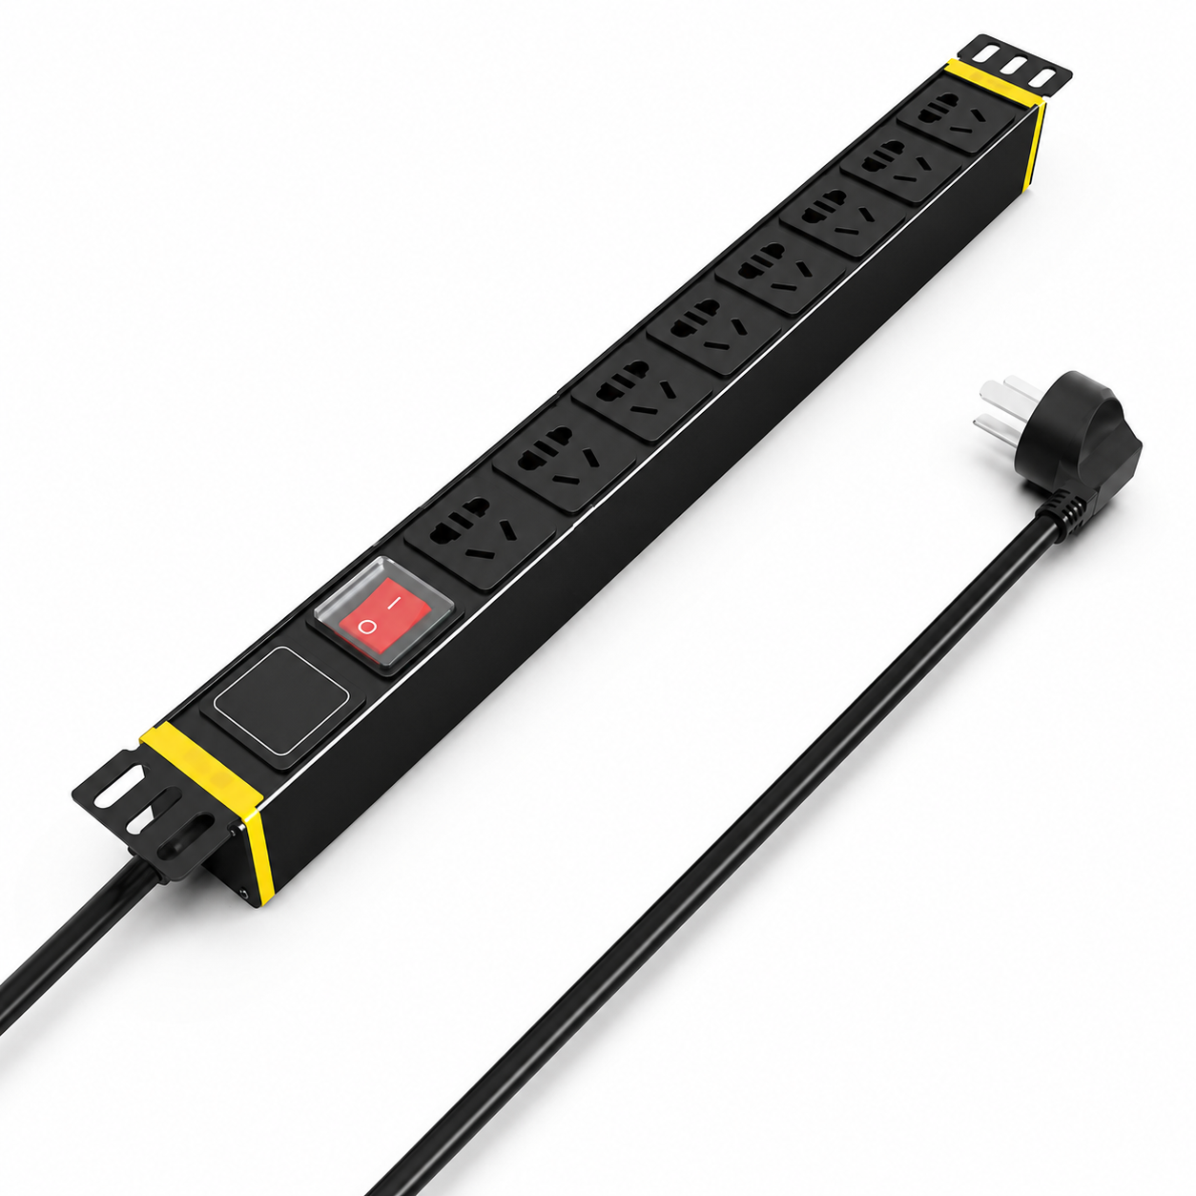 | 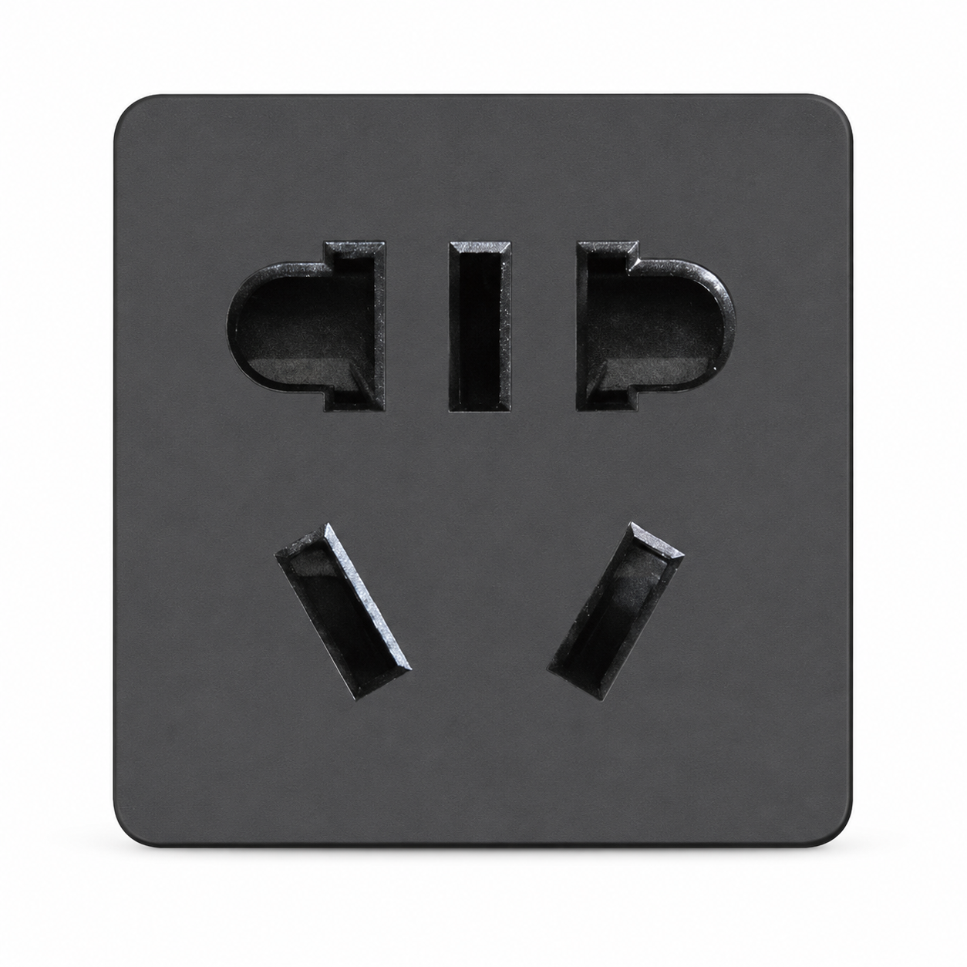 | 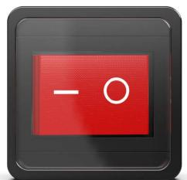
LS8113 · Primary | LS8113 · Gallery | LS8113 · Gallery

PRODUCT OVERVIEW
2 documented configurations are consolidated on this product-group page so buyers can compare specifications without duplicate catalog cards.
Product line | Rack PDU & Power Distribution
Series / family | pdu-basic
Exact model | LS8113
Applications | Network racks, Security equipment cabinets, IT equipment distribution
MODEL IDENTIFICATION
Exact model | Product / variant | Configurations | Input Current | Conductor Cross-Section
LS8113 | LS8113 Basic Switched Rack PDU | 2 | 10 A | 2.5 mm² (catalog unit normalized for website display)
TECHNICAL SPECIFICATIONS
Parameter | Specification
Configurations | 2
Input Current | 10 A
Conductor Cross-Section | 2.5 mm² (catalog unit normalized for website display)
Input Plug | 10A Chinese-standard plug
Function Module | Switch protection
Output | 8 × 10 A new Chinese-standard outlets
Rated Load | 2500 W
Dimensions | 485 × 44.5 × 44.5 mm
Product series | Basic Switched Rack PDU Series
Entity type | Product group with selectable configurations
APPLICATIONS & RFQ CONFIRMATION
Typical applications | Confirm in the project RFQ
Network racks  Security equipment cabinets  IT equipment distribution | Confirm the application, rack or room position, destination-market interface and mounting requirement.  Confirm electrical, network, accessory or protection scope from the product family and project drawings.  Confirm quantity, labeling, packing and required documents before purchase order.
Project supply: MOQ — Confirm by model and project quantity · Lead time — Confirm after configuration review · FOB port — Confirm in project quotation · OEM/ODM — To be confirmed
PROJECT CONFIGURATION CHECKLIST
Exact model | LS8113
Application and site conditions | Confirm installation environment and operating requirements.
Quantity and model mix | Confirm forecast quantity, phase plan and required variants.
Interfaces and accessories | Confirm compatible interfaces, accessories and system integration scope.
Finish, branding and packing | Confirm only when project customization is required.
Documentation and destination | Confirm drawings, datasheets, packing documents and destination country or port.

