
RACK PDU & POWER DISTRIBUTION

DS8118 Hardwired 8-Outlet New Chinese-Standard PDU
  - Exact model: DS8118
PRODUCT IMAGES
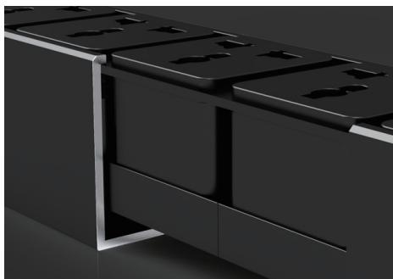 | 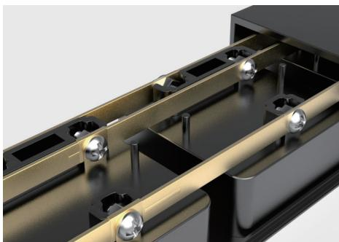 | 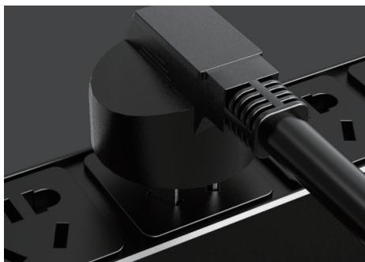
DS8118 · Structural Detail · Series Reference View | DS8118 · Structural Detail · Series Reference View | DS8118 · Structural Detail · Series Reference View

PRODUCT OVERVIEW
High-power and special-input/output rack PDU configurations for project-specific power distribution.
Product line | Rack PDU & Power Distribution
Series / family | pdu-special
Exact model | DS8118
Applications | Special-input equipment racks, High-load cabinets, Project-configured power distribution
MODEL IDENTIFICATION
Exact model | Product / variant | Input Method | Input Current | Rated Load
DS8118 | DS8118 Hardwired 8-Outlet New Chinese-Standard PDU | No input cable; terminal-block / hardwired input | 16 A | 4000 W
TECHNICAL SPECIFICATIONS
Parameter | Specification
Input Method | No input cable; terminal-block / hardwired input
Input Current | 16 A
Rated Load | 4000 W
Function Module | Switch protection
Output | 8 × 10 A new Chinese-standard outlets
Dimensions | 485 × 44.5 × 44.5 mm
Product series | High-Power & Special I/O PDU Series
Product category | PDU
APPLICATIONS & RFQ CONFIRMATION
Typical applications | Confirm in the project RFQ
Special-input equipment racks  High-load cabinets  Project-configured power distribution | Confirm the application, rack or room position, destination-market interface and mounting requirement.  Confirm electrical, network, accessory or protection scope from the product family and project drawings.  Confirm quantity, labeling, packing and required documents before purchase order.
Project supply: MOQ — Confirm by model and project quantity · Lead time — Confirm after configuration review · FOB port — Confirm in project quotation · OEM/ODM — To be confirmed
PROJECT CONFIGURATION CHECKLIST
Exact model | DS8118
Application and site conditions | Confirm installation environment and operating requirements.
Quantity and model mix | Confirm forecast quantity, phase plan and required variants.
Interfaces and accessories | Confirm compatible interfaces, accessories and system integration scope.
Finish, branding and packing | Confirm only when project customization is required.
Documentation and destination | Confirm drawings, datasheets, packing documents and destination country or port.

