
RACK KVM & REMOTE CONSOLE MANAGEMENT

32-Port CAT5/IP KVM Series
  - Models: SP8732 | SP8932
PRODUCT IMAGES
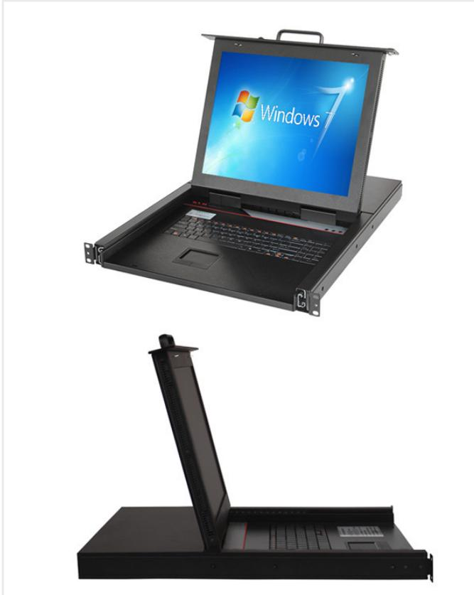 | 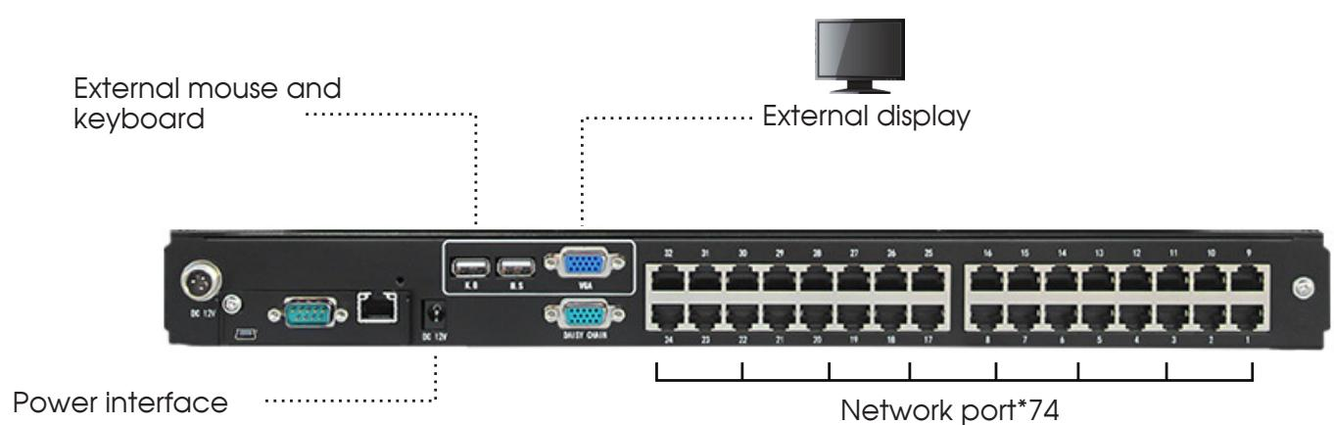 | 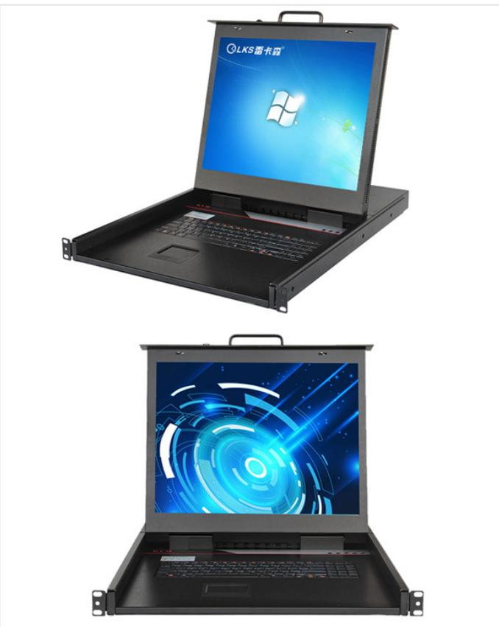 | 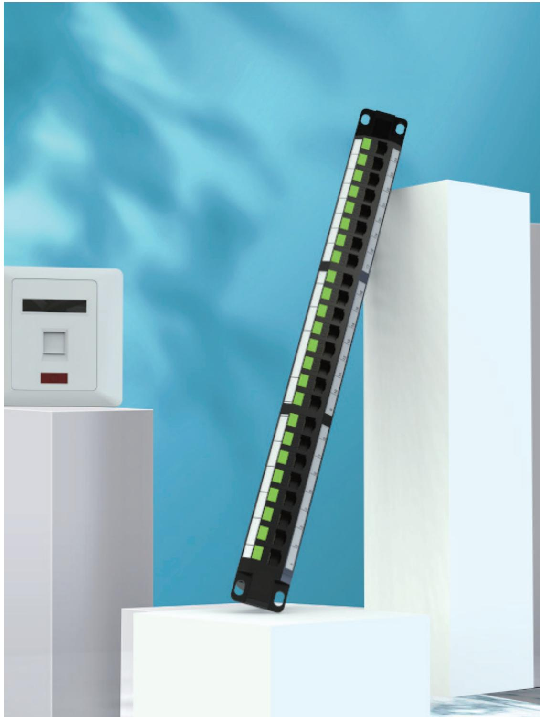
SP8732 · Primary | SP8732 · Diagram · Series Reference View | SP8932 · Primary | SP8932 · Gallery

SP8932 · Diagram · Series Reference View

PRODUCT OVERVIEW
CAT5/IP KVM consoles for high-density server management and cascading.
Product line | Rack KVM & Remote Console Management
Series / family | kvm-cat5
Exact model | SP8732 | SP8932
Applications | High-density server racks, CAT5 KVM extension, Data center operations
MODEL COMPARISON
Exact model | Product / variant | Port Count | Input / Output | Port Connection
SP8732 | SP8732 32-Port CAT5 Network KVM | 32 | PS/2 / USB dual-interface converter module | RJ45
SP8932 | SP8932 CAT5/IP KVM (Port Description Requires Review) | catalog value: 16 | PS/2 / USB dual-interface converter module | Not provided
TECHNICAL SPECIFICATIONS
Parameter | SP8732 | SP8932
Port Connection | RJ45 | Not provided
Port Count | 32 | catalog value: 16
Input / Output | PS/2 / USB dual-interface converter module | PS/2 / USB dual-interface converter module
Resolution | 1280 × 1024 | 1280 × 1024
Scan Interval | 5–255 seconds | 1–255 seconds
Supported Systems | Windows, Vista, Linux, etc. | Windows, Vista, Linux, etc.
Power Input | A C100-240V, 50-60Hz, 1 A | A C100-240V, 50-60Hz, 1 A
Power Consumption | 120V at 23 W; 230V at 25 W | 120V at 23 W; 230V at 25 W
Optional Modules | CAT5 module or IP remote-access card module | Not provided
Host Interface | USB / PS/2 | Not provided
Cascading | Supports bus and tree topologies | Not provided
Dimensions | 485 × 570 × 44 mm | 485 × 600 × 44 mm
Warranty | 3 years for main unit; 1 year for display | 3 years for main unit; 1 year for display
Product series | 32-Port CAT5/IP KVM Series | 32-Port CAT5/IP KVM Series
Product category | KVM | KVM
Maximum Cascade Capacity | Not provided | Up to 256 devices
Operating Temperature | Not provided | 0-40℃
Storage Temperature | Not provided | -20-60℃
Humidity | Not provided | 0-80%RH, non-condensing
APPLICATIONS & RFQ CONFIRMATION
Typical applications | Confirm in the project RFQ
High-density server racks  CAT5 KVM extension  Data center operations | Confirm the application, rack or room position, destination-market interface and mounting requirement.  Confirm electrical, network, accessory or protection scope from the product family and project drawings.  Confirm quantity, labeling, packing and required documents before purchase order.
Project supply: MOQ — Confirm by model and project quantity · Lead time — Confirm after configuration review · FOB port — Confirm in project quotation · OEM/ODM — To be confirmed
PROJECT CONFIGURATION CHECKLIST
Exact model | SP8732
Application and site conditions | Confirm installation environment and operating requirements.
Quantity and model mix | Confirm forecast quantity, phase plan and required variants.
Interfaces and accessories | Confirm compatible interfaces, accessories and system integration scope.
Finish, branding and packing | Confirm only when project customization is required.
Documentation and destination | Confirm drawings, datasheets, packing documents and destination country or port.

