
RACK KVM & REMOTE CONSOLE MANAGEMENT

SP8032 16-Port Digital KVM
  - Exact model: SP8032
PRODUCT IMAGES
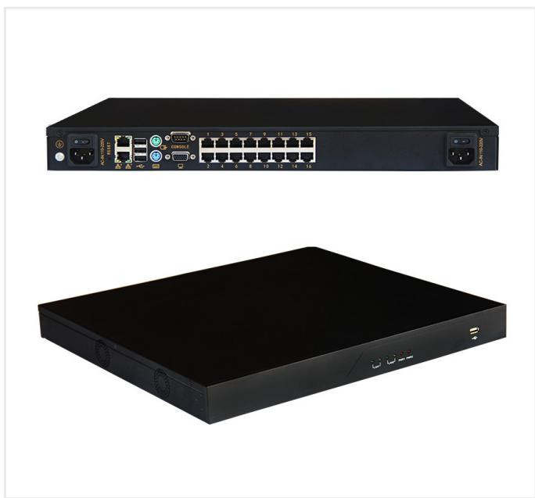 | 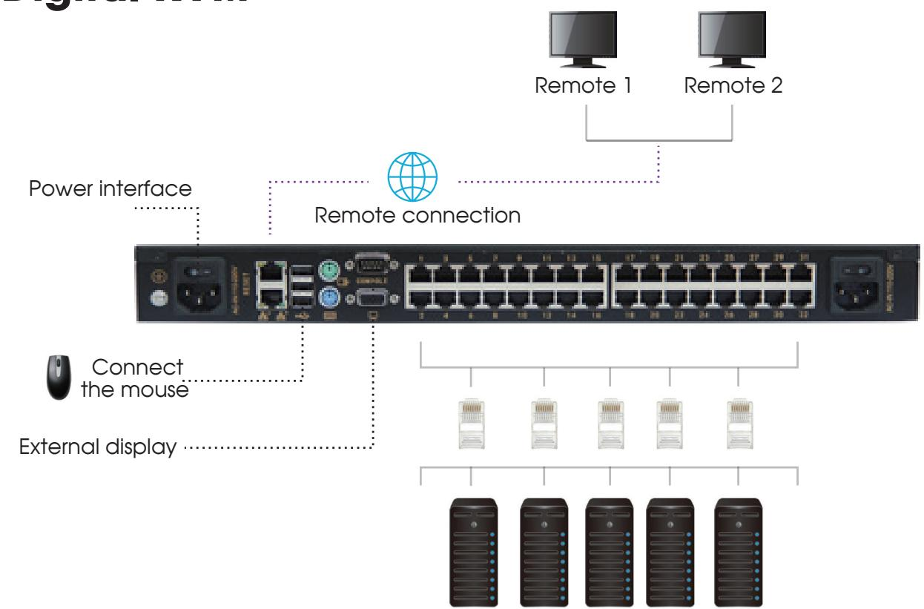
SP8032 · Primary | SP8032 · Gallery

PRODUCT OVERVIEW
2 documented configurations are consolidated on this product-group page so buyers can compare specifications without duplicate catalog cards.
Product line | Rack KVM & Remote Console Management
Series / family | kvm-sp8032
Exact model | SP8032
Applications | Server rack management, Data center operations, Remote equipment maintenance
MODEL IDENTIFICATION
Exact model | Product / variant | Configurations | Server Ports | Network Port
SP8032 | SP8032 16-Port Digital KVM | 2 | 16 | RJ45
TECHNICAL SPECIFICATIONS
Parameter | Specification
Configurations | 2
Server Ports | 16
Network Port | RJ45
Resolution | 1920 × 1200px
Supported Systems | Windows, Linux, Mac, Sun, etc.
Power | 60 W
Dimensions | 400 × 440 × 44 mm
Installation | 19-inch standard rack cabinet
Transmission Distance | 50 m
Weight | 6.6kg
User Configuration | 1 local user + 2 remote users
Product series | SP8032 16-Port Digital KVM
Entity type | Product group with selectable configurations
APPLICATIONS & RFQ CONFIRMATION
Typical applications | Confirm in the project RFQ
Server rack management  Data center operations  Remote equipment maintenance | Confirm the application, rack or room position, destination-market interface and mounting requirement.  Confirm electrical, network, accessory or protection scope from the product family and project drawings.  Confirm quantity, labeling, packing and required documents before purchase order.
Project supply: MOQ — Confirm by model and project quantity · Lead time — Confirm after configuration review · FOB port — Confirm in project quotation · OEM/ODM — To be confirmed
PROJECT CONFIGURATION CHECKLIST
Exact model | SP8032
Application and site conditions | Confirm installation environment and operating requirements.
Quantity and model mix | Confirm forecast quantity, phase plan and required variants.
Interfaces and accessories | Confirm compatible interfaces, accessories and system integration scope.
Finish, branding and packing | Confirm only when project customization is required.
Documentation and destination | Confirm drawings, datasheets, packing documents and destination country or port.

