
RACK KVM & REMOTE CONSOLE MANAGEMENT

16-Port Remote IP KVM Series
  - Models: SP5716 | SP5916
PRODUCT IMAGES
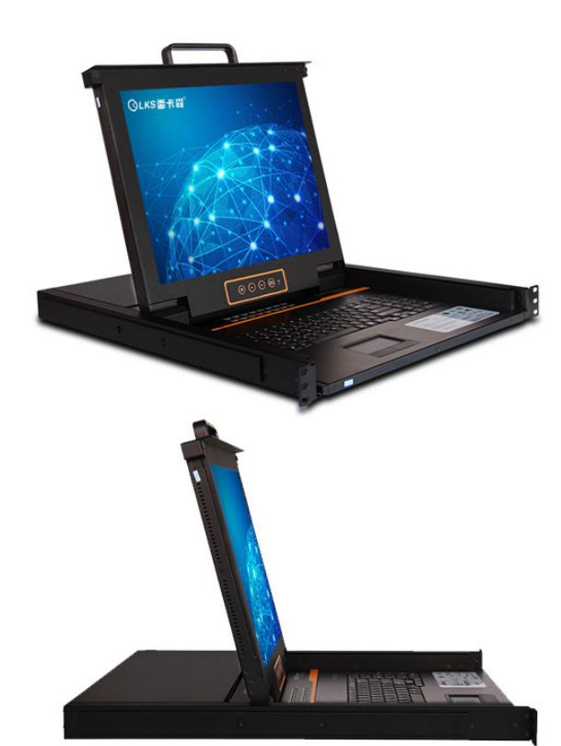 | 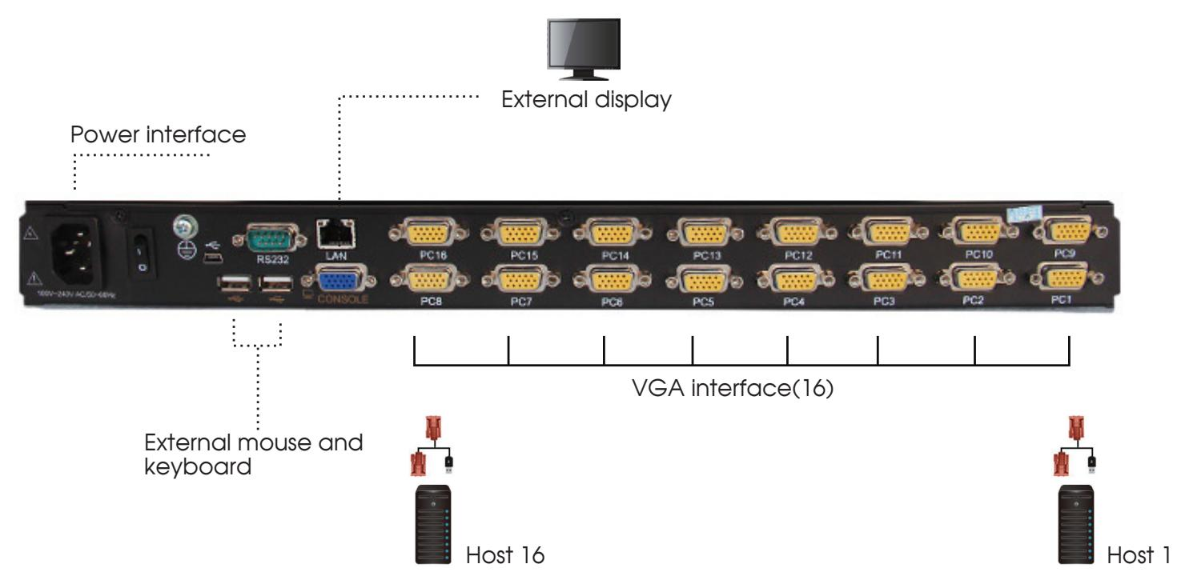 | 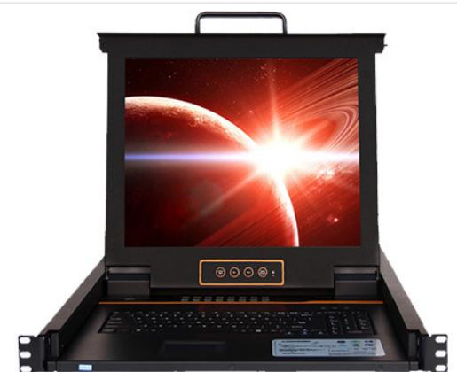 | 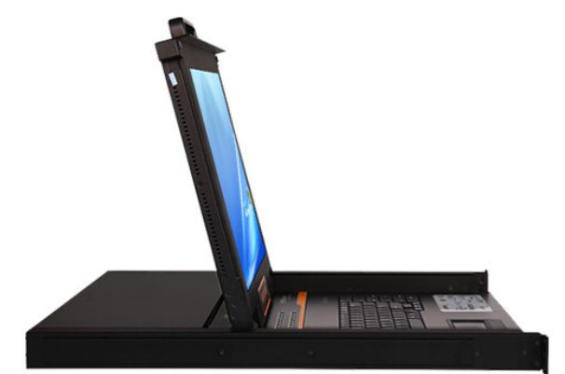
SP5716 · Primary | SP5716 · Diagram · Series Reference View | SP5916 · Primary | SP5916 · Gallery

SP5916 · Diagram · Series Reference View

PRODUCT OVERVIEW
16-port IP KVM consoles for local and remote server management.
Product line | Rack KVM & Remote Console Management
Series / family | kvm-ip16
Exact model | SP5716 | SP5916
Applications | Remote server access, Data center operations, Network equipment rooms
MODEL COMPARISON
Exact model | Product / variant | Port Count | Resolution | Dimensions
SP5716 | SP5716 16-port remote IP KVM | 16 | 1280 × 1024 | 485 × 570 × 44 mm
SP5916 | SP5916 16-Port Remote IP KVM, 600 mm Depth | 16 | 1280 × 1024 | 485 × 600 × 44 mm
TECHNICAL SPECIFICATIONS
Parameter | SP5716 | SP5916
Port Count | 16 | 16
Resolution | 1280 × 1024 | 1280 × 1024
Dimensions | 485 × 570 × 44 mm | 485 × 600 × 44 mm
Maximum Cascade Capacity | Up to 256 devices  Source catalog wording: “connections 256” | Up to 256 devices  Source catalog wording: “connections 256”
I/O Interface | PS/2 / USB dual-interface converter module | PS/2 / USB dual-interface converter module
Scan Interval | 1–255 seconds | 1–255 seconds
System Compatibility | Windows, Vista, Linux, etc. | Windows, Vista, Linux, etc.
Power Input | A C100-240V, 50-60Hz, 1 A | A C100-240V, 50-60Hz, 1 A
Power Consumption | 120V at 23 W; 230V at 25 W | 120V at 23 W; 230V at 25 W
Operating Temperature | 0-40℃ | 0-40℃
Storage Temperature | -20-60℃ | -20-60℃
Humidity | 0-80%RH, non-condensing | 0-80%RH, non-condensing
Warranty | 3 years for main unit; 1 year for display | 3 years for main unit; 1 year for display
Product series | 16-Port Remote IP KVM Series | 16-Port Remote IP KVM Series
Product category | KVM | KVM
APPLICATIONS & RFQ CONFIRMATION
Typical applications | Confirm in the project RFQ
Remote server access  Data center operations  Network equipment rooms | Confirm the application, rack or room position, destination-market interface and mounting requirement.  Confirm electrical, network, accessory or protection scope from the product family and project drawings.  Confirm quantity, labeling, packing and required documents before purchase order.
Project supply: MOQ — Confirm by model and project quantity · Lead time — Confirm after configuration review · FOB port — Confirm in project quotation · OEM/ODM — To be confirmed
PROJECT CONFIGURATION CHECKLIST
Exact model | SP5716
Application and site conditions | Confirm installation environment and operating requirements.
Quantity and model mix | Confirm forecast quantity, phase plan and required variants.
Interfaces and accessories | Confirm compatible interfaces, accessories and system integration scope.
Finish, branding and packing | Confirm only when project customization is required.
Documentation and destination | Confirm drawings, datasheets, packing documents and destination country or port.

