
RACK KVM & REMOTE CONSOLE MANAGEMENT

SP1708 8-Port Local VGA KVM Series
  - Models: SP1708-B | SP1708-C
PRODUCT IMAGES
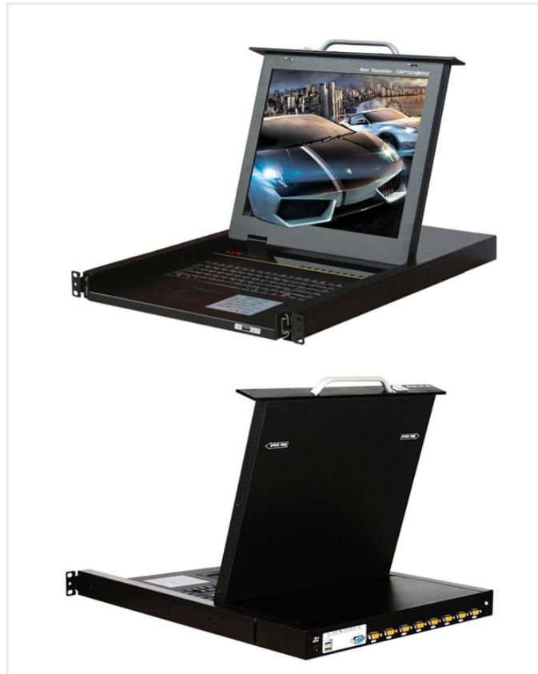 | 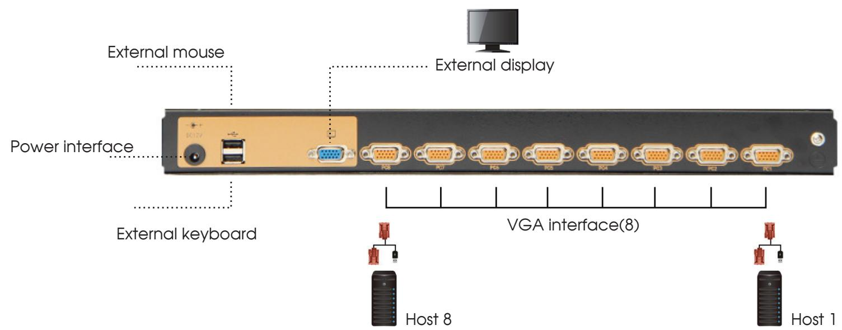 | 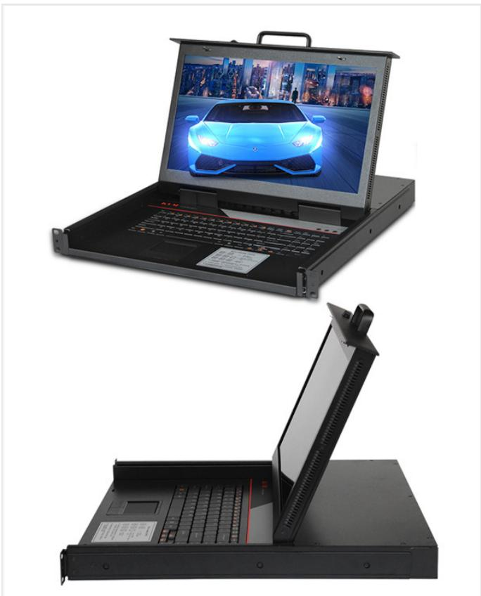
SP1708-B · Primary | SP1708-B · Diagram · Series Reference View | SP1708-C · Primary | SP1708-C · Diagram · Series Reference View

PRODUCT OVERVIEW
8-port local VGA KVM consoles for rack server management.
Product line | Rack KVM & Remote Console Management
Series / family | kvm-1708
Exact model | SP1708-B | SP1708-C
Applications | Local server management, Data-room racks, Maintenance consoles
MODEL COMPARISON
Exact model | Product / variant | Port Count | Resolution | Dimensions
SP1708-B | SP1708-B 8-port local VGA KVM (1280 × 1024) | 8 | 1280 × 1024 | 485 × 570 × 44 mm
SP1708-C | SP1708-C 8-port local VGA KVM (1920 × 1080) | 8 | 1920 × 1080 | 485 × 480 × 44 mm
TECHNICAL SPECIFICATIONS
Parameter | SP1708-B | SP1708-C
Port Count | 8 | 8
Resolution | 1280 × 1024 | 1920 × 1080
Dimensions | 485 × 570 × 44 mm | 485 × 480 × 44 mm
Maximum Cascade Capacity | Up to 256 devices  Source catalog wording: “connections 256” | Up to 256 devices  Source catalog wording: “connections 256”
I/O Interface | PS/2 / USB dual-interface converter module | PS/2 / USB dual-interface converter module
Scan Interval | 1–255 seconds | 1–255 seconds
System Compatibility | Windows, Vista, Linux, etc. | Windows, Vista, Linux, etc.
Power Input | A C100-240V, 50-60Hz, 1 A | A C100-240V, 50-60Hz, 1 A
Power Consumption | 120V at 23 W; 230V at 25 W | 120V at 23 W; 230V at 25 W
Operating Temperature | 0-40℃ | 0-40℃
Storage Temperature | -20-60℃ | -20-60℃
Humidity | 0-80%RH, non-condensing | 0-80%RH, non-condensing
Warranty | 3 years for main unit; 1 year for display | 3 years for main unit; 1 year for display
Product series | SP1708 8-Port Local VGA KVM Series | SP1708 8-Port Local VGA KVM Series
Product category | KVM | KVM
APPLICATIONS & RFQ CONFIRMATION
Typical applications | Confirm in the project RFQ
Local server management  Data-room racks  Maintenance consoles | Confirm the application, rack or room position, destination-market interface and mounting requirement.  Confirm electrical, network, accessory or protection scope from the product family and project drawings.  Confirm quantity, labeling, packing and required documents before purchase order.
Project supply: MOQ — Confirm by model and project quantity · Lead time — Confirm after configuration review · FOB port — Confirm in project quotation · OEM/ODM — To be confirmed
PROJECT CONFIGURATION CHECKLIST
Exact model | SP1708-B
Application and site conditions | Confirm installation environment and operating requirements.
Quantity and model mix | Confirm forecast quantity, phase plan and required variants.
Interfaces and accessories | Confirm compatible interfaces, accessories and system integration scope.
Finish, branding and packing | Confirm only when project customization is required.
Documentation and destination | Confirm drawings, datasheets, packing documents and destination country or port.

