
VEHICLE & PEDESTRIAN ENTRANCE CONTROL

NX-TE Series
  - Models: NX-TE-022 | NX-TE-023 | NX-TE-024 | NX-TE-026 | NX-TE-028
PRODUCT IMAGES
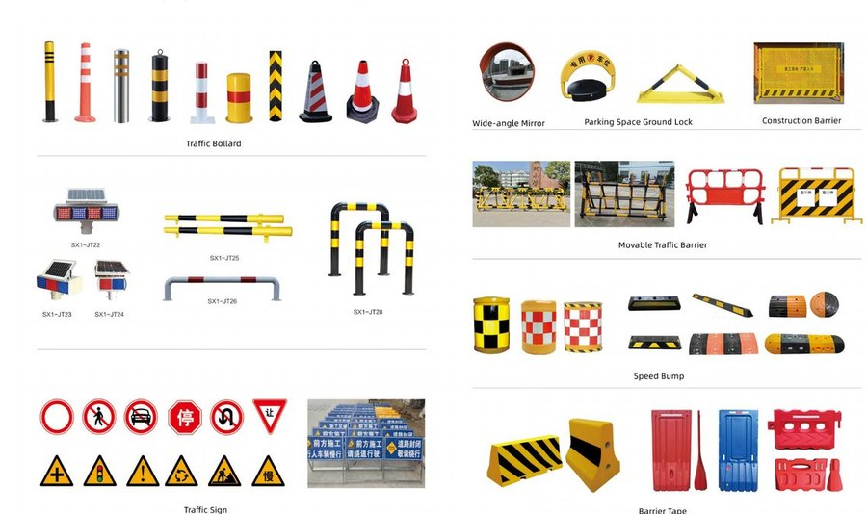 |  | 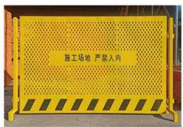 | 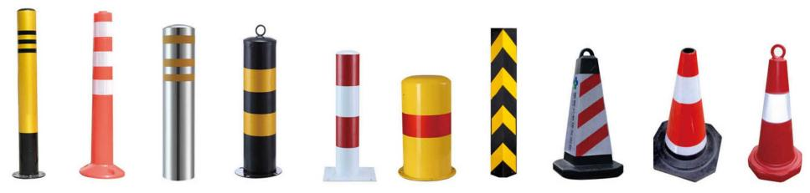
NX-TE-022 · Primary | NX-TE-023 · Primary | NX-TE-024 · Primary | NX-TE-026 · Primary

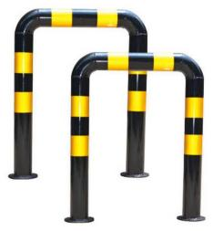
NX-TE-028 · Primary

PRODUCT OVERVIEW
Traffic Equipment : Road Barriers and Signs.
Product line | Vehicle & Pedestrian Entrance Control
Series / family | Perimeter & Site Equipment
Exact model | NX-TE-022 | NX-TE-023 | NX-TE-024 | NX-TE-026 | NX-TE-028
Applications | Parking circulation, Industrial roadway, Entrance safety
MODEL COMPARISON
Exact model | Product / variant | Product family | SKU | Supply
NX-TE-022 | NexPro Road Barriers and Signs - Road Barriers and Signs Collection | Traffic Equipment | NX-TE-022 | Project and bulk orders
NX-TE-023 | NexPro Wide-angle Mirror - Wide-angle Mirror | Traffic Equipment | NX-TE-023 | Project and bulk orders
NX-TE-024 | NexPro Parking Space Ground Lock - Parking Space Ground Lock | Traffic Equipment | NX-TE-024 | Project and bulk orders
NX-TE-026 | NexPro Traffic Bollard - Traffic Bollard | Traffic Equipment | NX-TE-026 | Project and bulk orders
NX-TE-028 | NexPro Movable Traffic Barrier - Movable Traffic Barrier | Traffic Equipment | NX-TE-028 | Project and bulk orders
TECHNICAL SPECIFICATIONS
Models: NX-TE-022 | NX-TE-023 | NX-TE-024 | NX-TE-026
Parameter | NX-TE-022 | NX-TE-023 | NX-TE-024 | NX-TE-026
Product family | Traffic Equipment | Traffic Equipment | Traffic Equipment | Traffic Equipment
SKU | NX-TE-022 | NX-TE-023 | NX-TE-024 | NX-TE-026
Supply | Project and bulk orders | Project and bulk orders | Project and bulk orders | Project and bulk orders
Category | Traffic Equipment | Traffic Equipment | Traffic Equipment | Traffic Equipment
System group | Perimeter & Site Equipment | Perimeter & Site Equipment | Perimeter & Site Equipment | Perimeter & Site Equipment
Quotation type | Project and bulk quotation | Project and bulk quotation | Project and bulk quotation | Project and bulk quotation
OEM/ODM | Available after scope confirmation | Available after scope confirmation | Available after scope confirmation | Available after scope confirmation
Required input | Lane layout, quantity, control method and destination | Lane layout, quantity, control method and destination | Lane layout, quantity, control method and destination | Lane layout, quantity, control method and destination
Documents | Confirm required datasheet, drawing and installation references | Confirm required datasheet, drawing and installation references | Confirm required datasheet, drawing and installation references | Confirm required datasheet, drawing and installation references
Models: NX-TE-028
Parameter | Specification
Product family | Traffic Equipment
SKU | NX-TE-028
Supply | Project and bulk orders
Category | Traffic Equipment
System group | Perimeter & Site Equipment
Quotation type | Project and bulk quotation
OEM/ODM | Available after scope confirmation
Required input | Lane layout, quantity, control method and destination
Documents | Confirm required datasheet, drawing and installation references
APPLICATIONS & RFQ CONFIRMATION
Typical applications | Confirm in the project RFQ
Parking circulation  Industrial roadway  Entrance safety | Confirm lane dimensions and installation environment before final model selection.  Confirm recognition, payment, safety detection and third-party integration requirements.  Technical parameters must be confirmed against the final quotation and datasheet.
Project supply: MOQ — Confirm by model, quantity and customization · Lead time — Confirm after project scope review · FOB port — China main ports · OEM/ODM — Available; confirm project scope
PROJECT CONFIGURATION CHECKLIST
Exact model | NX-TE-022
Application and site conditions | Confirm installation environment and operating requirements.
Quantity and model mix | Confirm forecast quantity, phase plan and required variants.
Interfaces and accessories | Confirm compatible interfaces, accessories and system integration scope.
Finish, branding and packing | Confirm only when project customization is required.
Documentation and destination | Confirm drawings, datasheets, packing documents and destination country or port.

