
VEHICLE & PEDESTRIAN ENTRANCE CONTROL

NX-PA Series
  - Models: NX-PA-016 | NX-PA-017 | NX-PA-018 | NX-PA-019 | NX-PA-020
PRODUCT IMAGES
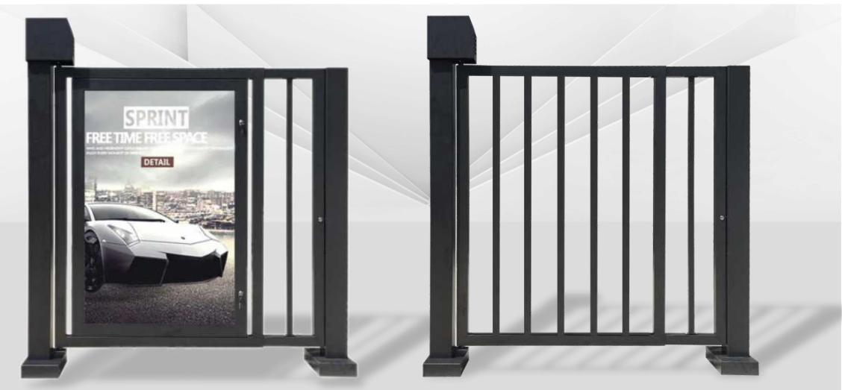 | 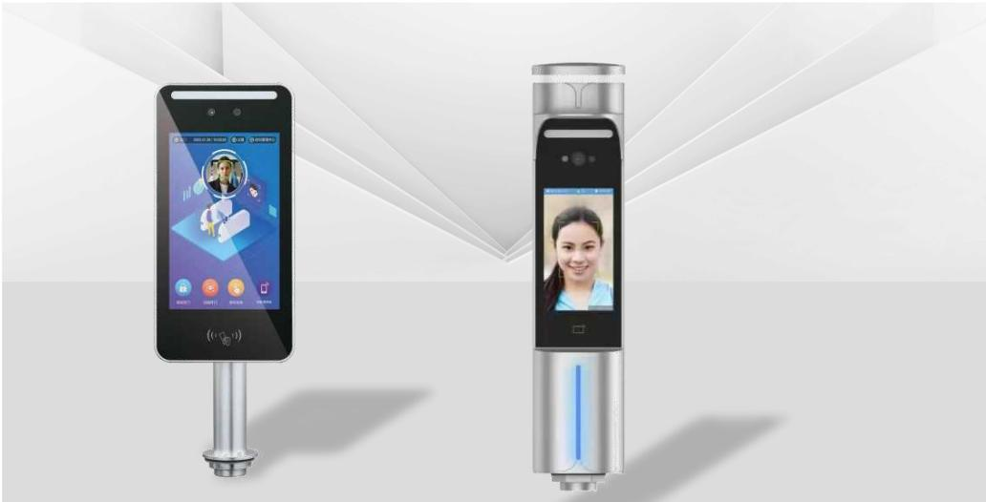 | 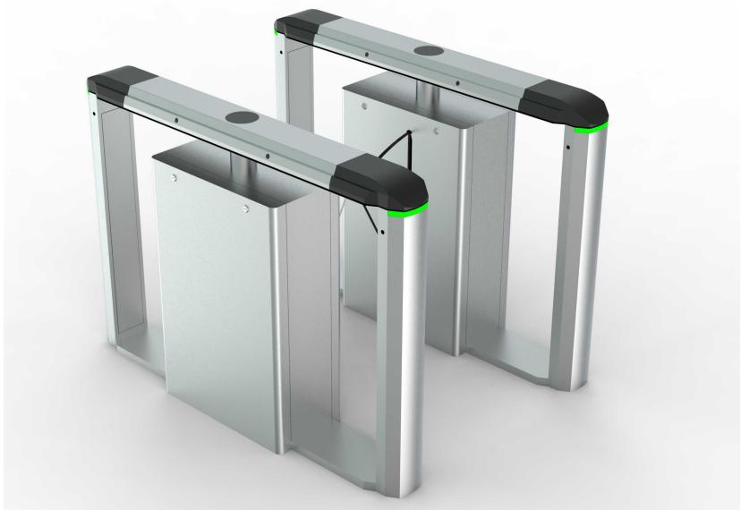 | 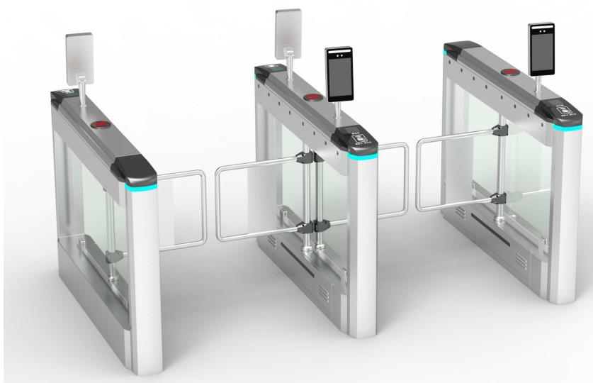
NX-PA-016 · Primary | NX-PA-017 · Primary | NX-PA-018 · Primary | NX-PA-019 · Primary

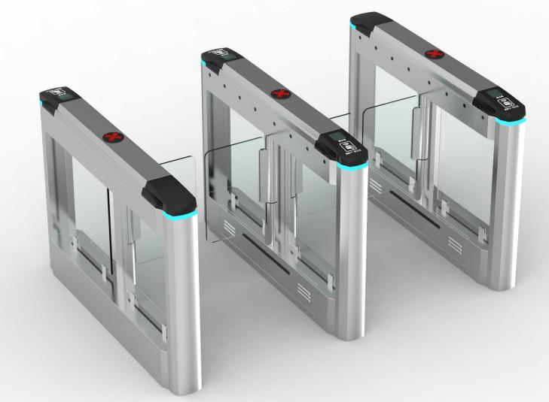
NX-PA-020 · Primary

PRODUCT OVERVIEW
Pedestrian Access Control : G01/G02. Chassis material: 201 stainless steel, automotive baking paint | Cabinet dimensions: 1830(H)x180(L)x1800(W)mm (widest) | Passage clear width: 850\~1450mm.
Product line | Vehicle & Pedestrian Entrance Control
Series / family | Pedestrian Control
Exact model | NX-PA-016 | NX-PA-017 | NX-PA-018 | NX-PA-019 | NX-PA-020
Applications | Campus entrance, Office building, Factory personnel gate
MODEL COMPARISON
Exact model | Product / variant | Product family | SKU | Supply
NX-PA-016 | NexPro G01/G02 - Electric Magnetic Door G01/G02 | Pedestrian Access Control | NX-PA-016 | Project and bulk orders
NX-PA-017 | NexPro F01/F02 - Face Recognition System F01/F02 | Pedestrian Access Control | NX-PA-017 | Project and bulk orders
NX-PA-018 | NexPro Wing Gate - Wing Gate | Pedestrian Access Control | NX-PA-018 | Project and bulk orders
NX-PA-019 | NexPro Swing Gate - Swing Gate | Pedestrian Access Control | NX-PA-019 | Project and bulk orders
NX-PA-020 | NexPro High-speed Access Gate - High-speed Access Gate | Pedestrian Access Control | NX-PA-020 | Project and bulk orders
TECHNICAL SPECIFICATIONS
Models: NX-PA-016 | NX-PA-017 | NX-PA-018 | NX-PA-019
Parameter | NX-PA-016 | NX-PA-017 | NX-PA-018 | NX-PA-019
Product family | Pedestrian Access Control | Pedestrian Access Control | Pedestrian Access Control | Pedestrian Access Control
SKU | NX-PA-016 | NX-PA-017 | NX-PA-018 | NX-PA-019
Supply | Project and bulk orders | Project and bulk orders | Project and bulk orders | Project and bulk orders
Category | Pedestrian Access Control | Pedestrian Access Control | Pedestrian Access Control | Pedestrian Access Control
System group | Pedestrian Control | Pedestrian Control | Pedestrian Control | Pedestrian Control
Quotation type | Project and bulk quotation | Project and bulk quotation | Project and bulk quotation | Project and bulk quotation
OEM/ODM | Available after scope confirmation | Available after scope confirmation | Available after scope confirmation | Available after scope confirmation
Required input | Lane layout, quantity, control method and destination | Lane layout, quantity, control method and destination | Lane layout, quantity, control method and destination | Lane layout, quantity, control method and destination
Documents | Confirm required datasheet, drawing and installation references | Confirm required datasheet, drawing and installation references | Confirm required datasheet, drawing and installation references | Confirm required datasheet, drawing and installation references
Models: NX-PA-020
Parameter | Specification
Product family | Pedestrian Access Control
SKU | NX-PA-020
Supply | Project and bulk orders
Category | Pedestrian Access Control
System group | Pedestrian Control
Quotation type | Project and bulk quotation
OEM/ODM | Available after scope confirmation
Required input | Lane layout, quantity, control method and destination
Documents | Confirm required datasheet, drawing and installation references
APPLICATIONS & RFQ CONFIRMATION
Typical applications | Confirm in the project RFQ
Campus entrance  Office building  Factory personnel gate | Confirm lane dimensions and installation environment before final model selection.  Confirm recognition, payment, safety detection and third-party integration requirements.  Technical parameters must be confirmed against the final quotation and datasheet.
Project supply: MOQ — Confirm by model, quantity and customization · Lead time — Confirm after project scope review · FOB port — China main ports · OEM/ODM — Available; confirm project scope
PROJECT CONFIGURATION CHECKLIST
Exact model | NX-PA-016
Application and site conditions | Confirm installation environment and operating requirements.
Quantity and model mix | Confirm forecast quantity, phase plan and required variants.
Interfaces and accessories | Confirm compatible interfaces, accessories and system integration scope.
Finish, branding and packing | Confirm only when project customization is required.
Documentation and destination | Confirm drawings, datasheets, packing documents and destination country or port.

