
VEHICLE & PEDESTRIAN ENTRANCE CONTROL

NX-GB Series
  - Models: NX-GB-037 | NX-GB-038 | NX-GB-039 | NX-GB-040 | NX-GB-041 | NX-GB-042 | NX-GB-043 | NX-GB-044 | NX-GB-045 | NX-GB-046 | NX-GB-047 | NX-GB-048
PRODUCT IMAGES
 |  | 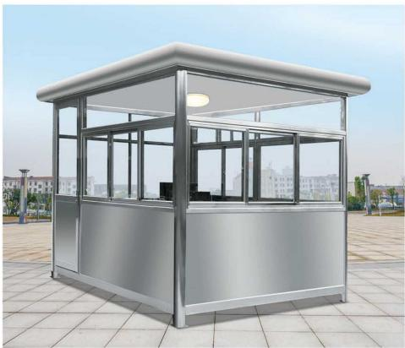 | 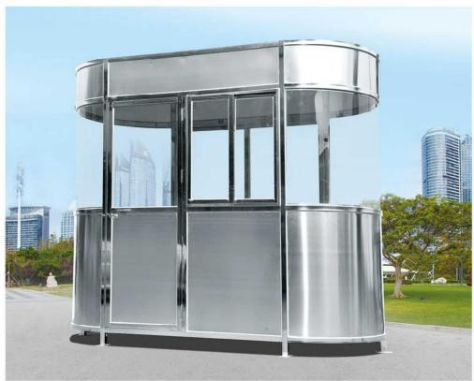
NX-GB-037 · Primary | NX-GB-038 · Primary | NX-GB-039 · Primary | NX-GB-040 · Primary

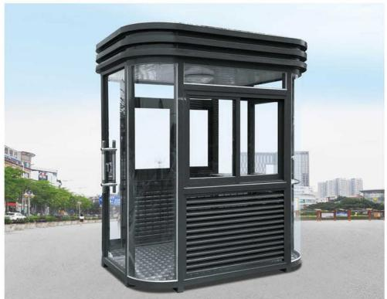 | 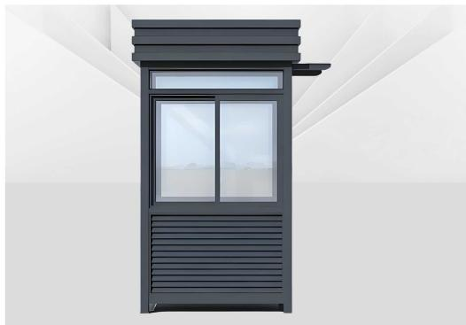 | 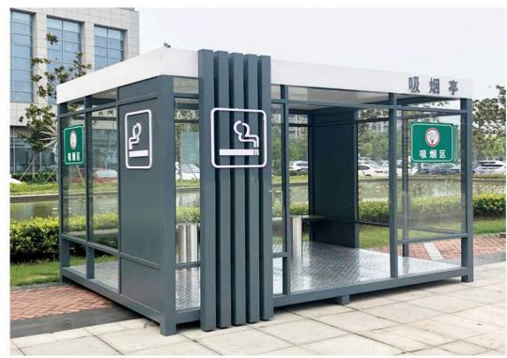 | 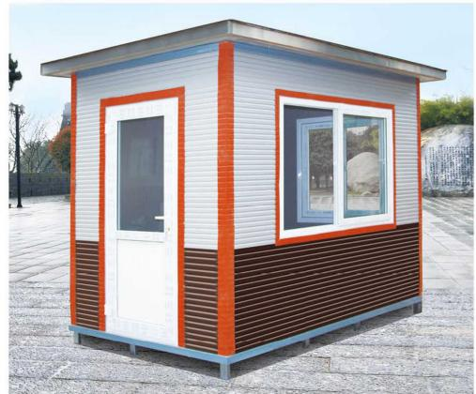
NX-GB-041 · Primary | NX-GB-042 · Primary | NX-GB-043 · Primary | NX-GB-044 · Primary

PRODUCT OVERVIEW
Guard Booths : Space Capsule Guard Booth.
Product line | Vehicle & Pedestrian Entrance Control
Series / family | Perimeter & Site Equipment
Exact model | NX-GB-037 | NX-GB-038 | NX-GB-039 | NX-GB-040 | NX-GB-041 | NX-GB-042 | NX-GB-043 | NX-GB-044 | NX-GB-045 | NX-GB-046 | NX-GB-047 | NX-GB-048
Applications | Property entrance, Factory checkpoint, Parking management
MODEL COMPARISON
Exact model | Product / variant | Product family | SKU | Supply
NX-GB-037 | NexPro Space Capsule Guard Booth - Space Capsule-style Guard Booth | Guard Booths | NX-GB-037 | Project and bulk orders
NX-GB-038 | NexPro Apple Guard Booth - Apple-style Guard Booth | Guard Booths | NX-GB-038 | Project and bulk orders
NX-GB-039 | NexPro GT01 - GT01 Stainless Steel Guard Booth | Guard Booths | NX-GB-039 | Project and bulk orders
NX-GB-040 | NexPro GT03 - GT03 Stainless Steel Guard Booth | Guard Booths | NX-GB-040 | Project and bulk orders
NX-GB-041 | NexPro GT02 - GT02 Stainless Steel Guard Booth | Guard Booths | NX-GB-041 | Project and bulk orders
NX-GB-042 | NexPro GT04 - GT04 Stainless Steel Guard Booth | Guard Booths | NX-GB-042 | Project and bulk orders
NX-GB-043 | NexPro GT05 - GT05 Aluminum Alloy Guard Booth | Guard Booths | NX-GB-043 | Project and bulk orders
NX-GB-044 | NexPro GT07 - GT07 Smoking Guard Booth | Guard Booths | NX-GB-044 | Project and bulk orders
NX-GB-045 | NexPro GT09 - GT09 Portable Cabin | Guard Booths | NX-GB-045 | Project and bulk orders
NX-GB-046 | NexPro GT06 - GT06 Stainless Steel Guard Booth | Guard Booths | NX-GB-046 | Project and bulk orders
NX-GB-047 | NexPro GT08 - GT08 Portable Cabin | Guard Booths | NX-GB-047 | Project and bulk orders
NX-GB-048 | NexPro GT10 - GT10 Portable Cabin | Guard Booths | NX-GB-048 | Project and bulk orders
TECHNICAL SPECIFICATIONS
Models: NX-GB-037 | NX-GB-038 | NX-GB-039 | NX-GB-040
Parameter | NX-GB-037 | NX-GB-038 | NX-GB-039 | NX-GB-040
Product family | Guard Booths | Guard Booths | Guard Booths | Guard Booths
SKU | NX-GB-037 | NX-GB-038 | NX-GB-039 | NX-GB-040
Supply | Project and bulk orders | Project and bulk orders | Project and bulk orders | Project and bulk orders
Category | Guard Booths | Guard Booths | Guard Booths | Guard Booths
System group | Perimeter & Site Equipment | Perimeter & Site Equipment | Perimeter & Site Equipment | Perimeter & Site Equipment
Quotation type | Project and bulk quotation | Project and bulk quotation | Project and bulk quotation | Project and bulk quotation
OEM/ODM | Available after scope confirmation | Available after scope confirmation | Available after scope confirmation | Available after scope confirmation
Required input | Lane layout, quantity, control method and destination | Lane layout, quantity, control method and destination | Lane layout, quantity, control method and destination | Lane layout, quantity, control method and destination
Documents | Confirm required datasheet, drawing and installation references | Confirm required datasheet, drawing and installation references | Confirm required datasheet, drawing and installation references | Confirm required datasheet, drawing and installation references
Models: NX-GB-041 | NX-GB-042 | NX-GB-043 | NX-GB-044
Parameter | NX-GB-041 | NX-GB-042 | NX-GB-043 | NX-GB-044
Product family | Guard Booths | Guard Booths | Guard Booths | Guard Booths
SKU | NX-GB-041 | NX-GB-042 | NX-GB-043 | NX-GB-044
Supply | Project and bulk orders | Project and bulk orders | Project and bulk orders | Project and bulk orders
Category | Guard Booths | Guard Booths | Guard Booths | Guard Booths
System group | Perimeter & Site Equipment | Perimeter & Site Equipment | Perimeter & Site Equipment | Perimeter & Site Equipment
Quotation type | Project and bulk quotation | Project and bulk quotation | Project and bulk quotation | Project and bulk quotation
OEM/ODM | Available after scope confirmation | Available after scope confirmation | Available after scope confirmation | Available after scope confirmation
Required input | Lane layout, quantity, control method and destination | Lane layout, quantity, control method and destination | Lane layout, quantity, control method and destination | Lane layout, quantity, control method and destination
Documents | Confirm required datasheet, drawing and installation references | Confirm required datasheet, drawing and installation references | Confirm required datasheet, drawing and installation references | Confirm required datasheet, drawing and installation references
Models: NX-GB-045 | NX-GB-046 | NX-GB-047 | NX-GB-048
Parameter | NX-GB-045 | NX-GB-046 | NX-GB-047 | NX-GB-048
Product family | Guard Booths | Guard Booths | Guard Booths | Guard Booths
SKU | NX-GB-045 | NX-GB-046 | NX-GB-047 | NX-GB-048
Supply | Project and bulk orders | Project and bulk orders | Project and bulk orders | Project and bulk orders
Category | Guard Booths | Guard Booths | Guard Booths | Guard Booths
System group | Perimeter & Site Equipment | Perimeter & Site Equipment | Perimeter & Site Equipment | Perimeter & Site Equipment
Quotation type | Project and bulk quotation | Project and bulk quotation | Project and bulk quotation | Project and bulk quotation
OEM/ODM | Available after scope confirmation | Available after scope confirmation | Available after scope confirmation | Available after scope confirmation
Required input | Lane layout, quantity, control method and destination | Lane layout, quantity, control method and destination | Lane layout, quantity, control method and destination | Lane layout, quantity, control method and destination
Documents | Confirm required datasheet, drawing and installation references | Confirm required datasheet, drawing and installation references | Confirm required datasheet, drawing and installation references | Confirm required datasheet, drawing and installation references
APPLICATIONS & RFQ CONFIRMATION
Typical applications | Confirm in the project RFQ
Property entrance  Factory checkpoint  Parking management | Confirm lane dimensions and installation environment before final model selection.  Confirm recognition, payment, safety detection and third-party integration requirements.  Technical parameters must be confirmed against the final quotation and datasheet.
Project supply: MOQ — Confirm by model, quantity and customization · Lead time — Confirm after project scope review · FOB port — China main ports · OEM/ODM — Available; confirm project scope
PROJECT CONFIGURATION CHECKLIST
Exact model | NX-GB-037
Application and site conditions | Confirm installation environment and operating requirements.
Quantity and model mix | Confirm forecast quantity, phase plan and required variants.
Interfaces and accessories | Confirm compatible interfaces, accessories and system integration scope.
Finish, branding and packing | Confirm only when project customization is required.
Documentation and destination | Confirm drawings, datasheets, packing documents and destination country or port.

