
VEHICLE & PEDESTRIAN ENTRANCE CONTROL

NX-BG Series
  - Models: NX-BG-036 | NX-BG-037 | NX-BG-039 | NX-BG-040 | NX-BG-042
PRODUCT IMAGES
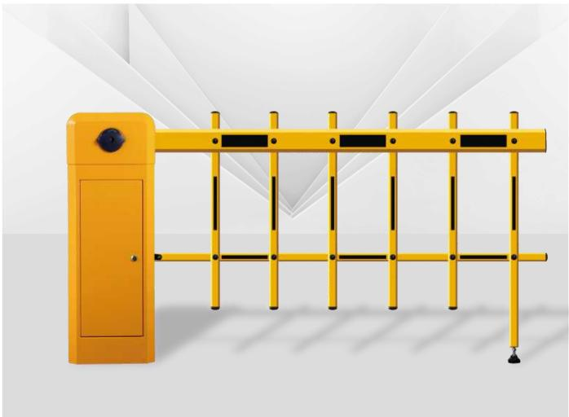 | 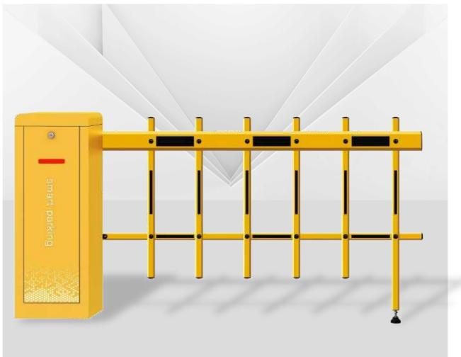 | 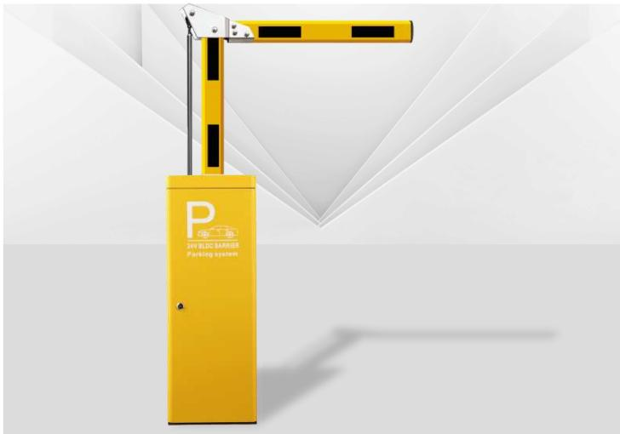 | 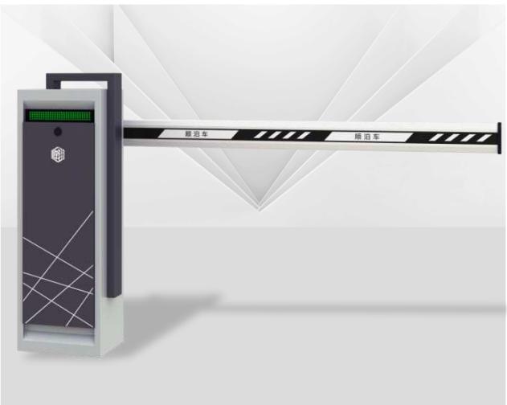
NX-BG-036 · Primary | NX-BG-037 · Primary | NX-BG-039 · Primary | NX-BG-040 · Primary

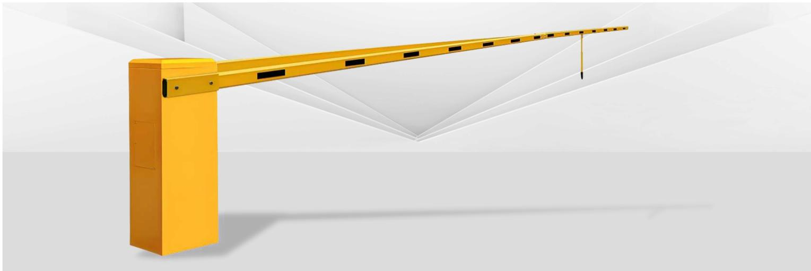
NX-BG-042 · Primary

PRODUCT OVERVIEW
Intelligent Barrier Gates : D10. Working power supply: AC220V+10%/50HZ | Motor power: 200W | Operating ambient temperature: -35°C to + 75°C.
Product line | Vehicle & Pedestrian Entrance Control
Series / family | Vehicle Lane Control
Exact model | NX-BG-036 | NX-BG-037 | NX-BG-039 | NX-BG-040 | NX-BG-042
Applications | Parking entrance, Factory gate, Residential community
MODEL COMPARISON
Exact model | Product / variant | Product family | SKU | Supply
NX-BG-036 | NexPro D10 - AC Motor Barrier Gate D10 | Intelligent Barrier Gates | NX-BG-036 | Project and bulk orders
NX-BG-037 | NexPro SC04 - Brushless DC Barrier Gate SC04 | Intelligent Barrier Gates | NX-BG-037 | Project and bulk orders
NX-BG-039 | NexPro WS01 - AC Motor Barrier Gate WS01 | Intelligent Barrier Gates | NX-BG-039 | Project and bulk orders
NX-BG-040 | NexPro TK01 - Brushless DC Barrier Gate TK01 | Intelligent Barrier Gates | NX-BG-040 | Project and bulk orders
NX-BG-042 | NexPro Railway Double-bar - Super-long Double-bar Barrier Gate for Railway | Intelligent Barrier Gates | NX-BG-042 | Project and bulk orders
TECHNICAL SPECIFICATIONS
Models: NX-BG-036 | NX-BG-037 | NX-BG-039 | NX-BG-040
Parameter | NX-BG-036 | NX-BG-037 | NX-BG-039 | NX-BG-040
Product family | Intelligent Barrier Gates | Intelligent Barrier Gates | Intelligent Barrier Gates | Intelligent Barrier Gates
SKU | NX-BG-036 | NX-BG-037 | NX-BG-039 | NX-BG-040
Supply | Project and bulk orders | Project and bulk orders | Project and bulk orders | Project and bulk orders
Category | Intelligent Barrier Gates | Intelligent Barrier Gates | Intelligent Barrier Gates | Intelligent Barrier Gates
System group | Vehicle Lane Control | Vehicle Lane Control | Vehicle Lane Control | Vehicle Lane Control
Quotation type | Project and bulk quotation | Project and bulk quotation | Project and bulk quotation | Project and bulk quotation
OEM/ODM | Available after scope confirmation | Available after scope confirmation | Available after scope confirmation | Available after scope confirmation
Required input | Lane layout, quantity, control method and destination | Lane layout, quantity, control method and destination | Lane layout, quantity, control method and destination | Lane layout, quantity, control method and destination
Documents | Confirm required datasheet, drawing and installation references | Confirm required datasheet, drawing and installation references | Confirm required datasheet, drawing and installation references | Confirm required datasheet, drawing and installation references
Models: NX-BG-042
Parameter | Specification
Product family | Intelligent Barrier Gates
SKU | NX-BG-042
Supply | Project and bulk orders
Category | Intelligent Barrier Gates
System group | Vehicle Lane Control
Quotation type | Project and bulk quotation
OEM/ODM | Available after scope confirmation
Required input | Lane layout, quantity, control method and destination
Documents | Confirm required datasheet, drawing and installation references
APPLICATIONS & RFQ CONFIRMATION
Typical applications | Confirm in the project RFQ
Parking entrance  Factory gate  Residential community | Confirm lane dimensions and installation environment before final model selection.  Confirm recognition, payment, safety detection and third-party integration requirements.  Technical parameters must be confirmed against the final quotation and datasheet.
Project supply: MOQ — Confirm by model, quantity and customization · Lead time — Confirm after project scope review · FOB port — China main ports · OEM/ODM — Available; confirm project scope
PROJECT CONFIGURATION CHECKLIST
Exact model | NX-BG-036
Application and site conditions | Confirm installation environment and operating requirements.
Quantity and model mix | Confirm forecast quantity, phase plan and required variants.
Interfaces and accessories | Confirm compatible interfaces, accessories and system integration scope.
Finish, branding and packing | Confirm only when project customization is required.
Documentation and destination | Confirm drawings, datasheets, packing documents and destination country or port.

