
VEHICLE & PEDESTRIAN ENTRANCE CONTROL

NexPro F01/F02 - Face Recognition System F01/F02
  - Exact model: NX-PA-017
PRODUCT IMAGES
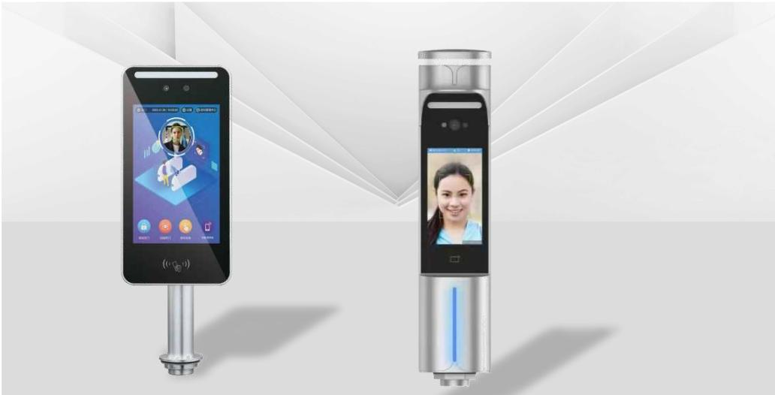
NX-PA-017 · Primary

PRODUCT OVERVIEW
Pedestrian Access Control : F01/F02. Specifications: 246mm (length) x 129mm (width) x 23mm (thickness) | Resolution: 1024x600 FHD screen | Processor: Rv1109 dedicated AI chip, 2 cores 1.5 GHZ.
Product line | Vehicle & Pedestrian Entrance Control
Series / family | Pedestrian Control
Exact model | NX-PA-017
Applications | Campus entrance, Office building, Factory personnel gate
MODEL IDENTIFICATION
Exact model | Product / variant | Product family | SKU | Supply
NX-PA-017 | NexPro F01/F02 - Face Recognition System F01/F02 | Pedestrian Access Control | NX-PA-017 | Project and bulk orders
TECHNICAL SPECIFICATIONS
Parameter | Specification
Product family | Pedestrian Access Control
SKU | NX-PA-017
Supply | Project and bulk orders
Category | Pedestrian Access Control
System group | Pedestrian Control
Quotation type | Project and bulk quotation
OEM/ODM | Available after scope confirmation
Required input | Lane layout, quantity, control method and destination
Documents | Confirm required datasheet, drawing and installation references
APPLICATIONS & RFQ CONFIRMATION
Typical applications | Confirm in the project RFQ
Campus entrance  Office building  Factory personnel gate | Confirm lane dimensions and installation environment before final model selection.  Confirm recognition, payment, safety detection and third-party integration requirements.  Technical parameters must be confirmed against the final quotation and datasheet.
Project supply: MOQ — Confirm by model, quantity and customization · Lead time — Confirm after project scope review · FOB port — China main ports · OEM/ODM — Available; confirm project scope
PROJECT CONFIGURATION CHECKLIST
Exact model | NX-PA-017
Application and site conditions | Confirm installation environment and operating requirements.
Quantity and model mix | Confirm forecast quantity, phase plan and required variants.
Interfaces and accessories | Confirm compatible interfaces, accessories and system integration scope.
Finish, branding and packing | Confirm only when project customization is required.
Documentation and destination | Confirm drawings, datasheets, packing documents and destination country or port.

