
VEHICLE & PEDESTRIAN ENTRANCE CONTROL

NexPro D02 - Advertising and Media Barrier D02
  - Exact model: NX-AD-013
PRODUCT IMAGES
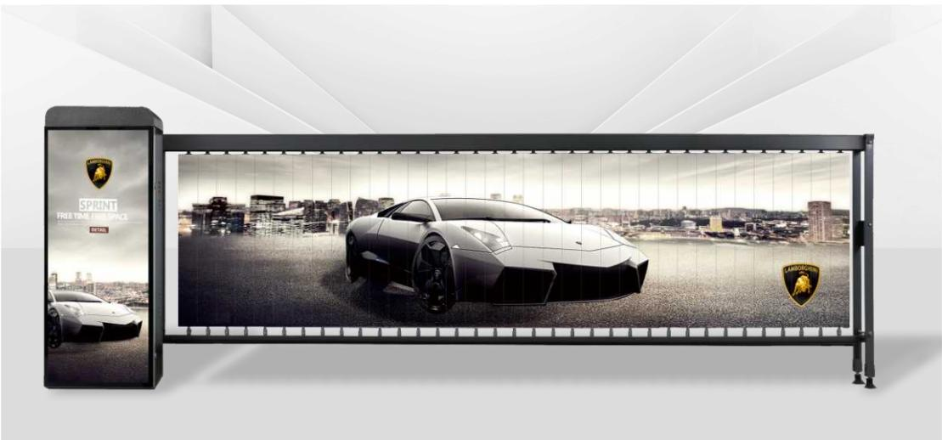
NX-AD-013 · Primary

PRODUCT OVERVIEW
Advertising Barrier Gates : D02. Working Voltage: 220V+10%/50HZ | Lifting Time: 3-6 seconds | Motor Power: 140W/200W.
Product line | Vehicle & Pedestrian Entrance Control
Series / family | Vehicle Lane Control
Exact model | NX-AD-013
Applications | Residential community, Commercial parking, Property management
MODEL IDENTIFICATION
Exact model | Product / variant | Product family | SKU | Supply
NX-AD-013 | NexPro D02 - Advertising and Media Barrier D02 | Advertising Barrier Gates | NX-AD-013 | Project and bulk orders
TECHNICAL SPECIFICATIONS
Parameter | Specification
Product family | Advertising Barrier Gates
SKU | NX-AD-013
Supply | Project and bulk orders
Category | Advertising Barrier Gates
System group | Vehicle Lane Control
Quotation type | Project and bulk quotation
OEM/ODM | Available after scope confirmation
Required input | Lane layout, quantity, control method and destination
Documents | Confirm required datasheet, drawing and installation references
APPLICATIONS & RFQ CONFIRMATION
Typical applications | Confirm in the project RFQ
Residential community  Commercial parking  Property management | Confirm lane dimensions and installation environment before final model selection.  Confirm recognition, payment, safety detection and third-party integration requirements.  Technical parameters must be confirmed against the final quotation and datasheet.
Project supply: MOQ — Confirm by model, quantity and customization · Lead time — Confirm after project scope review · FOB port — China main ports · OEM/ODM — Available; confirm project scope
PROJECT CONFIGURATION CHECKLIST
Exact model | NX-AD-013
Application and site conditions | Confirm installation environment and operating requirements.
Quantity and model mix | Confirm forecast quantity, phase plan and required variants.
Interfaces and accessories | Confirm compatible interfaces, accessories and system integration scope.
Finish, branding and packing | Confirm only when project customization is required.
Documentation and destination | Confirm drawings, datasheets, packing documents and destination country or port.

