
CCTV & SURVEILLANCE SYSTEM

NexPro 3MP Wi-Fi 6 Smart Dual-Light Bullet (AI, Two-Way Audio)
  - Exact model: NexPro-WB006-B12
PRODUCT IMAGES
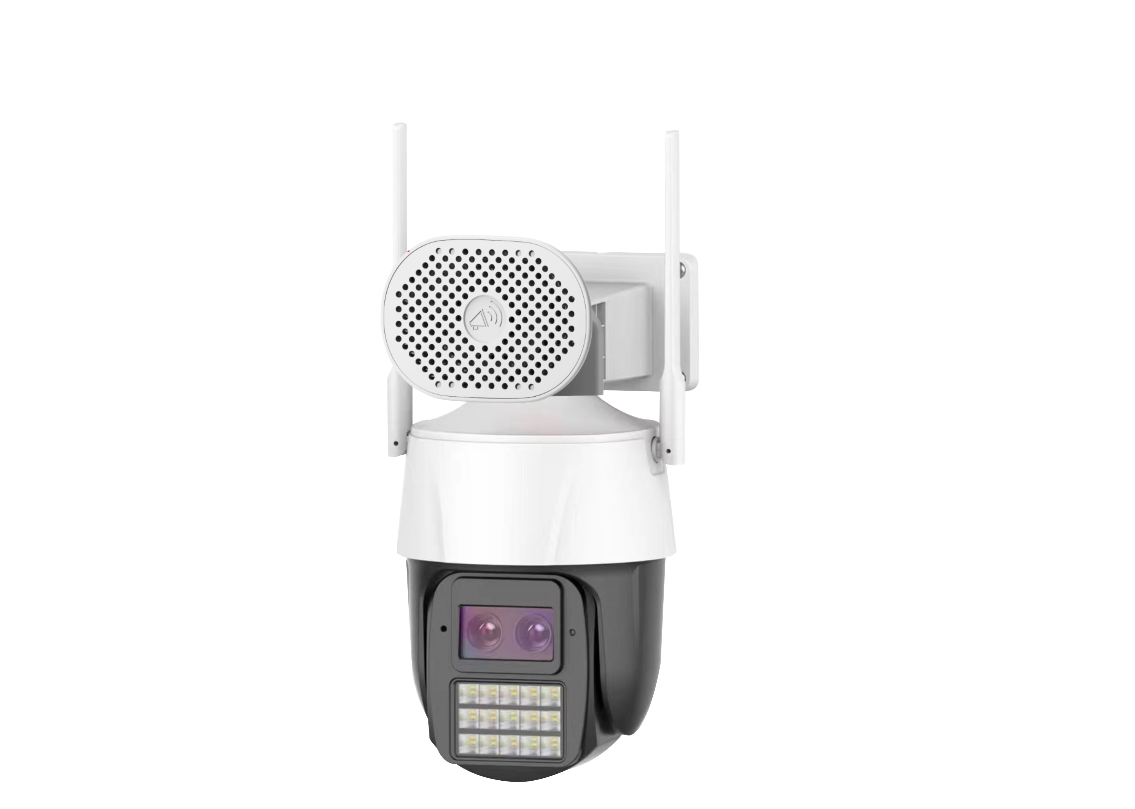
NexPro-WB006-B12 · Primary

PRODUCT OVERVIEW
3MP dual-light, Wi-Fi 6, Bluetooth, two-way audio, 256GB SD, V2.0 180k-cycle hinge
Product line | CCTV & Surveillance System
Series / family | Standalone model
Exact model | NexPro-WB006-B12
Applications | Home, Small Retail, Office
MODEL IDENTIFICATION
Exact model | Product / variant | Resolution | Wireless | Illuminator
NexPro-WB006-B12 | NexPro 3MP Wi-Fi 6 Smart Dual-Light Bullet (AI, Two-Way Audio) | 3MP | Wi-Fi 6 + Bluetooth | 4-IR + 2-White LED
TECHNICAL SPECIFICATIONS
Parameter | Specification
Resolution | 3MP
Wireless | Wi-Fi 6 + Bluetooth; Wi-Fi 6, Bluetooth pairing, RJ45 wired port
Illuminator | 4-IR + 2-White LED; 4×14mil IR + 2×0.5W white LEDs, smart dual-light
Camera Type | 3MP Wi-Fi 6 Smart Dual-Light Network Bullet Camera
Solution | Tianview TD53B12
Image Sensor | 1/2.7″ 3MP ultra-low illumination CMOS
Lens | F1.4 5MP starlight lens
Video | H.265+, 256GB SD card continuous recording
Audio | Built-in speaker & microphone, two-way voice communication
Mechanical | V2.0 upgraded hinge, 180,000-cycle swing test life
Quotation Type | Bulk project quotation
OEM/ODM | Available for selected orders
Documents | Datasheet and installation reference
Category | CCTV System
APPLICATIONS & RFQ CONFIRMATION
Typical applications | Confirm in the project RFQ
Home  Small Retail  Office | Confirm the exact model and required configuration.  Confirm quantity, destination, packing, branding, and documentation requirements.
Project supply: MOQ — Confirm by project quantity · Lead time — Confirm by project list · FOB port — China main ports · OEM/ODM — Available; confirm project scope
PROJECT CONFIGURATION CHECKLIST
Exact model | NexPro-WB006-B12
Application and site conditions | Confirm installation environment and operating requirements.
Quantity and model mix | Confirm forecast quantity, phase plan and required variants.
Interfaces and accessories | Confirm compatible interfaces, accessories and system integration scope.
Finish, branding and packing | Confirm only when project customization is required.
Documentation and destination | Confirm drawings, datasheets, packing documents and destination country or port.

