
CCTV & SURVEILLANCE SYSTEM

NexPro 26-Port Gigabit PoE Switch
  - Exact model: NexPro SW-POE2426G
PRODUCT IMAGES
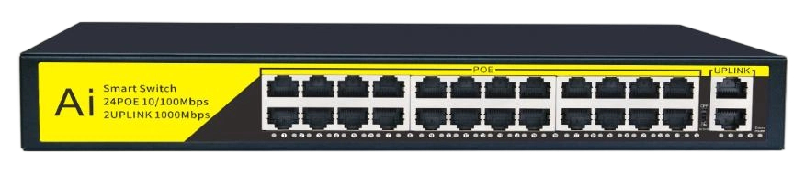
NexPro SW-POE2426G · Primary

PRODUCT OVERVIEW
26-port gigabit PoE switch with 24 PoE ports, 2 uplink, IEEE 802.3af/at, designed for large CCTV and enterprise network deployments
Product line | CCTV & Surveillance System
Series / family | Standalone model
Exact model | NexPro SW-POE2426G
Applications | Large CCTV System, Enterprise Network
MODEL IDENTIFICATION
Exact model | Product / variant | Ports | Speed | Standard
NexPro SW-POE2426G | NexPro 26-Port Gigabit PoE Switch | 24 PoE + 2 Uplink | Gigabit | IEEE 802.3af/at
TECHNICAL SPECIFICATIONS
Parameter | Specification
Ports | 24 PoE + 2 Uplink
Speed | Gigabit
Standard | IEEE 802.3af/at
Type | 26-Port Gigabit PoE Network Switch
PoE Ports | 24× PoE (10/100M) with IEEE 802.3af/at
Uplink Ports | 2× Gigabit uplink
Switching Capacity | Gigabit wire-speed forwarding
Installation | Rack-mountable, plug-and-play
Quotation Type | Bulk project quotation
OEM/ODM | Available for selected orders
Documents | Datasheet and installation reference
Category | CCTV System
APPLICATIONS & RFQ CONFIRMATION
Typical applications | Confirm in the project RFQ
Large CCTV System  Enterprise Network | Confirm the exact model and required configuration.  Confirm quantity, destination, packing, branding, and documentation requirements.
Project supply: MOQ — Confirm by project quantity · Lead time — Confirm by project list · FOB port — China main ports · OEM/ODM — Available; confirm project scope
PROJECT CONFIGURATION CHECKLIST
Exact model | NexPro SW-POE2426G
Application and site conditions | Confirm installation environment and operating requirements.
Quantity and model mix | Confirm forecast quantity, phase plan and required variants.
Interfaces and accessories | Confirm compatible interfaces, accessories and system integration scope.
Finish, branding and packing | Confirm only when project customization is required.
Documentation and destination | Confirm drawings, datasheets, packing documents and destination country or port.

