
CCTV & SURVEILLANCE SYSTEM

NexPro 4MP Anti-Flicker Camera for LED Screens & POS (5-50mm, AI560 Housing)
  - Exact model: NexPro-SC560LED-4MP-5-50
PRODUCT IMAGES
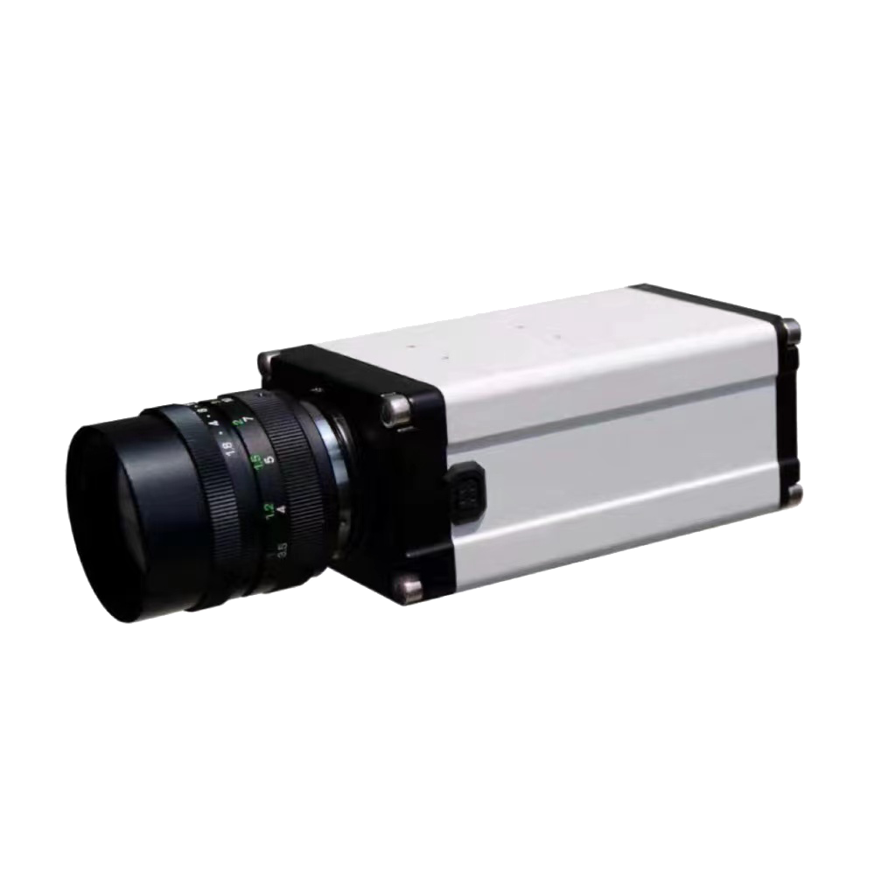
NexPro-SC560LED-4MP-5-50 · Primary

PRODUCT OVERVIEW
4MP, anti-flicker, 5-50mm manual zoom, alternative AI560 housing for specific installation constraints
Product line | CCTV & Surveillance System
Series / family | Standalone model
Exact model | NexPro-SC560LED-4MP-5-50
Applications | Cashier POS, Weighbridge, Logistics Label
MODEL IDENTIFICATION
Exact model | Product / variant | Resolution | Feature | Lens
NexPro-SC560LED-4MP-5-50 | NexPro 4MP Anti-Flicker Camera for LED Screens & POS (5-50mm, AI560 Housing) | 4MP | Anti-flicker | 5-50mm zoom
TECHNICAL SPECIFICATIONS
Parameter | Specification
Resolution | 4MP
Feature | Anti-flicker
Lens | 5-50mm zoom; 5mm–50mm manual zoom
Camera Type | 4MP Anti-Flicker Network Camera for LED Screens & POS  (560 Housing)
Purpose | Professional capture of LED screens, POS terminals, weighbridge displays, logistics labels without flicker
Installation | Distance ≤4m, tilt ~45°, manual aperture adjustment
Video | 4MP
Quotation Type | Bulk project quotation
OEM/ODM | Available for selected orders
Documents | Datasheet and installation reference
Category | CCTV System
APPLICATIONS & RFQ CONFIRMATION
Typical applications | Confirm in the project RFQ
Cashier POS  Weighbridge  Logistics Label | Confirm the exact model and required configuration.  Confirm quantity, destination, packing, branding, and documentation requirements.
Project supply: MOQ — Confirm by project quantity · Lead time — Confirm by project list · FOB port — China main ports · OEM/ODM — Available; confirm project scope
PROJECT CONFIGURATION CHECKLIST
Exact model | NexPro-SC560LED-4MP-5-50
Application and site conditions | Confirm installation environment and operating requirements.
Quantity and model mix | Confirm forecast quantity, phase plan and required variants.
Interfaces and accessories | Confirm compatible interfaces, accessories and system integration scope.
Finish, branding and packing | Confirm only when project customization is required.
Documentation and destination | Confirm drawings, datasheets, packing documents and destination country or port.

