
CCTV & SURVEILLANCE SYSTEM

PTL10 Series
  - Models: NexPro-PTL10-4MP-40X | NexPro-PTL10-5MP-25X | NexPro-PTL10-5MP-25X-FC
PRODUCT IMAGES
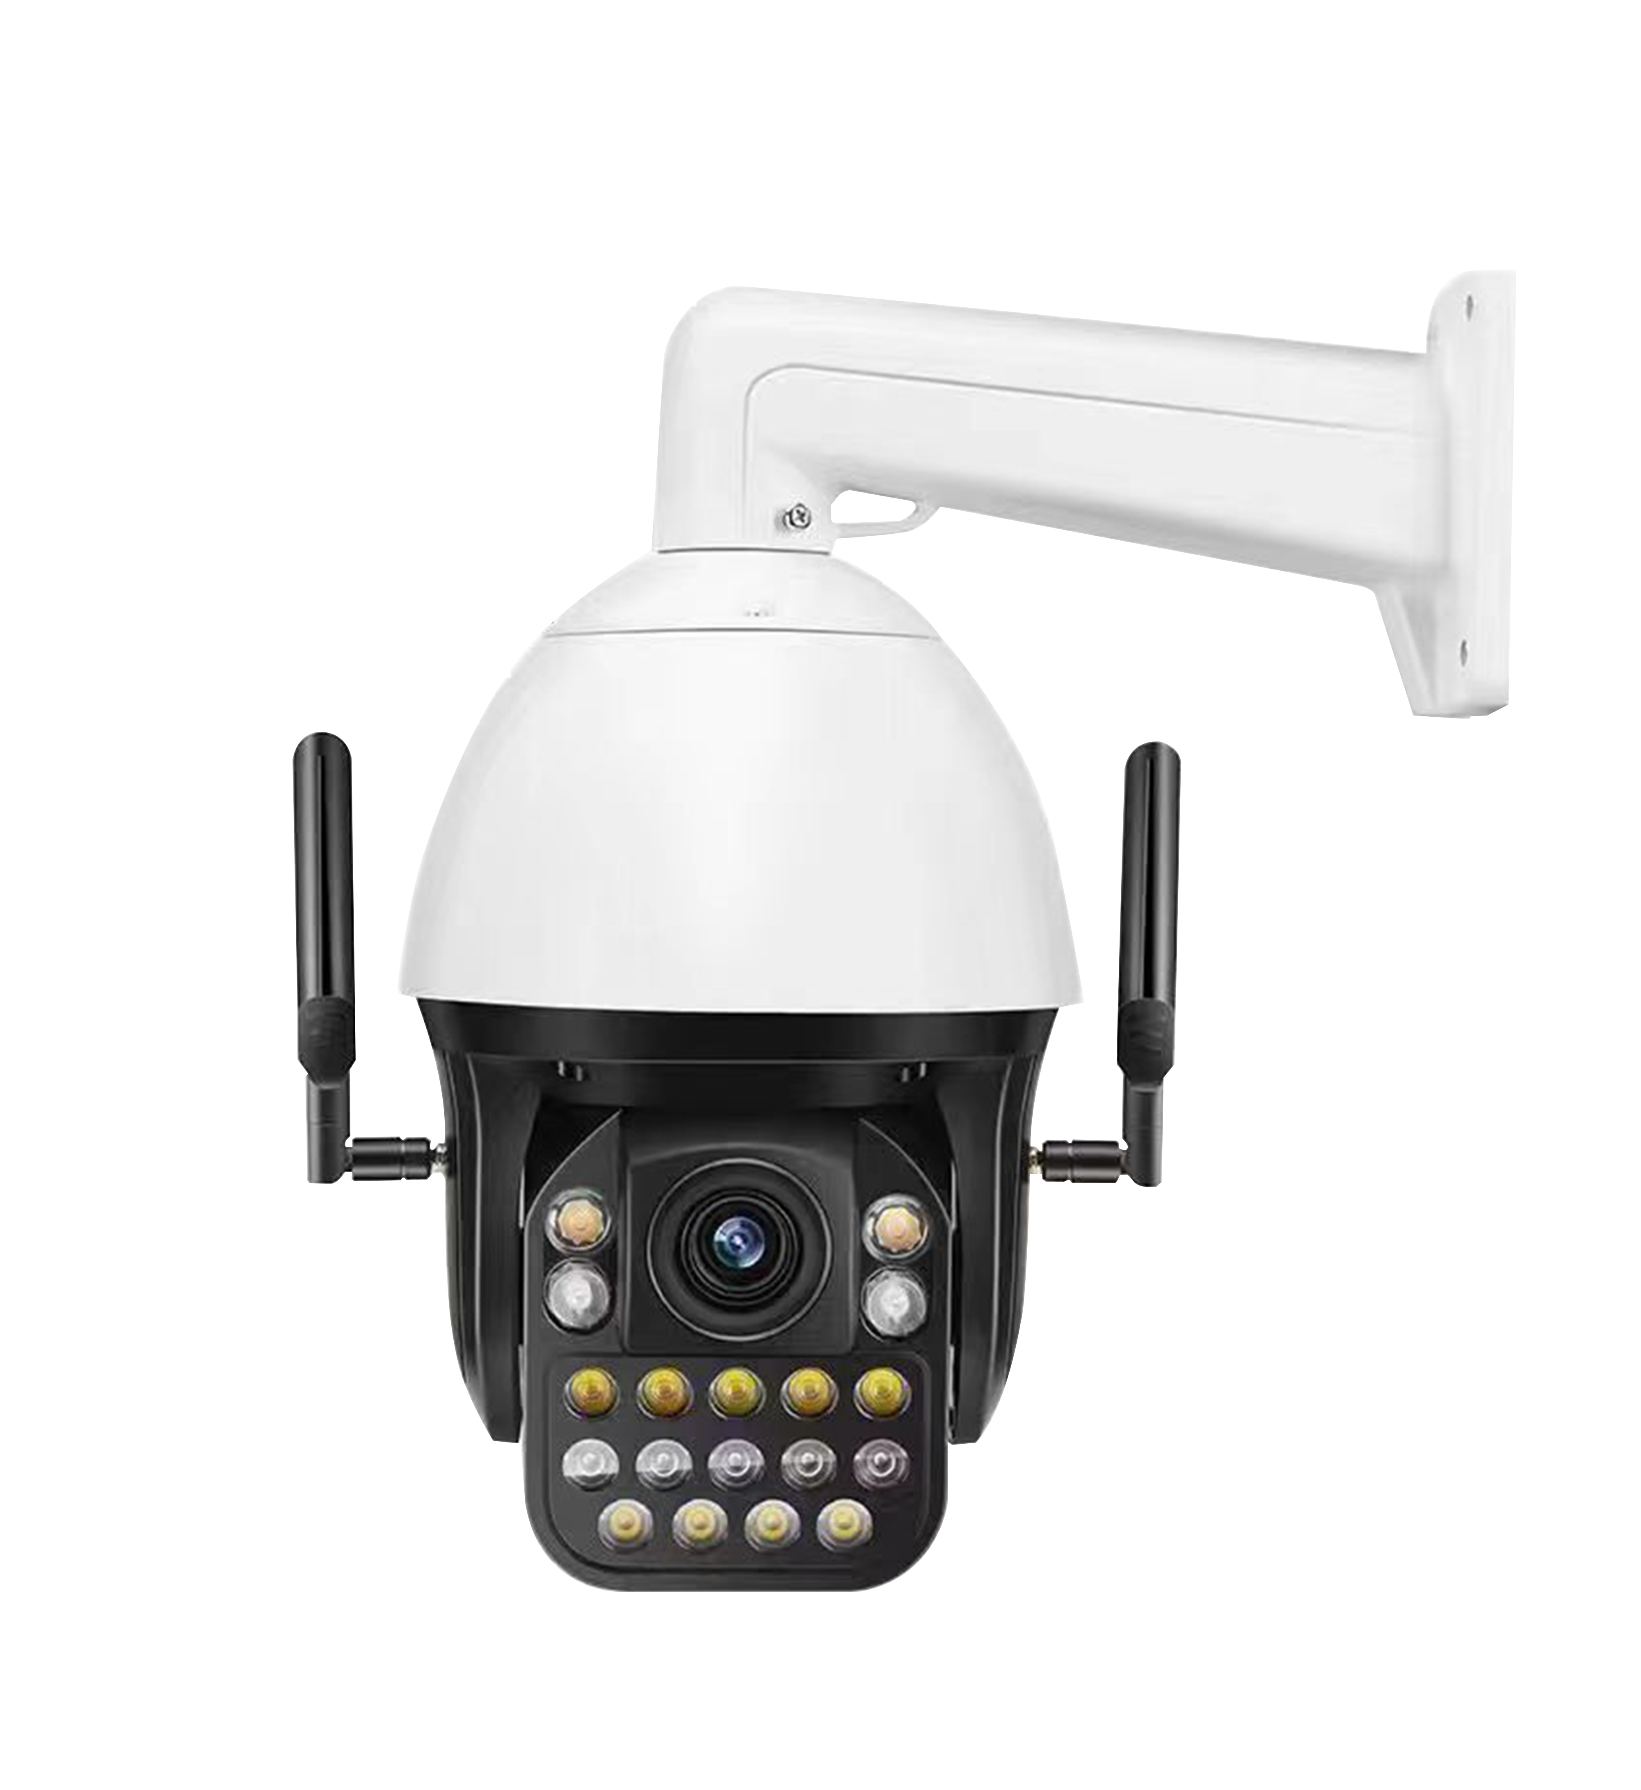
NexPro-PTL10-4MP-40X · Primary

PRODUCT OVERVIEW
4MP, 40x optical zoom, 7 laser IR + 11 warm LEDs, 150m illumination, AI 3-target detection, tracking, area alert, two-way audio, NVR popup, offline push
Product line | CCTV & Surveillance System
Series / family | PTL10
Exact model | NexPro-PTL10-4MP-40X | NexPro-PTL10-5MP-25X | NexPro-PTL10-5MP-25X-FC
Applications | Large Perimeter, Industrial Compound, Oil & Gas
MODEL COMPARISON
Exact model | Product / variant | Resolution | Zoom | Illuminator
NexPro-PTL10-4MP-40X | NexPro 4MP 10-inch Laser Active Deterrence PTZ (40x Zoom, 150m IR, AI Tracking) | 4MP | 40x optical | Laser IR + Warm LED
NexPro-PTL10-5MP-25X | NexPro 5MP 10-inch Laser PTZ (25x, 200m IR, AI Human+Vehicle Tracking, TF) | 5MP | 25x optical | Laser 200m
NexPro-PTL10-5MP-25X-FC | NexPro 5MP 10-inch Full-Color Laser PTZ (25x, 200m, AI Human+Vehicle, TF) | 5MP | 25x optical | 15-laser full-color 200m
TECHNICAL SPECIFICATIONS
Parameter | NexPro-PTL10-4MP-40X | NexPro-PTL10-5MP-25X | NexPro-PTL10-5MP-25X-FC
Resolution | 4MP | 5MP | 5MP
Zoom | 40x optical | 25x optical | 25x optical
Illuminator | Laser IR + Warm LED; 7 laser IR LEDs + 11 warm white LEDs, 150m illumination | Laser 200m; 10 laser IR + 9 warm white LEDs, 200m | 15-laser full-color 200m; 15 high-power laser warm white LEDs, 200m full-color
Camera Type | 10-inch 4MP Laser Dual-Light Active Deterrence PTZ Camera | 10-inch 5MP Laser Dual-Light Active Deterrence PTZ with Vehicle AI | 10-inch 5MP Laser Full-Color PTZ Camera
Solution | Tianview Z20 platform | Tianview customized platform | Tianview customized platform
Image Sensor | 4MP, H.265 encoding, 25fps | 5MP, H.265, 25fps, onboard TF card slot | 5MP, H.265, 25fps, built-in TF card
Lens | 40x optical zoom, F1.6, 4.7mm–84.6mm | 25x optical zoom, F1.4, 5.3mm–130mm | 25x optical zoom, F1.4, 5.3mm–130mm
AI Features | 3-target human detection, tracking, line crossing & area intrusion alert, popup, offline push | Human & vehicle detection, tracking, line crossing, area intrusion, voice, NVR popup, offline push | Human & vehicle detection, tracking, line crossing, area intrusion, custom voice, popup, offline push
Audio | External speaker support, two-way voice intercom | External speaker support, two-way voice intercom | External speaker support, two-way intercom
Alarm | NVR popup alert, offline mobile push | NVR popup, offline push | NVR popup, offline push
Quotation Type | Bulk project quotation | Bulk project quotation | Bulk project quotation
OEM/ODM | Available for selected orders | Available for selected orders | Available for selected orders
Documents | Datasheet and installation reference | Datasheet and installation reference | Datasheet and installation reference
Category | CCTV System | CCTV System | CCTV System
APPLICATIONS & RFQ CONFIRMATION
Typical applications | Confirm in the project RFQ
Large Perimeter  Industrial Compound  Oil & Gas  Critical Infrastructure  Oil Depot  Logistics Hub  Forensic Perimeter  Port | Confirm the exact model and required configuration.  Confirm quantity, destination, packing, branding, and documentation requirements.
Project supply: MOQ — Confirm by project quantity · Lead time — Confirm by project list · FOB port — China main ports · OEM/ODM — Available; confirm project scope
PROJECT CONFIGURATION CHECKLIST
Exact model | NexPro-PTL10-4MP-40X
Application and site conditions | Confirm installation environment and operating requirements.
Quantity and model mix | Confirm forecast quantity, phase plan and required variants.
Interfaces and accessories | Confirm compatible interfaces, accessories and system integration scope.
Finish, branding and packing | Confirm only when project customization is required.
Documentation and destination | Confirm drawings, datasheets, packing documents and destination country or port.

