
CCTV & SURVEILLANCE SYSTEM

NexPro 6MP Dual-Lens Starlight PTZ (Metal, Wi-Fi 6, Hisilicon AI, F1.0)
  - Exact model: NexPro-PT6058WZ40Y-6MP
PRODUCT IMAGES
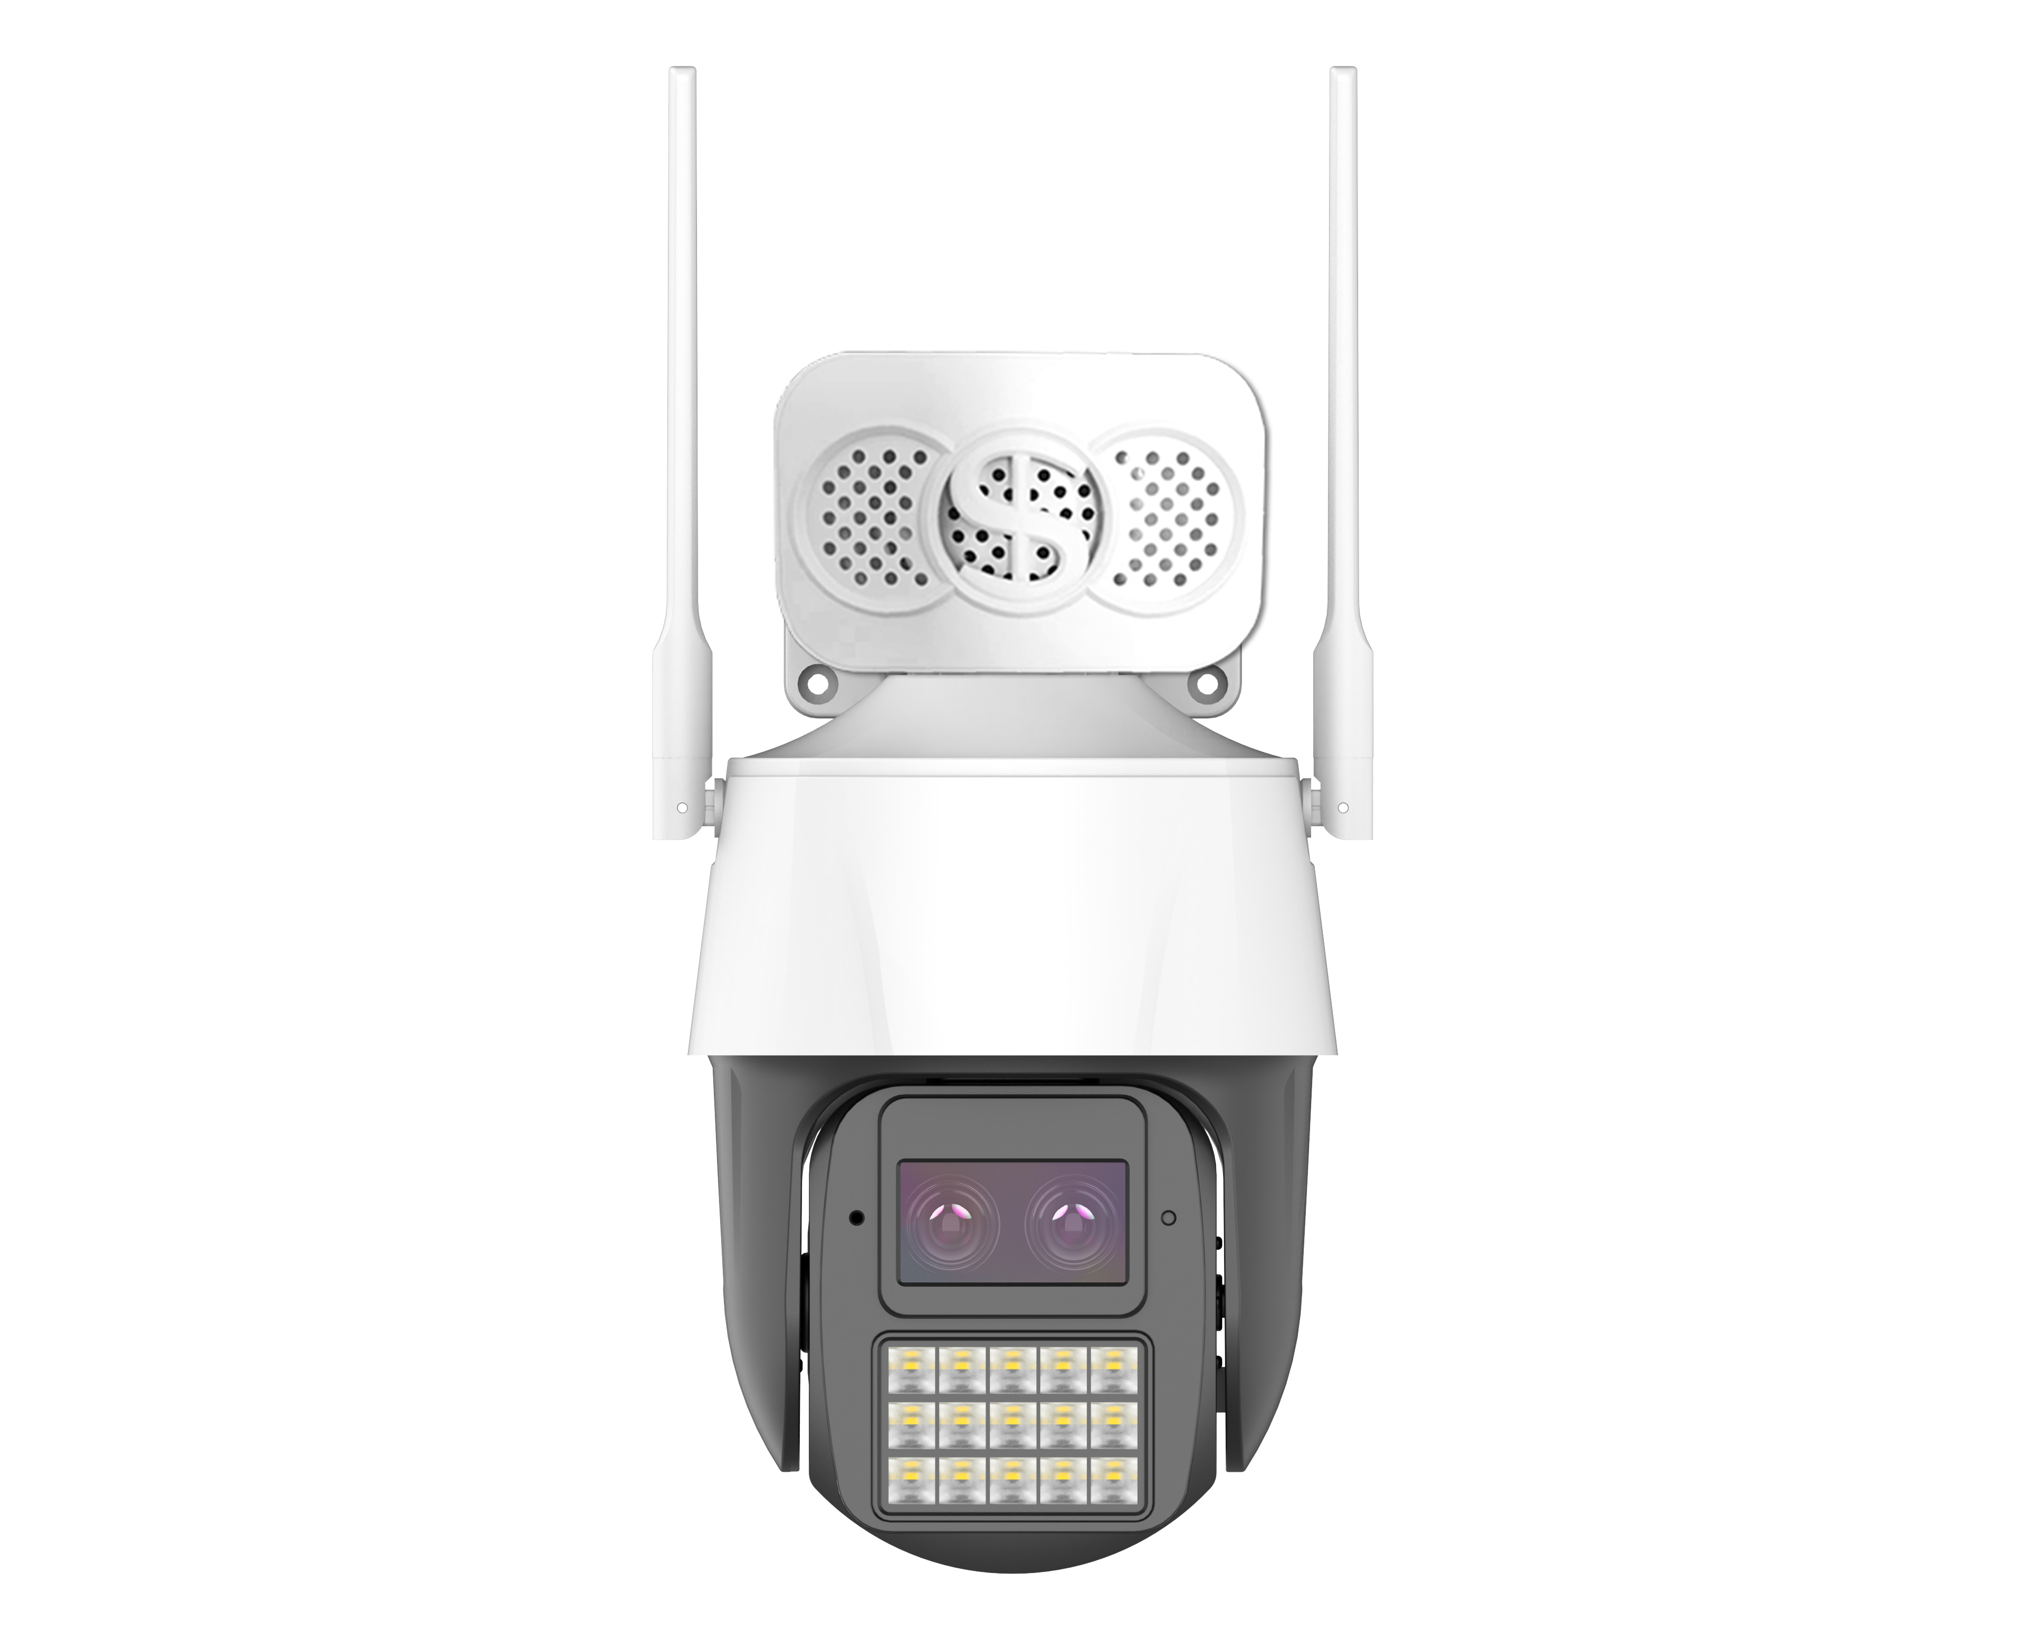
NexPro-PT6058WZ40Y-6MP · Primary

PRODUCT OVERVIEW
6MP dual-lens fusion, F1.0 blue-wave lens, Hisilicon AI, human/vehicle detection, Wi-Fi 6, metal body
Product line | CCTV & Surveillance System
Series / family | Standalone model
Exact model | NexPro-PT6058WZ40Y-6MP
Applications | Premium Perimeter, Villa, Commercial
MODEL IDENTIFICATION
Exact model | Product / variant | Resolution | Lens | AI
NexPro-PT6058WZ40Y-6MP | NexPro 6MP Dual-Lens Starlight PTZ (Metal, Wi-Fi 6, Hisilicon AI, F1.0) | 6MP Dual-Lens | F1.0 blue-wave | Hisilicon chip
TECHNICAL SPECIFICATIONS
Parameter | Specification
Resolution | 6MP Dual-Lens
Lens | F1.0 blue-wave
AI | Hisilicon chip
Camera Type | 6MP Dual-Lens Starlight Full-Color PTZ Camera with Hisilicon AI
Solution | Tianview TD53D52, Hisilicon AI chip
Image Sensor | 1/2.7″ 4MP ultra-low-light Starlight CMOS (dual-lens fusion)
Lens 1 (Full-Color) | F1.0 5MP YTOT blue-wave lens, night-as-day full-color
Lens 2 (IR) | F1.4 5MP lens, long-range IR + smart white light supplement
Illuminator | 15 IR LEDs + 15×1W warm white LEDs
AI Features | Human/vehicle detection, line crossing, area intrusion
Audio | Built-in speaker & mic
Wireless | Wi-Fi 6, Bluetooth, RJ45
Quotation Type | Bulk project quotation
OEM/ODM | Available for selected orders
Documents | Datasheet and installation reference
Category | CCTV System
APPLICATIONS & RFQ CONFIRMATION
Typical applications | Confirm in the project RFQ
Premium Perimeter  Villa  Commercial | Confirm the exact model and required configuration.  Confirm quantity, destination, packing, branding, and documentation requirements.
Project supply: MOQ — Confirm by project quantity · Lead time — Confirm by project list · FOB port — China main ports · OEM/ODM — Available; confirm project scope
PROJECT CONFIGURATION CHECKLIST
Exact model | NexPro-PT6058WZ40Y-6MP
Application and site conditions | Confirm installation environment and operating requirements.
Quantity and model mix | Confirm forecast quantity, phase plan and required variants.
Interfaces and accessories | Confirm compatible interfaces, accessories and system integration scope.
Finish, branding and packing | Confirm only when project customization is required.
Documentation and destination | Confirm drawings, datasheets, packing documents and destination country or port.

