
CCTV & SURVEILLANCE SYSTEM

NexPro 64CH 8-Bay 4K NVR (H.265+, Dual-LAN, Alarm I/O)
  - Exact model: NexPro-NVR8864-4K
PRODUCT IMAGES
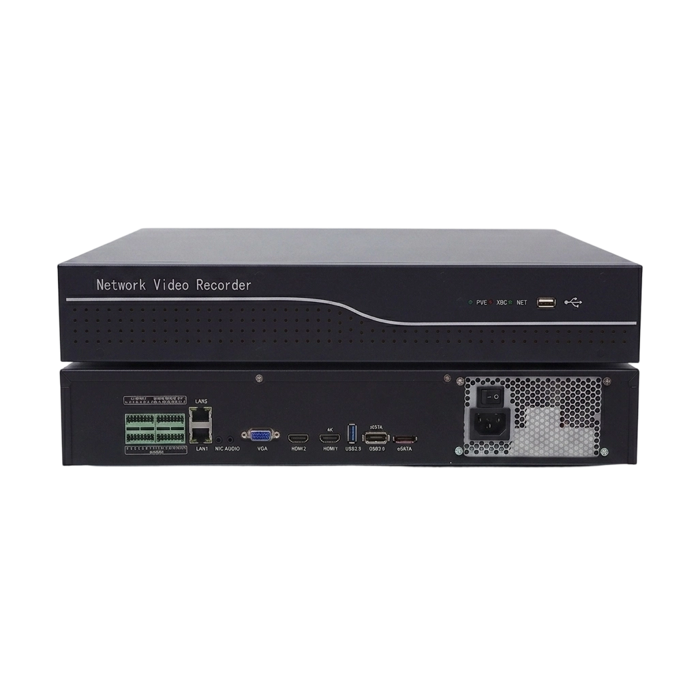
NexPro-NVR8864-4K · Primary

PRODUCT OVERVIEW
64CH 5MP/16×4K, 8×18TB SATA, 8CH 2MP/2×5MP/1×4K playback, dual HDMI, RS485/232, 16in/4out alarm
Product line | CCTV & Surveillance System
Series / family | Standalone model
Exact model | NexPro-NVR8864-4K
Applications | Large Hotel, Industrial Campus, Enterprise Facility
MODEL IDENTIFICATION
Exact model | Product / variant | Channels | Recording | Storage
NexPro-NVR8864-4K | NexPro 64CH 8-Bay 4K NVR (H.265+, Dual-LAN, Alarm I/O) | 64CH IP | Up to 4K | 8×SATA, 144TB total
TECHNICAL SPECIFICATIONS
Parameter | Specification
Channels | 64CH IP
Recording | Up to 4K
Storage | 8×SATA, 144TB total; 8×SATA, max 18TB each  (144TB total); eSATA expansion
Recorder Type | 64-Channel 8-Bay H.265+ Network Video Recorder
Video Input | 64CH IP, 320Mbps bandwidth, auto-search/add/record/preview
Recording Resolution | Up to 4K
Network | 2×RJ45 10/100/1000M; ONVIF, P2P, SMTP, GB28181
Alarm | 16×input, 4×relay output
Cloud | Seetong Cloud, Seetong APP instantaneous preview
Quotation Type | Bulk project quotation
OEM/ODM | Available for selected orders
Documents | Datasheet and installation reference
Category | CCTV System
APPLICATIONS & RFQ CONFIRMATION
Typical applications | Confirm in the project RFQ
Large Hotel  Industrial Campus  Enterprise Facility | Confirm the exact model and required configuration.  Confirm quantity, destination, packing, branding, and documentation requirements.
Project supply: MOQ — Confirm by project quantity · Lead time — Confirm by project list · FOB port — China main ports · OEM/ODM — Available; confirm project scope
PROJECT CONFIGURATION CHECKLIST
Exact model | NexPro-NVR8864-4K
Application and site conditions | Confirm installation environment and operating requirements.
Quantity and model mix | Confirm forecast quantity, phase plan and required variants.
Interfaces and accessories | Confirm compatible interfaces, accessories and system integration scope.
Finish, branding and packing | Confirm only when project customization is required.
Documentation and destination | Confirm drawings, datasheets, packing documents and destination country or port.

