
CCTV & SURVEILLANCE SYSTEM

406 Series
  - Models: NexPro-DM406D3-4MP-TRI | NexPro-DM406D3-4MP-TRI-DJ | NexPro-DM406MQ5-5MP-TRI-DJ
PRODUCT IMAGES
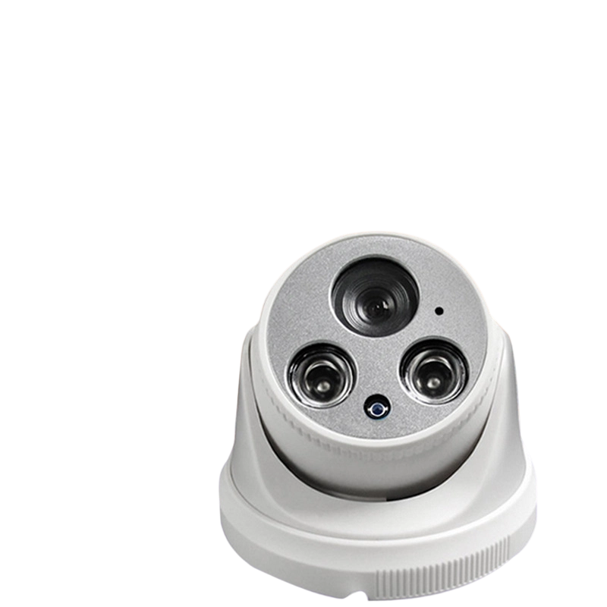
NexPro-DM406D3-4MP-TRI · Primary

PRODUCT OVERVIEW
4MP full-color, transistor-based, 12 LEDs, built-in mic, 4000V surge protection
Product line | CCTV & Surveillance System
Series / family | 406
Exact model | NexPro-DM406D3-4MP-TRI | NexPro-DM406D3-4MP-TRI-DJ | NexPro-DM406MQ5-5MP-TRI-DJ
Applications | Budget Project, Indoor Area, Corridor
MODEL COMPARISON
Exact model | Product / variant | Resolution | Lens | Illuminator
NexPro-DM406D3-4MP-TRI | NexPro 4MP Cost-Effective Dual-Light Dome (12-LED, Built-in Mic) | 4MP | F1.4 5MP fixed | 12-LED dual light
NexPro-DM406D3-4MP-TRI-DJ | NexPro 4MP Smart Dual-Light Dome (12-LED, Two-Way Audio & Custom Voice Alert) | 4MP (5MP sensor) | F1.4 5MP fixed | 12-LED dual light (1W)
NexPro-DM406MQ5-5MP-TRI-DJ | NexPro 5MP Ultra-Bright Smart Dual-Light Dome (30-LED, Two-Way Audio & Custom Voice Alert) | 5MP | F1.4 5MP fixed | 30-LED ultra-bright
TECHNICAL SPECIFICATIONS
Parameter | NexPro-DM406D3-4MP-TRI | NexPro-DM406D3-4MP-TRI-DJ | NexPro-DM406MQ5-5MP-TRI-DJ
Resolution | 4MP (2560×1440) @ real-time | 4MP (5MP sensor); 4MP (2560×1440) @ real-time | 5MP (2592×1944) @ real-time
Lens | F1.4 5MP fixed lens | F1.4 5MP fixed lens | F1.4 5MP fixed lens
Illuminator | 12-LED dual light (6×20mil IR + 6×1W warm white) | 12-LED dual light  (1W); 12-LED dual light (6×20mil IR + 6×1W warm white) | 30-LED ultra-bright dual light  (15×20mil IR + 15×0.5W warm white)
Camera Type | 4MP Full-Color Dual-Light Network Dome Camera – Cost-Effective Series  (406 Series) | 4MP Smart Full-Color Dual-Light Network Dome Camera with Two-Way Audio & Custom Voice  (406 Series) | 5MP Ultra-Bright Smart Full-Color Dual-Light Network Dome Camera  (406 Series)
Solution | Tianview TR38Y33 | Tianview TB38Y51 (5MP sensor, output 4MP) | Tianview TB38M55
Image Sensor | 1/2.7″ 4MP CMOS, low illumination | 1/2.7″ 5MP CMOS, low illumination | 1/2.7″ 5MP CMOS, low illumination
Lamp Board | Transistor-based circuit design (cost-effective) | Transistor-based circuit design | Transistor-based circuit design
Audio | Built-in microphone | Built-in microphone and speaker, two-way audio with custom voice messages | Built-in microphone and speaker, two-way audio with custom voice messages
Protection | Metal front cover, 4000V lightning surge protection | Metal front cover, front heat dissipation, 4000V surge protection | Metal front cover, front heat dissipation, 4000V surge protection
Light Control | 3 switchable modes | 3 switchable modes | 3 switchable modes
Quotation Type | Bulk project quotation | Bulk project quotation | Bulk project quotation
OEM/ODM | Available for selected orders | Available for selected orders | Available for selected orders
Documents | Datasheet and installation reference | Datasheet and installation reference | Datasheet and installation reference
Category | CCTV System | CCTV System | CCTV System
Intelligent Features | Not provided | Customizable perimeter alert | Intelligent perimeter alert
APPLICATIONS & RFQ CONFIRMATION
Typical applications | Confirm in the project RFQ
Budget Project  Indoor Area  Corridor  Smart Office  Retail  Lobby  Large Warehouse  Industrial  Commercial Lobby | Confirm the exact model and required configuration.  Confirm quantity, destination, packing, branding, and documentation requirements.
Project supply: MOQ — Confirm by project quantity · Lead time — Confirm by project list · FOB port — China main ports · OEM/ODM — Available; confirm project scope
PROJECT CONFIGURATION CHECKLIST
Exact model | NexPro-DM406D3-4MP-TRI
Application and site conditions | Confirm installation environment and operating requirements.
Quantity and model mix | Confirm forecast quantity, phase plan and required variants.
Interfaces and accessories | Confirm compatible interfaces, accessories and system integration scope.
Finish, branding and packing | Confirm only when project customization is required.
Documentation and destination | Confirm drawings, datasheets, packing documents and destination country or port.

