
CCTV & SURVEILLANCE SYSTEM

206 Series
  - Models: NexPro-DM206D3-4MP-DIC | NexPro-DM206D3-4MP-DIC-DJ | NexPro-DM206MQ5-5MP-DIC-DJ
PRODUCT IMAGES
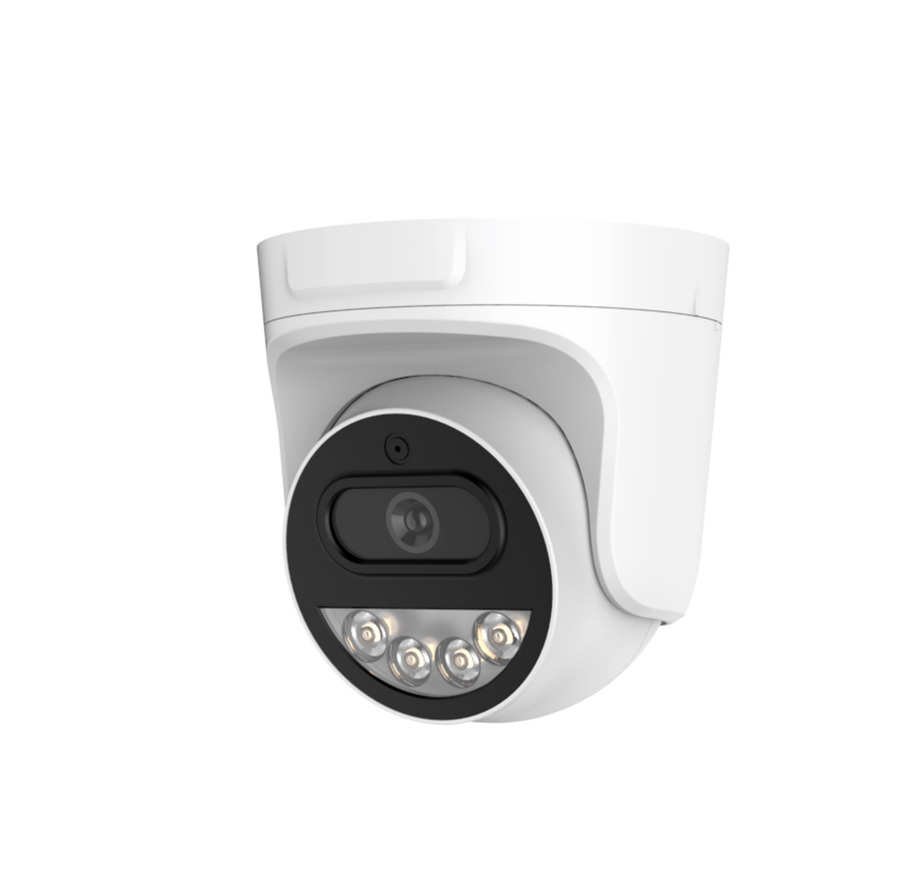
NexPro-DM206D3-4MP-DIC · Primary

PRODUCT OVERVIEW
4MP full-color, dual-IC, 16 LEDs long-range, built-in mic, 4000V surge protection
Product line | CCTV & Surveillance System
Series / family | 206
Exact model | NexPro-DM206D3-4MP-DIC | NexPro-DM206D3-4MP-DIC-DJ | NexPro-DM206MQ5-5MP-DIC-DJ
Applications | Large Indoor, Warehouse, Lobby
MODEL COMPARISON
Exact model | Product / variant | Resolution | Lens | Illuminator
NexPro-DM206D3-4MP-DIC | NexPro 4MP Long-Range Dual-Light Dome (16-LED, Built-in Mic) | 4MP | F1.4 5MP fixed | 16-LED dual light
NexPro-DM206D3-4MP-DIC-DJ | NexPro 4MP High-Brightness Dual-Light Dome (12-LED, Two-Way Audio) | 4MP (5MP sensor) | F1.4 5MP fixed | 12-LED high-power (1W)
NexPro-DM206MQ5-5MP-DIC-DJ | NexPro 5MP Premium Long-Range Dual-Light Dome (12-LED, Two-Way Audio) | 5MP | F1.4 5MP fixed | 12-LED high-power (1W)
TECHNICAL SPECIFICATIONS
Parameter | NexPro-DM206D3-4MP-DIC | NexPro-DM206D3-4MP-DIC-DJ | NexPro-DM206MQ5-5MP-DIC-DJ
Resolution | 4MP (2560×1440) @ real-time | 4MP (5MP sensor); 4MP (2560×1440) @ real-time | 5MP (2592×1944) @ real-time
Lens | F1.4 5MP fixed lens | F1.4 5MP fixed lens | F1.4 5MP fixed lens
Illuminator | 16-LED dual light (8×20mil IR + 8×0.5W warm white) | 12-LED high-power  (1W); 12-LED high-power dual light (6×20mil IR + 6×1W warm white) | 12-LED high-power  (1W); 12-LED high-power dual light (6×20mil IR + 6×1W warm white)
Camera Type | 4MP Full-Color Dual-Light Network Dome Camera with Long-Range Night Vision  (206 Series) | 4MP High-Brightness Full-Color Dual-Light Network Dome Camera with Two-Way Audio  (206 Series) | 5MP Premium Full-Color Dual-Light Network Dome Camera with Long-Range Night Vision & Two-Way Audio  (206 Series)
Solution | Tianview TR38Y33 | Tianview TB38Y51 (5MP sensor, output 4MP) | Tianview TB38M55
Image Sensor | 1/2.7″ 4MP CMOS, low illumination | 1/2.7″ 5MP CMOS, low illumination | 1/2.7″ 5MP CMOS, low illumination
Lamp Board | Dual IC circuit design | Dual IC circuit design | Dual IC circuit design
Audio | Built-in microphone | Built-in microphone and speaker (two-way audio) | Built-in microphone and speaker (two-way audio)
Protection | Metal front cover, front heat dissipation, 4000V surge protection | Metal front cover, 4000V lightning surge protection | Metal front cover, 4000V lightning surge protection
Light Control | 3 switchable modes | 3 switchable modes | 3 switchable modes
Quotation Type | Bulk project quotation | Bulk project quotation | Bulk project quotation
OEM/ODM | Available for selected orders | Available for selected orders | Available for selected orders
Documents | Datasheet and installation reference | Datasheet and installation reference | Datasheet and installation reference
Category | CCTV System | CCTV System | CCTV System
APPLICATIONS & RFQ CONFIRMATION
Typical applications | Confirm in the project RFQ
Large Indoor  Warehouse  Lobby  Indoor Premium  Commercial  Large Commercial | Confirm the exact model and required configuration.  Confirm quantity, destination, packing, branding, and documentation requirements.
Project supply: MOQ — Confirm by project quantity · Lead time — Confirm by project list · FOB port — China main ports · OEM/ODM — Available; confirm project scope
PROJECT CONFIGURATION CHECKLIST
Exact model | NexPro-DM206D3-4MP-DIC
Application and site conditions | Confirm installation environment and operating requirements.
Quantity and model mix | Confirm forecast quantity, phase plan and required variants.
Interfaces and accessories | Confirm compatible interfaces, accessories and system integration scope.
Finish, branding and packing | Confirm only when project customization is required.
Documentation and destination | Confirm drawings, datasheets, packing documents and destination country or port.

