
CCTV & SURVEILLANCE SYSTEM

NexPro 4MP Dual-Lens Starlight Full-Color Bullet (AI, Two-Way Audio)
  - Exact model: NexPro-DL9018WZ-DJ
PRODUCT IMAGES
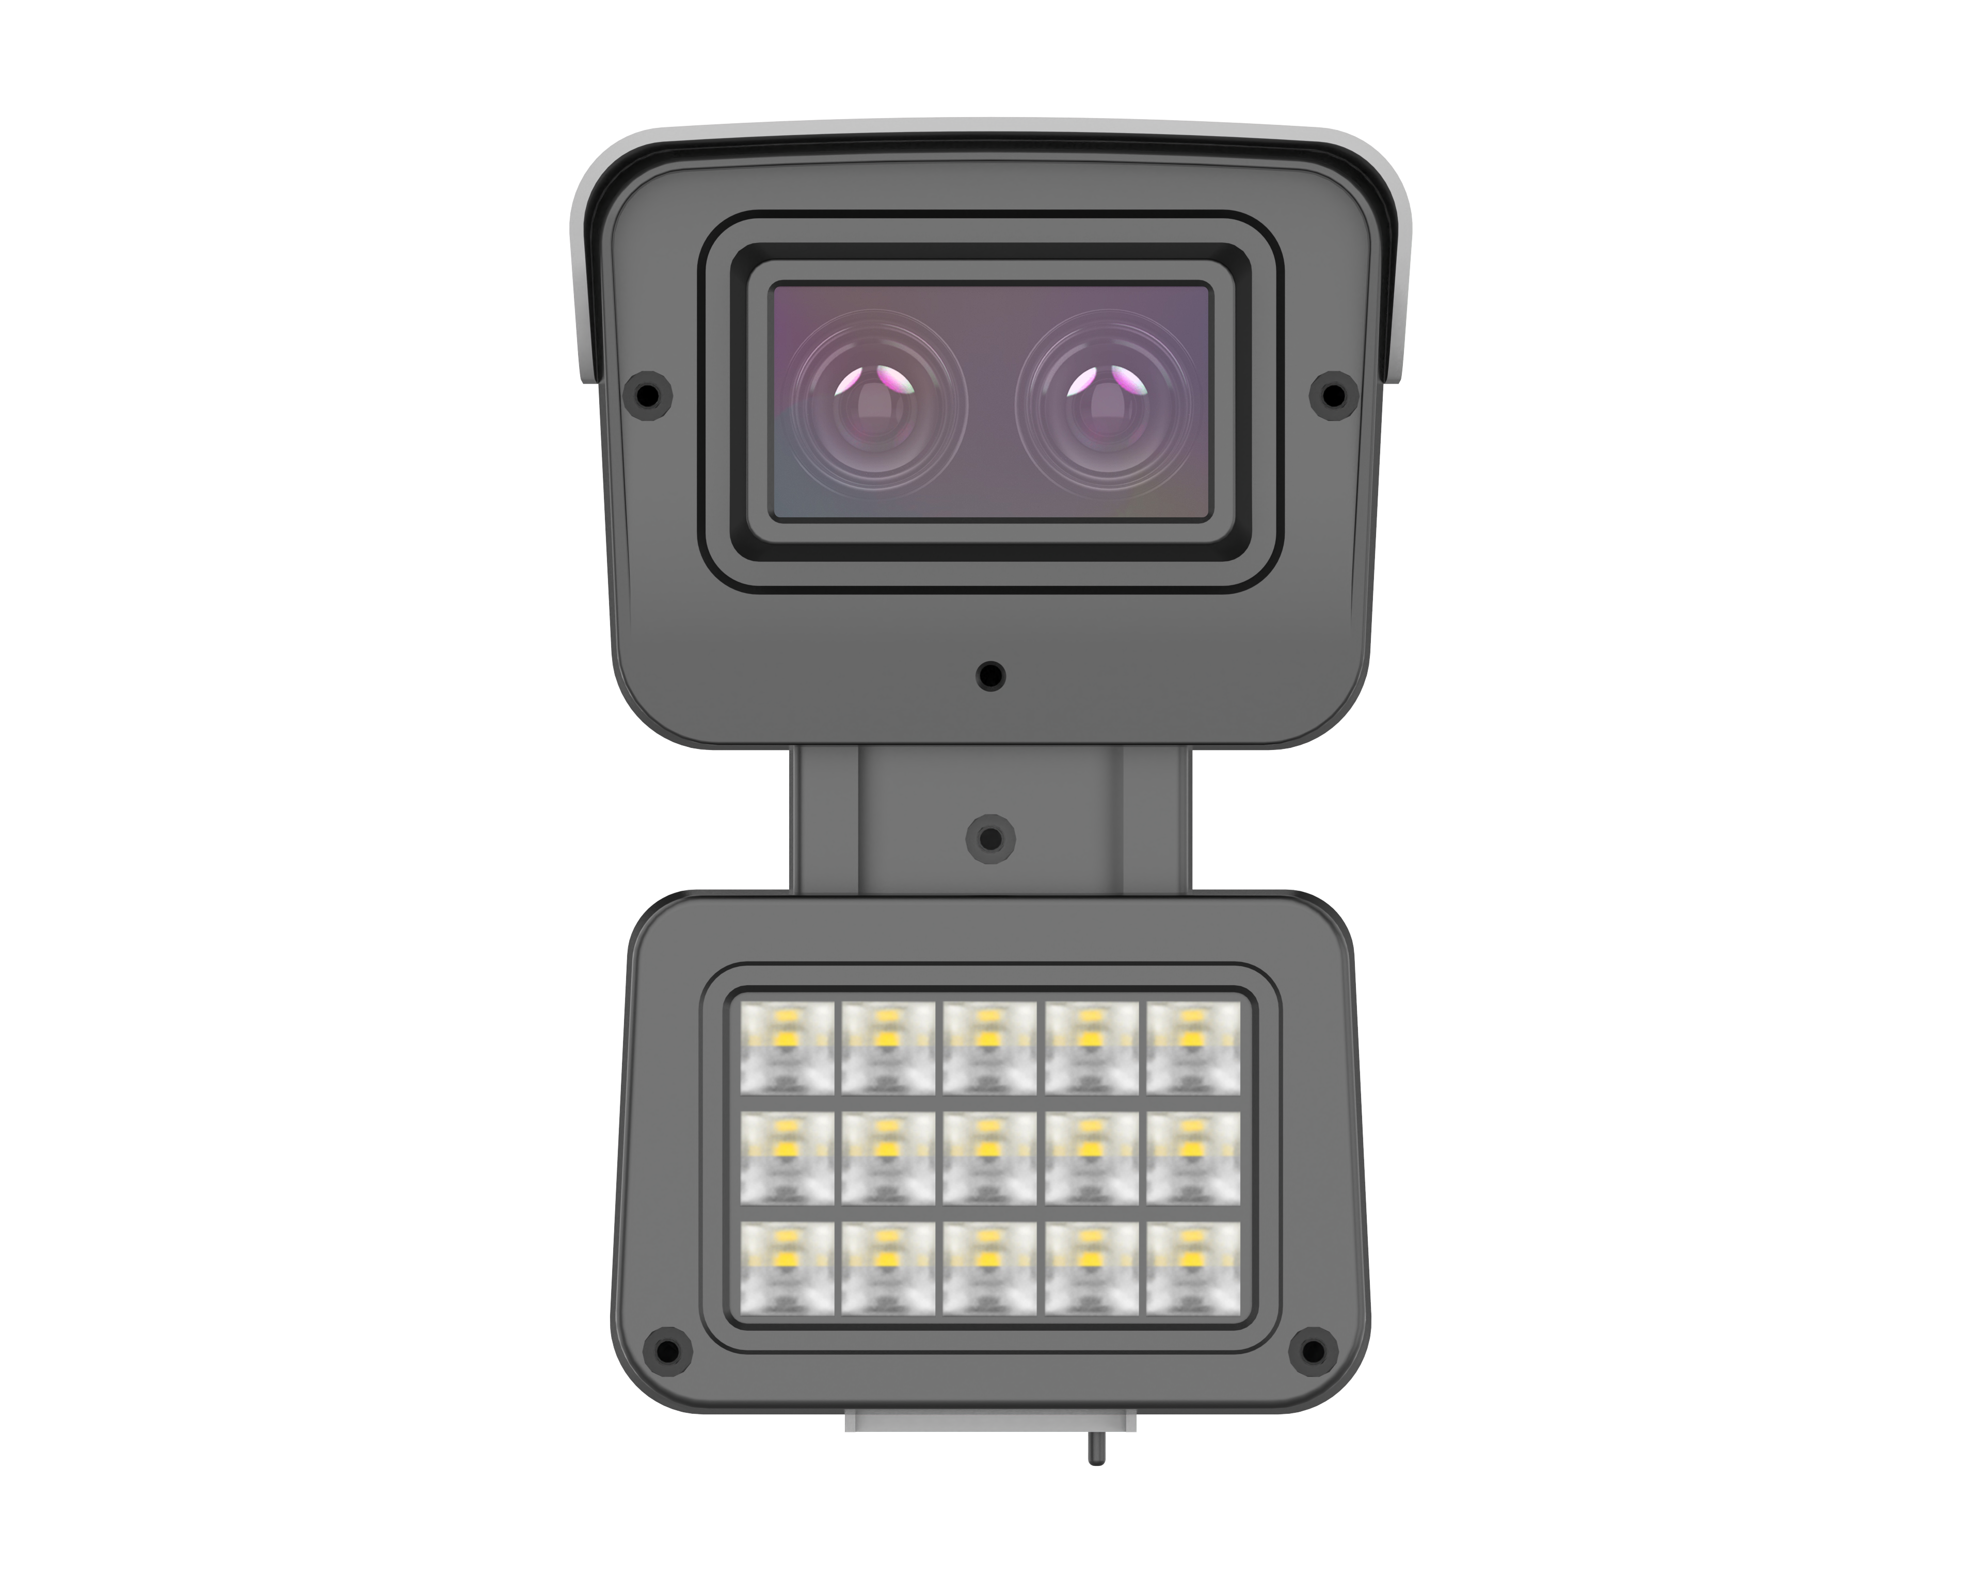
NexPro-DL9018WZ-DJ · Primary

PRODUCT OVERVIEW
Dual-lens fusion, Starlight full-color night vision, Hisilicon AI chip, human/vehicle detection, two-way audio
Product line | CCTV & Surveillance System
Series / family | Standalone model
Exact model | NexPro-DL9018WZ-DJ
Applications | Perimeter, Loading Dock, Industrial, Entrance
MODEL IDENTIFICATION
Exact model | Product / variant | Resolution | Lens 1 | AI
NexPro-DL9018WZ-DJ | NexPro 4MP Dual-Lens Starlight Full-Color Bullet (AI, Two-Way Audio) | 4MP Dual-Lens | F1.0 blue-wave | Hisilicon chip
TECHNICAL SPECIFICATIONS
Parameter | Specification
Resolution | 4MP Dual-Lens
Lens 1 | F1.0 blue-wave
AI | Hisilicon chip
Camera Type | 4MP Dual-Lens Starlight Full-Color Network Bullet Camera
Solution | Tianview TB53Q52
Processor | Hisilicon AI super-computing chip
Image Sensor | 1/2.7″ 4MP ultra-low-light Starlight CMOS
Lens 1 (Full-Color) | F1.0 5MP blue-wave lens — day-like full-color at night, no motion blur
Lens 2 (IR + Supplement) | F1.4 5MP lens — long-range IR + smart white light, dual-light fusion
Dual-Lens Fusion | Combines full-color detail with IR distance for perfect night imaging
AI Features | Human/vehicle detection, line crossing, intrusion region
Audio | Built-in two-way voice intercom
Quotation Type | Bulk project quotation
OEM/ODM | Available for selected orders
Documents | Datasheet and installation reference
Category | CCTV System
APPLICATIONS & RFQ CONFIRMATION
Typical applications | Confirm in the project RFQ
Perimeter  Loading Dock  Industrial  Entrance | Confirm the exact model and required configuration.  Confirm quantity, destination, packing, branding, and documentation requirements.
Project supply: MOQ — Confirm by project quantity · Lead time — Confirm by project list · FOB port — China main ports · OEM/ODM — Available; confirm project scope
PROJECT CONFIGURATION CHECKLIST
Exact model | NexPro-DL9018WZ-DJ
Application and site conditions | Confirm installation environment and operating requirements.
Quantity and model mix | Confirm forecast quantity, phase plan and required variants.
Interfaces and accessories | Confirm compatible interfaces, accessories and system integration scope.
Finish, branding and packing | Confirm only when project customization is required.
Documentation and destination | Confirm drawings, datasheets, packing documents and destination country or port.

