
CCTV & SURVEILLANCE SYSTEM

1070 Series
  - Models: NexPro-BL1070D3-4MP-TRI | NexPro-BL1070Y51-4MP-TRI | NexPro-BL1070M55-5MP-TRI
PRODUCT IMAGES
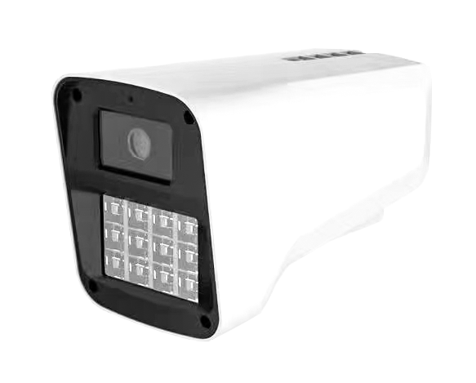
NexPro-BL1070D3-4MP-TRI · Primary

PRODUCT OVERVIEW
4MP full-color, triode lamp board, 24 LEDs (1W warm light), built-in mic, 4000V surge protection
Product line | CCTV & Surveillance System
Series / family | 1070
Exact model | NexPro-BL1070D3-4MP-TRI | NexPro-BL1070Y51-4MP-TRI | NexPro-BL1070M55-5MP-TRI
Applications | Large Perimeter, Parking Lot, Industrial Bay
MODEL COMPARISON
Exact model | Product / variant | Resolution | Lens | Illuminator
NexPro-BL1070D3-4MP-TRI | NexPro 4MP Bullet (Triode Lamp, 24-LED, Audio) | 4MP | F1.4 5MP fixed | 24-LED triode (1W)
NexPro-BL1070Y51-4MP-TRI | NexPro 4MP Bullet (5MP Sensor, Triode, 24-LED, Audio) | 4MP (5MP sensor) | F1.4 5MP fixed | 24-LED triode (1W)
NexPro-BL1070M55-5MP-TRI | NexPro 5MP Bullet (Triode Lamp, 24-LED, Audio) | 5MP | F1.4 5MP fixed | 24-LED triode (1W)
TECHNICAL SPECIFICATIONS
Parameter | NexPro-BL1070D3-4MP-TRI | NexPro-BL1070Y51-4MP-TRI | NexPro-BL1070M55-5MP-TRI
Resolution | 4MP (2560×1440) @ real-time | 4MP  (5MP sensor); 4MP (2560×1440) @ real-time (5MP sensor provides enhanced light sensitivity) | 5MP (2592×1944) @ real-time
Lens | F1.4 5MP fixed lens | F1.4 5MP fixed lens | F1.4 5MP fixed lens
Illuminator | 24-LED triode  (1W); 24-LED dual light (12×20mil IR + 12×1W high-power warm white) | 24-LED triode  (1W); 24-LED dual light (12×20mil IR + 12×1W warm white) | 24-LED triode  (1W); 24-LED dual light (12×20mil IR + 12×1W warm white)
Camera Type | 4MP Full-Color Network Bullet Camera with Triode Lamp Board | 4MP Full-Color Network Bullet Camera (5MP Sensor) | 5MP Full-Color Network Bullet Camera with Triode Lamp Board
Solution | Tianview TR38Y33 | Tianview TB38Y51 | Tianview TB38M55
Image Sensor | 1/2.7″ 4MP CMOS, low illumination | 1/2.7″ 5MP CMOS, low illumination | 1/2.7″ 5MP CMOS, low illumination
Lamp Board | Triode circuit design (high efficiency) | Triode circuit design | Triode circuit design
Audio | Built-in microphone | Built-in microphone | Built-in microphone
Protection | Metal front cover, 4000V lightning surge protection | Metal front cover, 4000V lightning surge protection | Metal front cover, 4000V lightning surge protection
Light Control | 3 switchable modes | 3 switchable modes | 3 switchable modes
Quotation Type | Bulk project quotation | Bulk project quotation | Bulk project quotation
OEM/ODM | Available for selected orders | Available for selected orders | Available for selected orders
Documents | Datasheet and installation reference | Datasheet and installation reference | Datasheet and installation reference
Category | CCTV System | CCTV System | CCTV System
APPLICATIONS & RFQ CONFIRMATION
Typical applications | Confirm in the project RFQ
Large Perimeter  Parking Lot  Industrial Bay  Perimeter  Loading Area  Industrial | Confirm the exact model and required configuration.  Confirm quantity, destination, packing, branding, and documentation requirements.
Project supply: MOQ — Confirm by project quantity · Lead time — Confirm by project list · FOB port — China main ports · OEM/ODM — Available; confirm project scope
PROJECT CONFIGURATION CHECKLIST
Exact model | NexPro-BL1070D3-4MP-TRI
Application and site conditions | Confirm installation environment and operating requirements.
Quantity and model mix | Confirm forecast quantity, phase plan and required variants.
Interfaces and accessories | Confirm compatible interfaces, accessories and system integration scope.
Finish, branding and packing | Confirm only when project customization is required.
Documentation and destination | Confirm drawings, datasheets, packing documents and destination country or port.

