
CCTV & SURVEILLANCE SYSTEM

NexPro 5MP ANPR Bullet (Black/White List, Traffic Stats, Dual Night Mode)
  - Exact model: NexPro-ANPR9017CP40Y-5MP
PRODUCT IMAGES
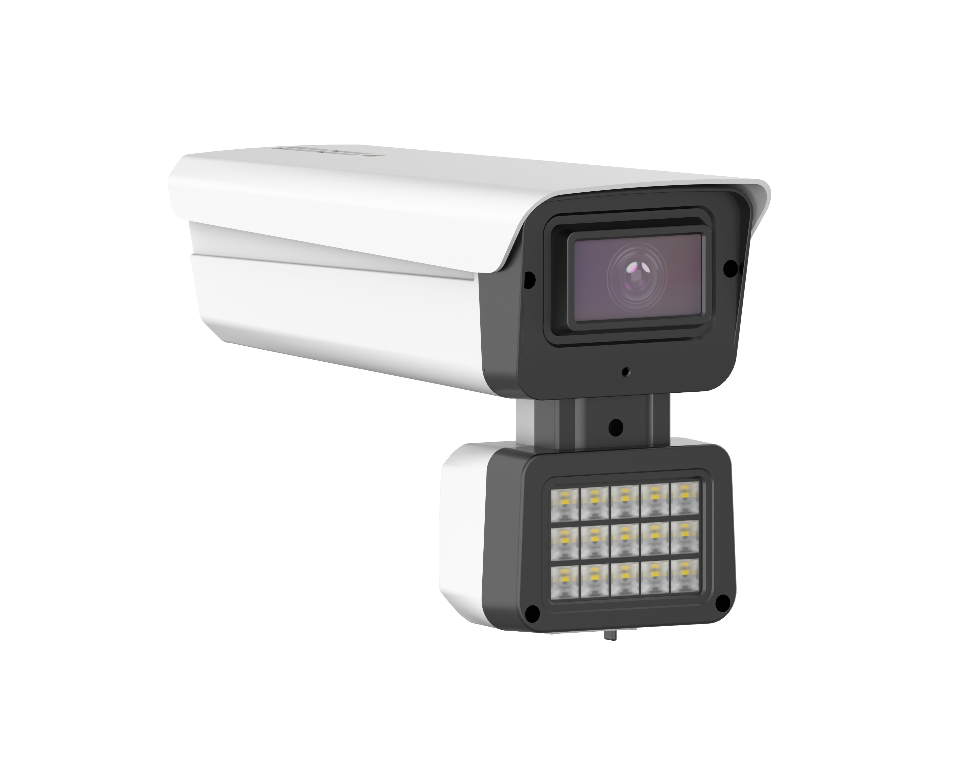
NexPro-ANPR9017CP40Y-5MP · Primary

PRODUCT OVERVIEW
5MP ANPR, built-in plate recognition, black/white list, vehicle counting, dual night mode (plate + full-color)
Product line | CCTV & Surveillance System
Series / family | Standalone model
Exact model | NexPro-ANPR9017CP40Y-5MP
Applications | Hotel Driveway, Factory Gate, Gated Community
MODEL IDENTIFICATION
Exact model | Product / variant | Resolution | ANPR | Night Mode
NexPro-ANPR9017CP40Y-5MP | NexPro 5MP ANPR Bullet (Black/White List, Traffic Stats, Dual Night Mode) | 5MP | Built-in engine | Dual (Plate + Full-Color)
TECHNICAL SPECIFICATIONS
Parameter | Specification
Resolution | 5MP
ANPR | Built-in engine
Night Mode | Dual  (Plate + Full-Color); Dual mode: auto plate capture on approach, full-color scene on departure
Camera Type | 5MP Automatic Number Plate Recognition  (ANPR) Network Bullet Camera
Image Sensor | 5MP, H.265
Lens | Fixed F1.4 lens
ANPR Engine | Dedicated built-in plate recognition, blacklist/whitelist/stranger management, image & video search by plate
Statistics | Vehicle entry/exit counting and statistics
Quotation Type | Bulk project quotation
OEM/ODM | Available for selected orders
Documents | Datasheet and installation reference
Category | CCTV System
APPLICATIONS & RFQ CONFIRMATION
Typical applications | Confirm in the project RFQ
Hotel Driveway  Factory Gate  Gated Community | Confirm the exact model and required configuration.  Confirm quantity, destination, packing, branding, and documentation requirements.
Project supply: MOQ — Confirm by project quantity · Lead time — Confirm by project list · FOB port — China main ports · OEM/ODM — Available; confirm project scope
PROJECT CONFIGURATION CHECKLIST
Exact model | NexPro-ANPR9017CP40Y-5MP
Application and site conditions | Confirm installation environment and operating requirements.
Quantity and model mix | Confirm forecast quantity, phase plan and required variants.
Interfaces and accessories | Confirm compatible interfaces, accessories and system integration scope.
Finish, branding and packing | Confirm only when project customization is required.
Documentation and destination | Confirm drawings, datasheets, packing documents and destination country or port.

