
CCTV & SURVEILLANCE SYSTEM

NexPro 5MP High-Altitude Object Detection Camera (Built-in Algorithm)
  - Exact model: NexPro-SC1040M15-GK
PRODUCT IMAGES
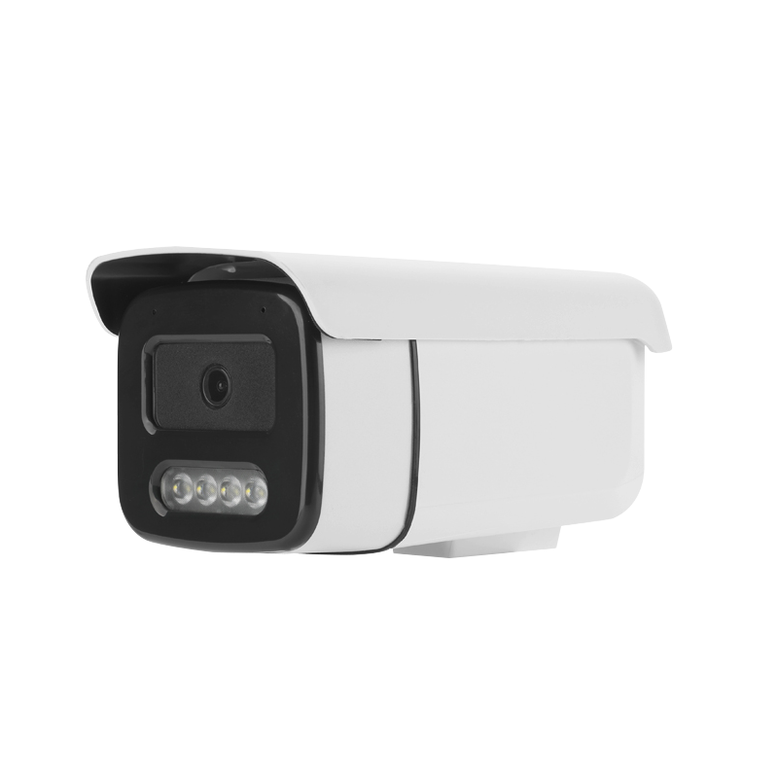
NexPro-SC1040M15-GK · Primary

PRODUCT OVERVIEW
5MP, built-in falling object trajectory algorithm, dedicated for high-rise littering surveillance
Product line | CCTV & Surveillance System
Series / family | Standalone model
Exact model | NexPro-SC1040M15-GK
Applications | Residential Tower, Commercial High-Rise, Property Management
MODEL IDENTIFICATION
Exact model | Product / variant | Resolution | Algorithm | Use Case
NexPro-SC1040M15-GK | NexPro 5MP High-Altitude Object Detection Camera (Built-in Algorithm) | 5MP | Built-in trajectory | High-rise anti-littering
TECHNICAL SPECIFICATIONS
Parameter | Specification
Resolution | 5MP
Algorithm | Built-in trajectory
Use Case | High-rise anti-littering
Camera Type | 5MP High-Altitude Object Detection Network Camera
Solution | SSC30KD + SmartSens SC500AI
Image Sensor | 1/2.7″ 5MP CMOS, H.265 encoding
Special Feature | Built-in object falling trajectory algorithm for high-rise littering and falling object monitoring
Application | Residential and commercial high-rise perimeters
Quotation Type | Bulk project quotation
OEM/ODM | Available for selected orders
Documents | Datasheet and installation reference
Category | CCTV System
APPLICATIONS & RFQ CONFIRMATION
Typical applications | Confirm in the project RFQ
Residential Tower  Commercial High-Rise  Property Management | Confirm the exact model and required configuration.  Confirm quantity, destination, packing, branding, and documentation requirements.
Project supply: MOQ — Confirm by project quantity · Lead time — Confirm by project list · FOB port — China main ports · OEM/ODM — Available; confirm project scope
PROJECT CONFIGURATION CHECKLIST
Exact model | NexPro-SC1040M15-GK
Application and site conditions | Confirm installation environment and operating requirements.
Quantity and model mix | Confirm forecast quantity, phase plan and required variants.
Interfaces and accessories | Confirm compatible interfaces, accessories and system integration scope.
Finish, branding and packing | Confirm only when project customization is required.
Documentation and destination | Confirm drawings, datasheets, packing documents and destination country or port.

