
CCTV & SURVEILLANCE SYSTEM

NexPro 7MP Dual-Light PTZ+Bullet Combo (Wi-Fi 6, 6x+8x Zoom, AI Tracking)
  - Exact model: NexPro-PTN008CK50Y-7MP
PRODUCT IMAGES
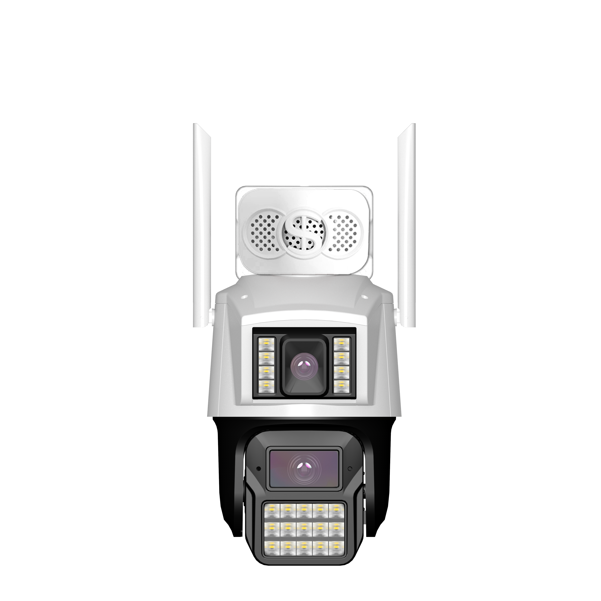
NexPro-PTN008CK50Y-7MP · Primary

PRODUCT OVERVIEW
7MP dual-camera, 4MP+3MP dual-light, 6x bullet + 8x PTZ zoom, AI tracking, custom voice, single IP dual stream
Product line | CCTV & Surveillance System
Series / family | Standalone model
Exact model | NexPro-PTN008CK50Y-7MP
Applications | Large Courtyard, Warehouse, Villa
MODEL IDENTIFICATION
Exact model | Product / variant | Resolution | Lens | Zoom
NexPro-PTN008CK50Y-7MP | NexPro 7MP Dual-Light PTZ+Bullet Combo (Wi-Fi 6, 6x+8x Zoom, AI Tracking) | 4MP Bullet + 3MP PTZ | F1.0 blacklight ×2 | 6x + 8x
TECHNICAL SPECIFICATIONS
Parameter | Specification
Resolution | 4MP Bullet + 3MP PTZ
Lens | F1.0 blacklight ×2
Zoom | 6x + 8x
Camera Type | 7MP Dual-Camera Dual-Light PTZ+Bullet Combo
Solution | Tianview TD53N31
Dual Camera | 4MP bullet  (F1.0 blacklight, 8×1W warm LEDs, 6x zoom) + 3MP PTZ (F1.0 blacklight, 15×1W warm LEDs, 8x zoom)
Single IP | App & NVR compatible, single IP adds two channels
AI Features | Custom area human/vehicle detection, human tracking, custom voice deterrence
Audio | Multimedia speaker & mic, two-way intercom
PTZ | 355° pan, 90° tilt
Wireless | Wi-Fi 6, Bluetooth, RJ45, app signal rate detection
Quotation Type | Bulk project quotation
OEM/ODM | Available for selected orders
Documents | Datasheet and installation reference
Category | CCTV System
APPLICATIONS & RFQ CONFIRMATION
Typical applications | Confirm in the project RFQ
Large Courtyard  Warehouse  Villa | Confirm the exact model and required configuration.  Confirm quantity, destination, packing, branding, and documentation requirements.
Project supply: MOQ — Confirm by project quantity · Lead time — Confirm by project list · FOB port — China main ports · OEM/ODM — Available; confirm project scope
PROJECT CONFIGURATION CHECKLIST
Exact model | NexPro-PTN008CK50Y-7MP
Application and site conditions | Confirm installation environment and operating requirements.
Quantity and model mix | Confirm forecast quantity, phase plan and required variants.
Interfaces and accessories | Confirm compatible interfaces, accessories and system integration scope.
Finish, branding and packing | Confirm only when project customization is required.
Documentation and destination | Confirm drawings, datasheets, packing documents and destination country or port.

