
CCTV & SURVEILLANCE SYSTEM

NexPro 5MP 10-inch Full-Color Laser PTZ (25x, 200m, AI Human+Vehicle, TF)
  - Exact model: NexPro-PTL10-5MP-25X-FC
PRODUCT IMAGES
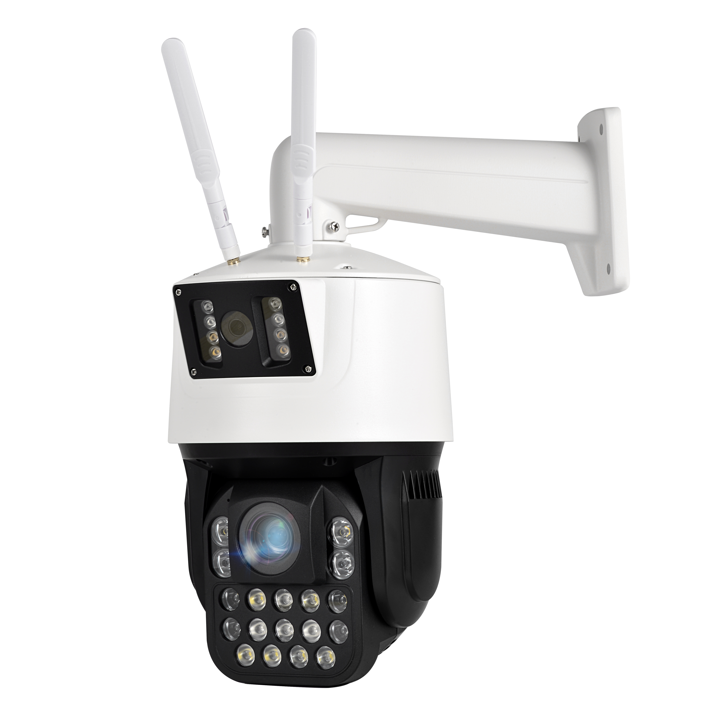
NexPro-PTL10-5MP-25X-FC · Primary

PRODUCT OVERVIEW
5MP, 25x zoom, 15 laser warm LEDs, 200m full-color, AI detection & tracking, onboard TF, voice, NVR popup
Product line | CCTV & Surveillance System
Series / family | PTL10
Exact model | NexPro-PTL10-5MP-25X-FC
Applications | Forensic Perimeter, Critical Infrastructure, Port
MODEL IDENTIFICATION
Exact model | Product / variant | Resolution | Zoom | Illuminator
NexPro-PTL10-5MP-25X-FC | NexPro 5MP 10-inch Full-Color Laser PTZ (25x, 200m, AI Human+Vehicle, TF) | 5MP | 25x optical | 15-laser full-color 200m
TECHNICAL SPECIFICATIONS
Parameter | Specification
Resolution | 5MP
Zoom | 25x optical
Illuminator | 15-laser full-color 200m; 15 high-power laser warm white LEDs, 200m full-color
Camera Type | 10-inch 5MP Laser Full-Color PTZ Camera
Solution | Tianview customized platform
Image Sensor | 5MP, H.265, 25fps, built-in TF card
Lens | 25x optical zoom, F1.4, 5.3mm–130mm
AI Features | Human & vehicle detection, tracking, line crossing, area intrusion, custom voice, popup, offline push
Audio | External speaker support, two-way intercom
Alarm | NVR popup, offline push
Quotation Type | Bulk project quotation
OEM/ODM | Available for selected orders
Documents | Datasheet and installation reference
Category | CCTV System
APPLICATIONS & RFQ CONFIRMATION
Typical applications | Confirm in the project RFQ
Forensic Perimeter  Critical Infrastructure  Port | Confirm the exact model and required configuration.  Confirm quantity, destination, packing, branding, and documentation requirements.
Project supply: MOQ — Confirm by project quantity · Lead time — Confirm by project list · FOB port — China main ports · OEM/ODM — Available; confirm project scope
PROJECT CONFIGURATION CHECKLIST
Exact model | NexPro-PTL10-5MP-25X-FC
Application and site conditions | Confirm installation environment and operating requirements.
Quantity and model mix | Confirm forecast quantity, phase plan and required variants.
Interfaces and accessories | Confirm compatible interfaces, accessories and system integration scope.
Finish, branding and packing | Confirm only when project customization is required.
Documentation and destination | Confirm drawings, datasheets, packing documents and destination country or port.

