
CCTV & SURVEILLANCE SYSTEM

NexPro 4MP 10-inch Laser Active Deterrence PTZ (40x Zoom, 150m IR, AI Tracking)
  - Exact model: NexPro-PTL10-4MP-40X
PRODUCT IMAGES
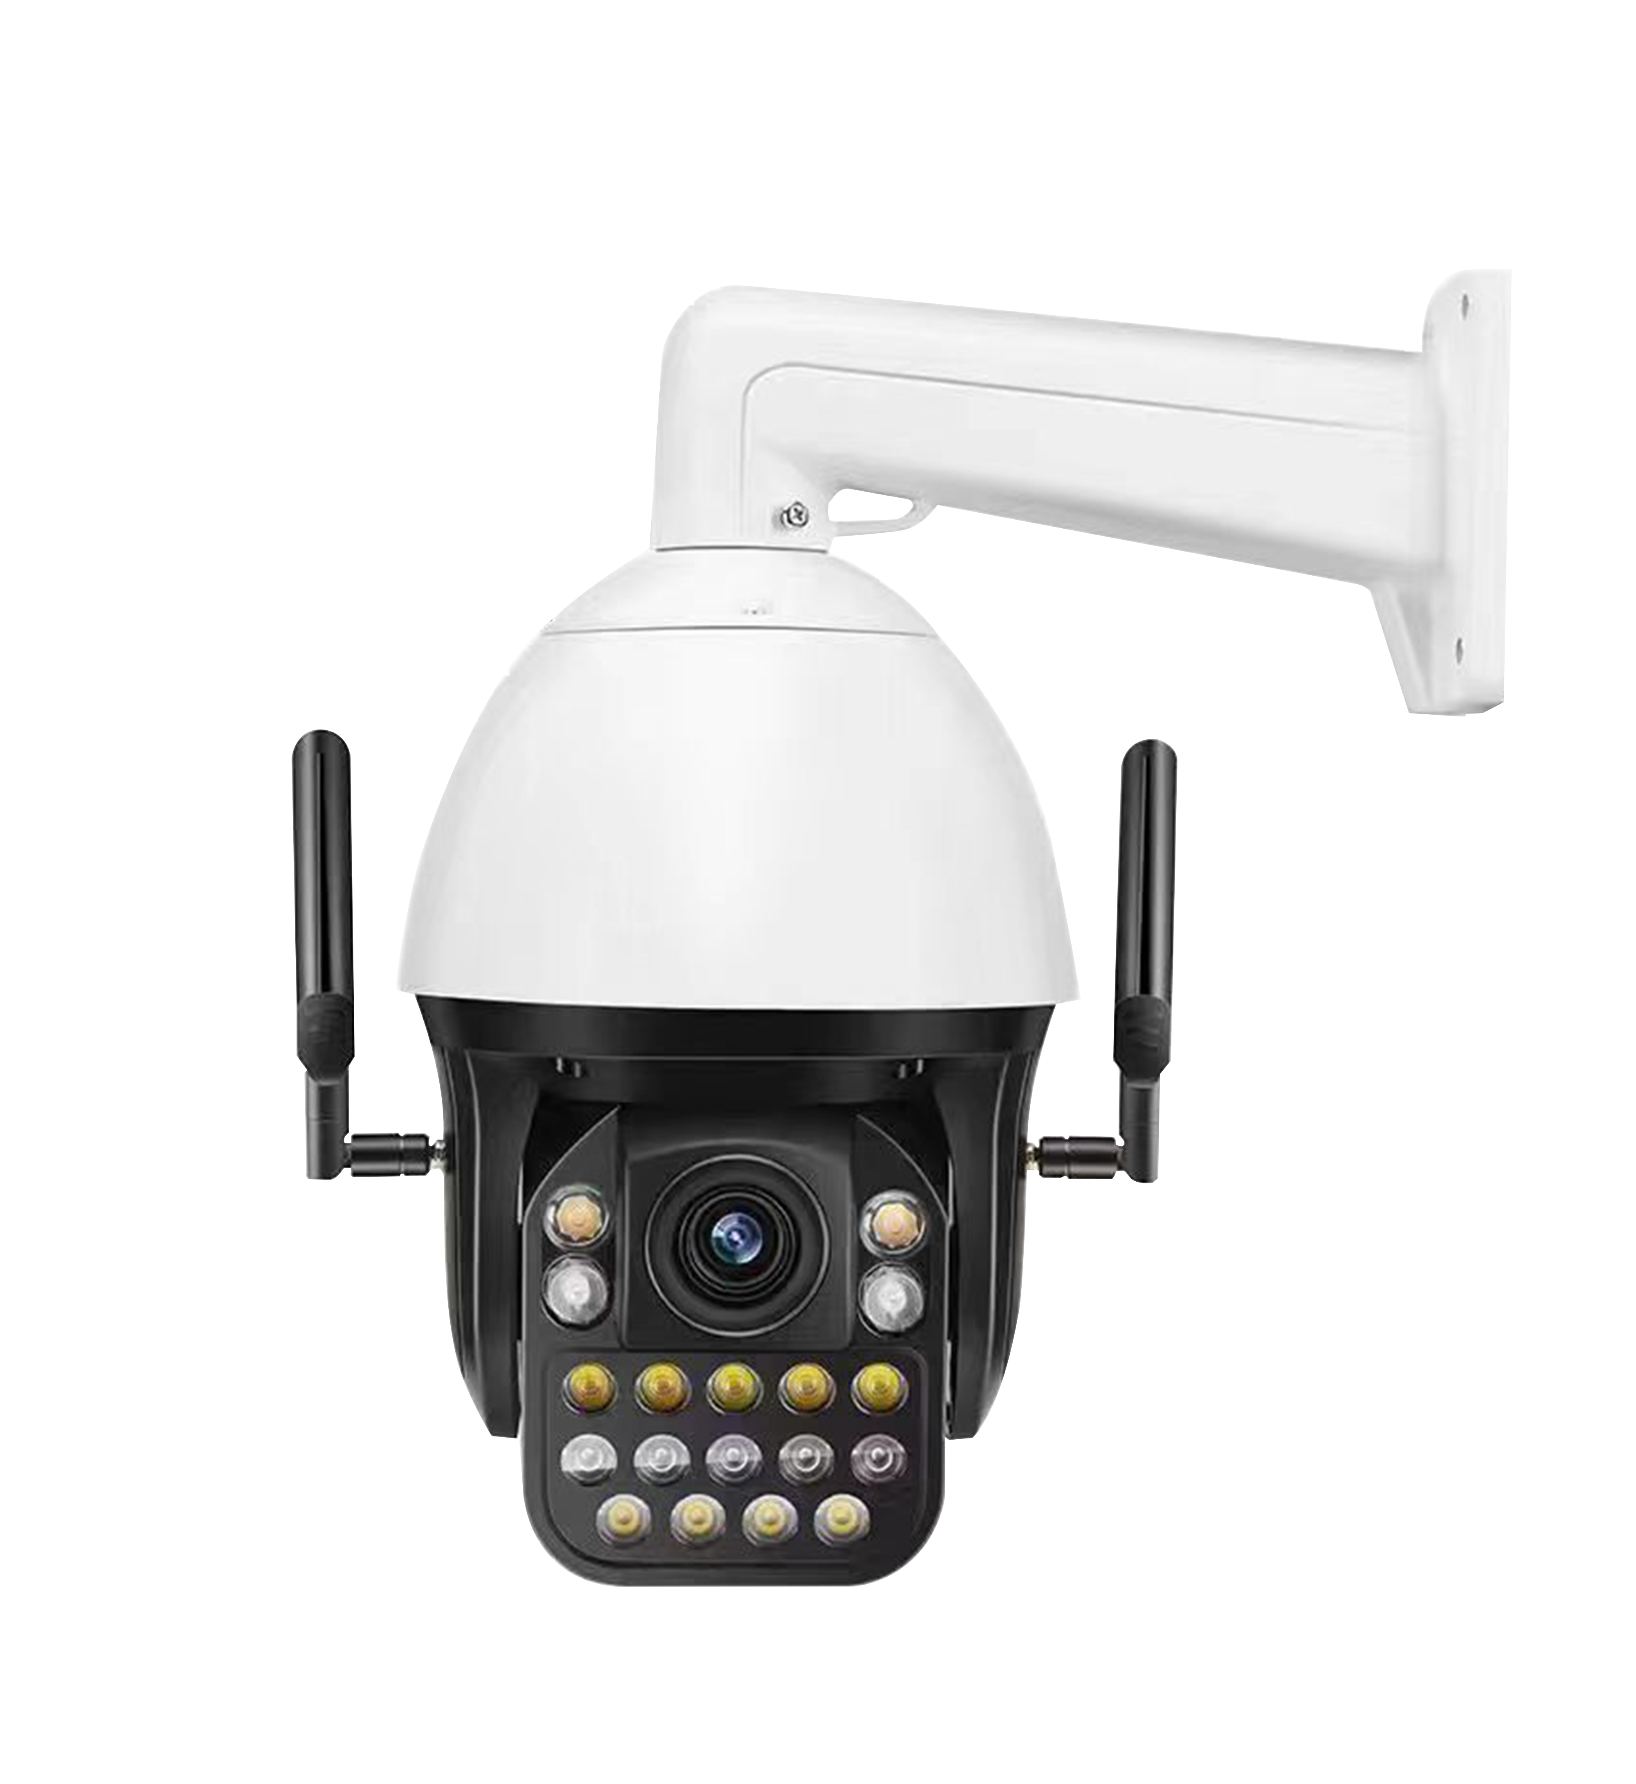
NexPro-PTL10-4MP-40X · Primary

PRODUCT OVERVIEW
4MP, 40x optical zoom, 7 laser IR + 11 warm LEDs, 150m illumination, AI 3-target detection, tracking, area alert, two-way audio, NVR popup, offline push
Product line | CCTV & Surveillance System
Series / family | PTL10
Exact model | NexPro-PTL10-4MP-40X
Applications | Large Perimeter, Industrial Compound, Oil & Gas
MODEL IDENTIFICATION
Exact model | Product / variant | Resolution | Zoom | Illuminator
NexPro-PTL10-4MP-40X | NexPro 4MP 10-inch Laser Active Deterrence PTZ (40x Zoom, 150m IR, AI Tracking) | 4MP | 40x optical | Laser IR + Warm LED
TECHNICAL SPECIFICATIONS
Parameter | Specification
Resolution | 4MP
Zoom | 40x optical
Illuminator | Laser IR + Warm LED; 7 laser IR LEDs + 11 warm white LEDs, 150m illumination
Camera Type | 10-inch 4MP Laser Dual-Light Active Deterrence PTZ Camera
Solution | Tianview Z20 platform
Image Sensor | 4MP, H.265 encoding, 25fps
Lens | 40x optical zoom, F1.6, 4.7mm–84.6mm
AI Features | 3-target human detection, tracking, line crossing & area intrusion alert, popup, offline push
Audio | External speaker support, two-way voice intercom
Alarm | NVR popup alert, offline mobile push
Quotation Type | Bulk project quotation
OEM/ODM | Available for selected orders
Documents | Datasheet and installation reference
Category | CCTV System
APPLICATIONS & RFQ CONFIRMATION
Typical applications | Confirm in the project RFQ
Large Perimeter  Industrial Compound  Oil & Gas | Confirm the exact model and required configuration.  Confirm quantity, destination, packing, branding, and documentation requirements.
Project supply: MOQ — Confirm by project quantity · Lead time — Confirm by project list · FOB port — China main ports · OEM/ODM — Available; confirm project scope
PROJECT CONFIGURATION CHECKLIST
Exact model | NexPro-PTL10-4MP-40X
Application and site conditions | Confirm installation environment and operating requirements.
Quantity and model mix | Confirm forecast quantity, phase plan and required variants.
Interfaces and accessories | Confirm compatible interfaces, accessories and system integration scope.
Finish, branding and packing | Confirm only when project customization is required.
Documentation and destination | Confirm drawings, datasheets, packing documents and destination country or port.

