
CCTV & SURVEILLANCE SYSTEM

NexPro 6MP 8-inch Dual-Lens Starlight PTZ (Heavy-Duty, Wi-Fi 6, V3.0 Hinge)
  - Exact model: NexPro-PT8052WZ-6MP
PRODUCT IMAGES
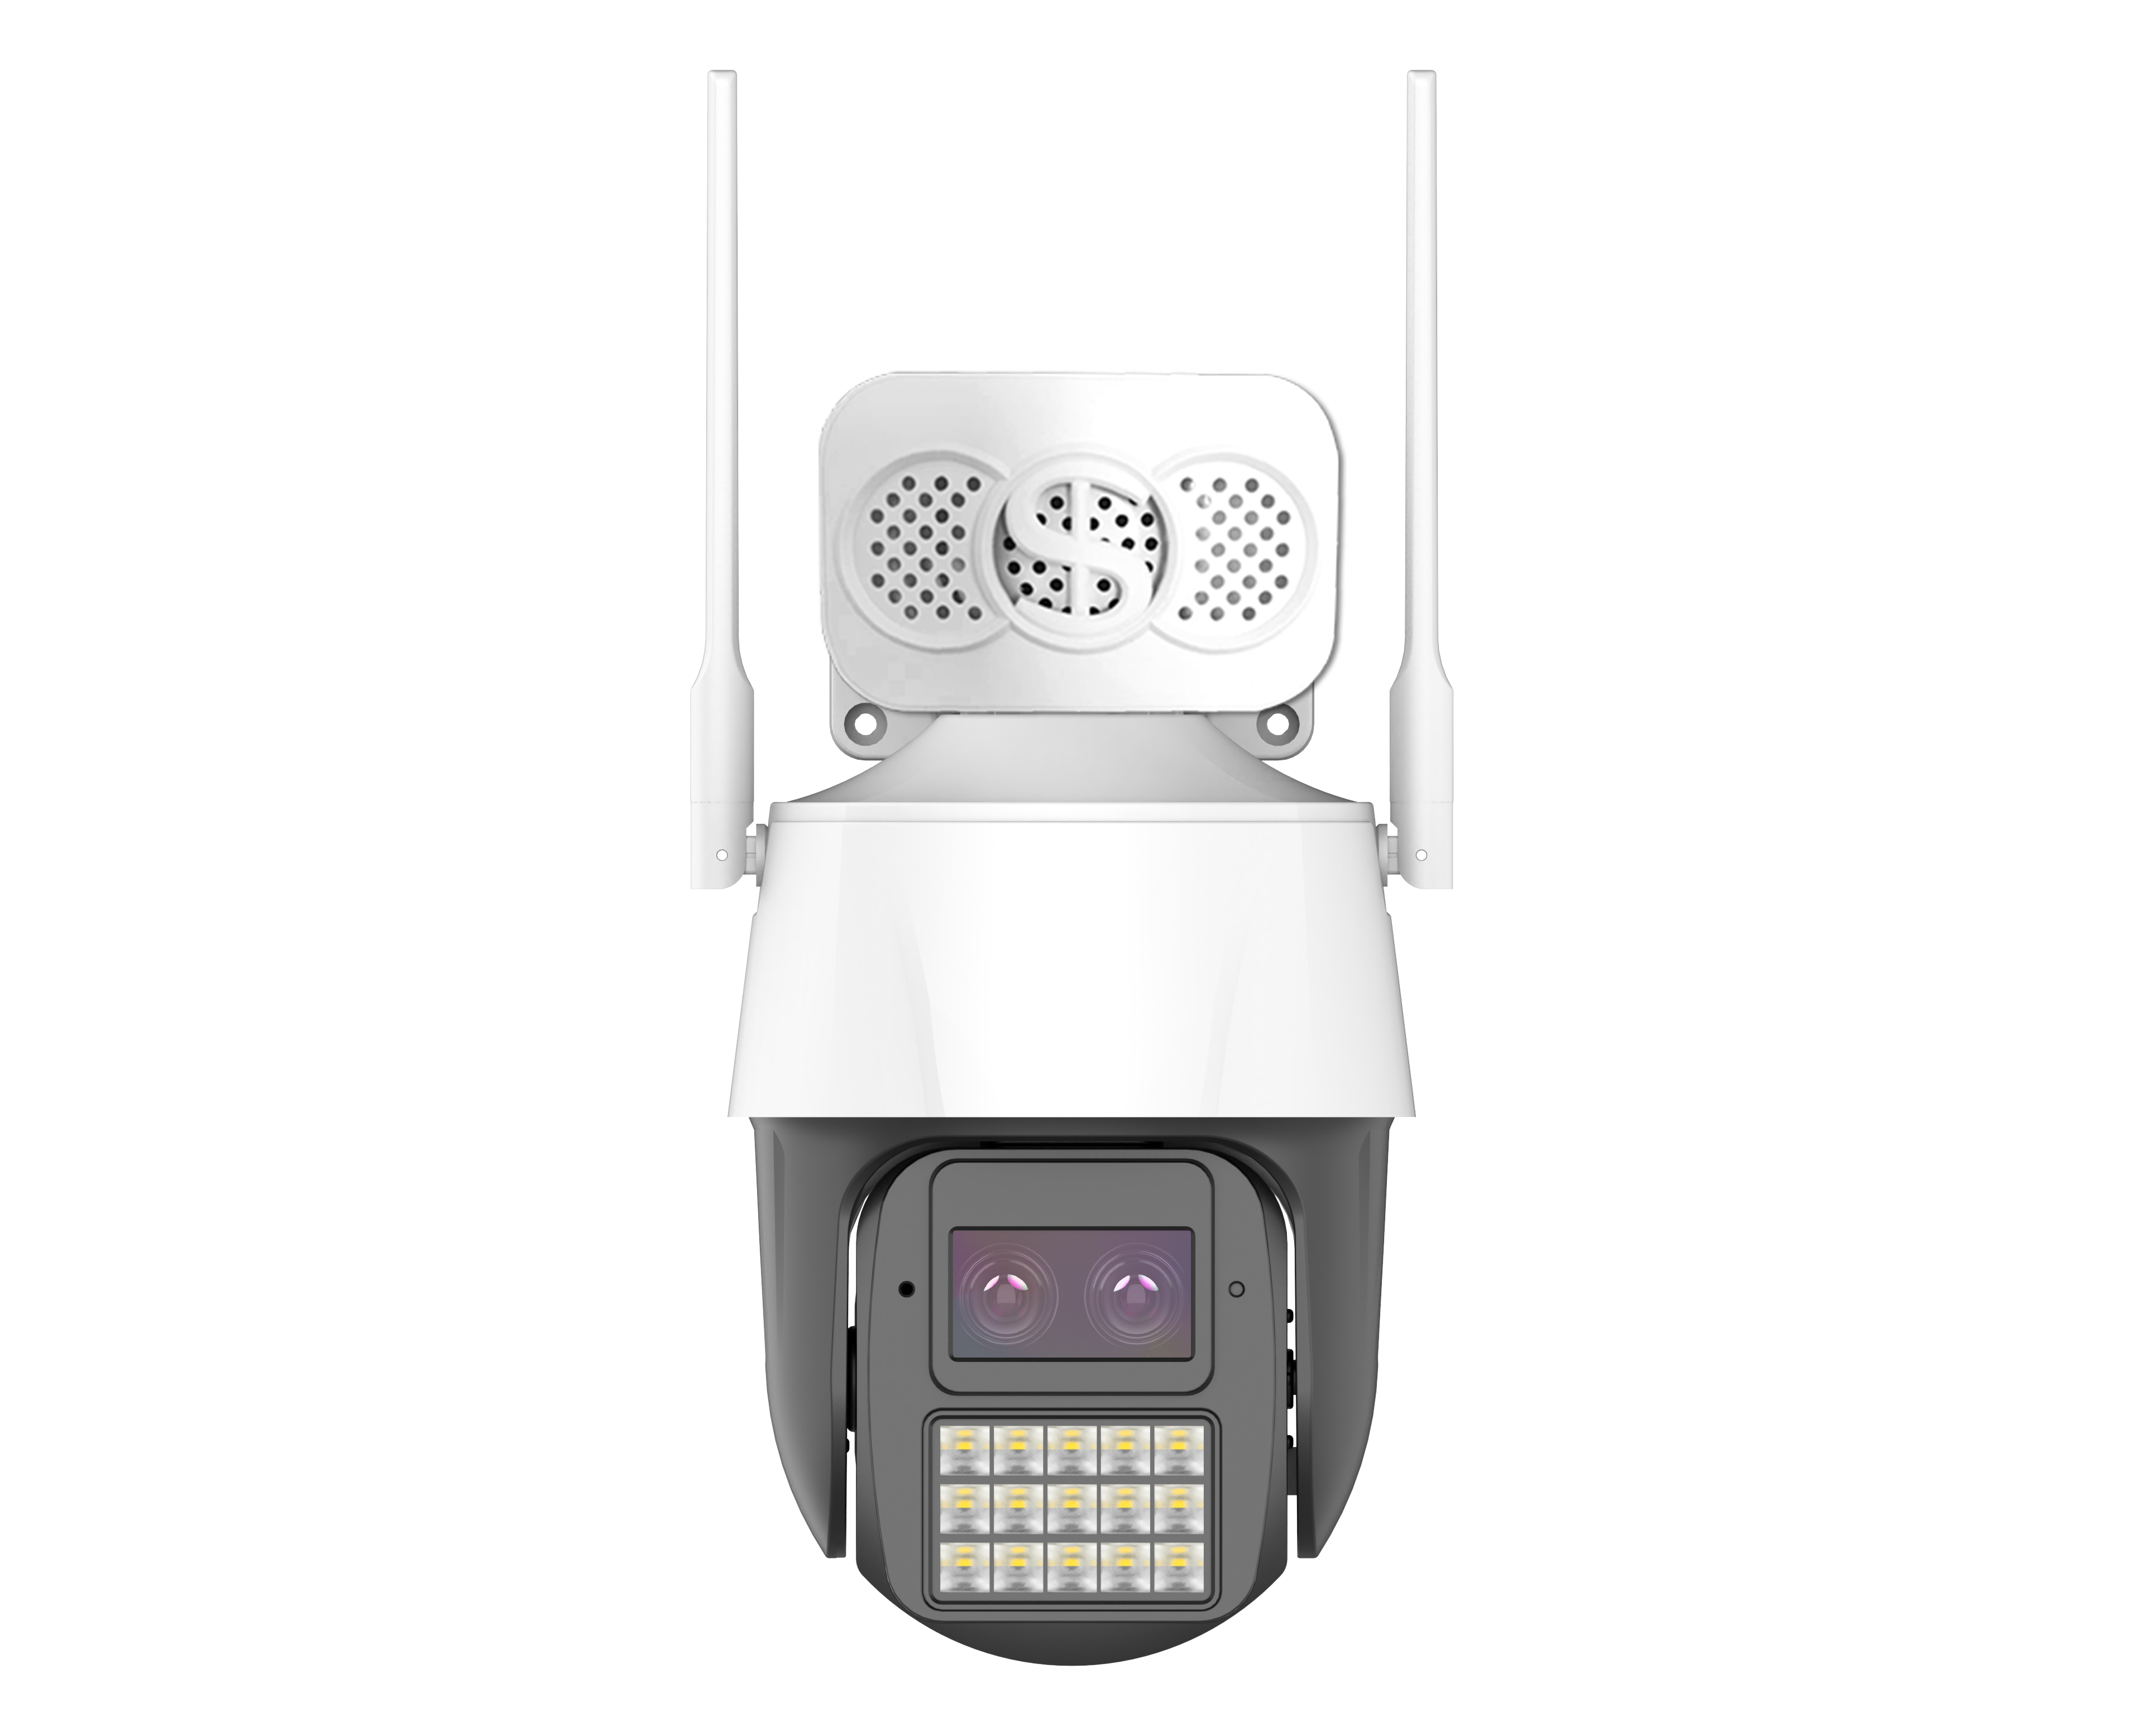
NexPro-PT8052WZ-6MP · Primary

PRODUCT OVERVIEW
8-inch, 6MP dual-lens, F1.0, Hisilicon AI, 8 high-power LEDs, Wi-Fi 6, V3.0 300k-cycle hinge
Product line | CCTV & Surveillance System
Series / family | Standalone model
Exact model | NexPro-PT8052WZ-6MP
Applications | Large Perimeter, Industrial, Public Space
MODEL IDENTIFICATION
Exact model | Product / variant | Resolution | Form Factor | Hinge
NexPro-PT8052WZ-6MP | NexPro 6MP 8-inch Dual-Lens Starlight PTZ (Heavy-Duty, Wi-Fi 6, V3.0 Hinge) | 6MP Dual-Lens | 8-inch heavy-duty | V3.0 300k-cycle
TECHNICAL SPECIFICATIONS
Parameter | Specification
Resolution | 6MP Dual-Lens
Form Factor | 8-inch heavy-duty
Hinge | V3.0 300k-cycle
Camera Type | 8-inch Heavy-Duty Dual-Lens Starlight PTZ with V3.0 Hinge
Solution | Tianview TD53D52, Hisilicon AI chip
Image Sensor | 1/2.7″ 4MP ultra-low-light Starlight CMOS, dual-lens fusion
Lens 1 (Full-Color) | F1.0 5MP YTOT blue-wave lens
Lens 2 (IR) | F1.4 5MP lens, long-range IR + smart white light
Illuminator | 8 high-power IR + 8 high-power warm white LEDs
AI Features | Human/vehicle detection, line crossing, area alert
Audio | Built-in speaker & mic
Wireless | Wi-Fi 6, Bluetooth, RJ45
Quotation Type | Bulk project quotation
OEM/ODM | Available for selected orders
Documents | Datasheet and installation reference
Category | CCTV System
APPLICATIONS & RFQ CONFIRMATION
Typical applications | Confirm in the project RFQ
Large Perimeter  Industrial  Public Space | Confirm the exact model and required configuration.  Confirm quantity, destination, packing, branding, and documentation requirements.
Project supply: MOQ — Confirm by project quantity · Lead time — Confirm by project list · FOB port — China main ports · OEM/ODM — Available; confirm project scope
PROJECT CONFIGURATION CHECKLIST
Exact model | NexPro-PT8052WZ-6MP
Application and site conditions | Confirm installation environment and operating requirements.
Quantity and model mix | Confirm forecast quantity, phase plan and required variants.
Interfaces and accessories | Confirm compatible interfaces, accessories and system integration scope.
Finish, branding and packing | Confirm only when project customization is required.
Documentation and destination | Confirm drawings, datasheets, packing documents and destination country or port.

