
CCTV & SURVEILLANCE SYSTEM

NexPro 4MP Wi-Fi 6 PTZ (AI Detection, Custom Voice, No Strobe)
  - Exact model: NexPro-PT6100J20-4MP
PRODUCT IMAGES
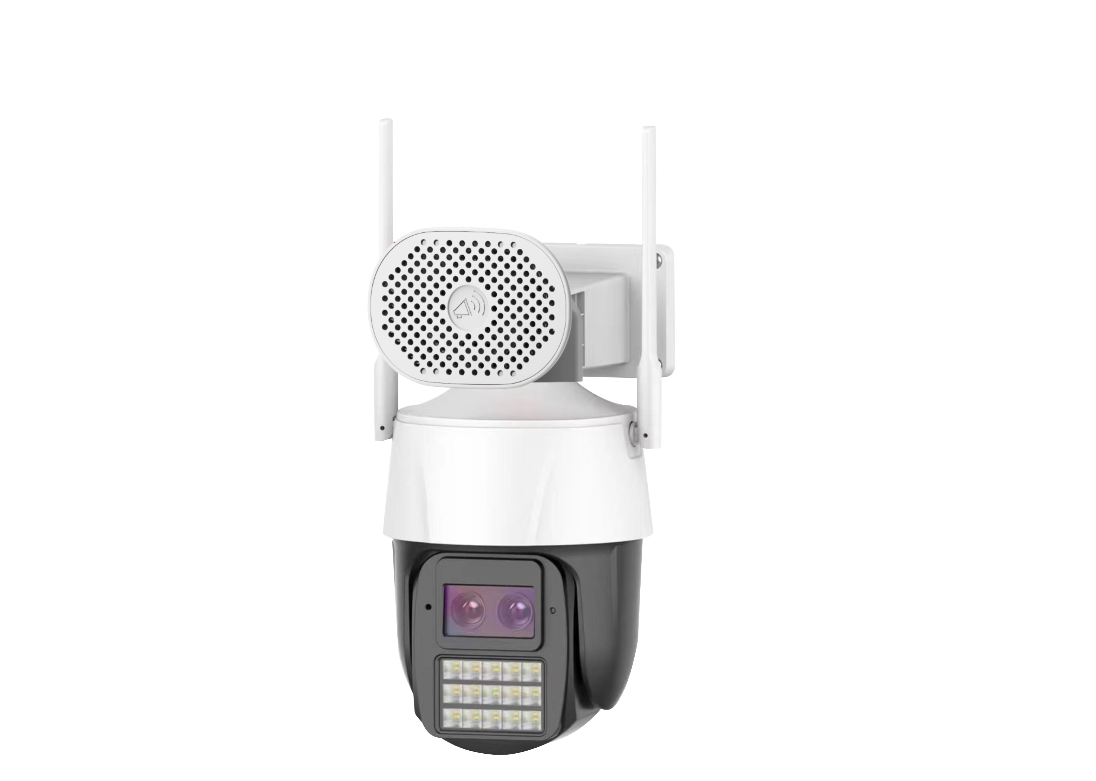
NexPro-PT6100J20-4MP · Primary

PRODUCT OVERVIEW
4MP, Wi-Fi 6, AI human/vehicle detection, custom voice deterrence, area alert, 256GB SD
Product line | CCTV & Surveillance System
Series / family | Standalone model
Exact model | NexPro-PT6100J20-4MP
Applications | Retail, Office, Courtyard
MODEL IDENTIFICATION
Exact model | Product / variant | Resolution | AI | Audio
NexPro-PT6100J20-4MP | NexPro 4MP Wi-Fi 6 PTZ (AI Detection, Custom Voice, No Strobe) | 4MP | Human + Vehicle | Custom Voice Alerts
TECHNICAL SPECIFICATIONS
Parameter | Specification
Resolution | 4MP
AI | Human + Vehicle
Audio | Custom Voice Alerts; Built-in speaker & mic, customizable voice alerts, two-way intercom
Camera Type | 4MP Wi-Fi 6 PTZ Camera with AI Analytics & Custom Voice
Solution | Tianview TD53J20
Image Sensor | 1/2.7″ 4MP low illumination CMOS
Lens | F1.4 5MP starlight lens
Illuminator | 12 IR + 12×1W warm white LEDs, dual-light full-color
AI Features | Human/vehicle detection, line crossing, area intrusion, face over-exposure prevention
PTZ | 355° pan, 90° tilt
Wireless | Wi-Fi 6, Bluetooth, RJ45
Quotation Type | Bulk project quotation
OEM/ODM | Available for selected orders
Documents | Datasheet and installation reference
Category | CCTV System
APPLICATIONS & RFQ CONFIRMATION
Typical applications | Confirm in the project RFQ
Retail  Office  Courtyard | Confirm the exact model and required configuration.  Confirm quantity, destination, packing, branding, and documentation requirements.
Project supply: MOQ — Confirm by project quantity · Lead time — Confirm by project list · FOB port — China main ports · OEM/ODM — Available; confirm project scope
PROJECT CONFIGURATION CHECKLIST
Exact model | NexPro-PT6100J20-4MP
Application and site conditions | Confirm installation environment and operating requirements.
Quantity and model mix | Confirm forecast quantity, phase plan and required variants.
Interfaces and accessories | Confirm compatible interfaces, accessories and system integration scope.
Finish, branding and packing | Confirm only when project customization is required.
Documentation and destination | Confirm drawings, datasheets, packing documents and destination country or port.

