
CCTV & SURVEILLANCE SYSTEM

NexPro 3MP Wi-Fi 6 PTZ (Top Speaker, 15-LED Dual-Light)
  - Exact model: NexPro-PT6100CK-3MP
PRODUCT IMAGES
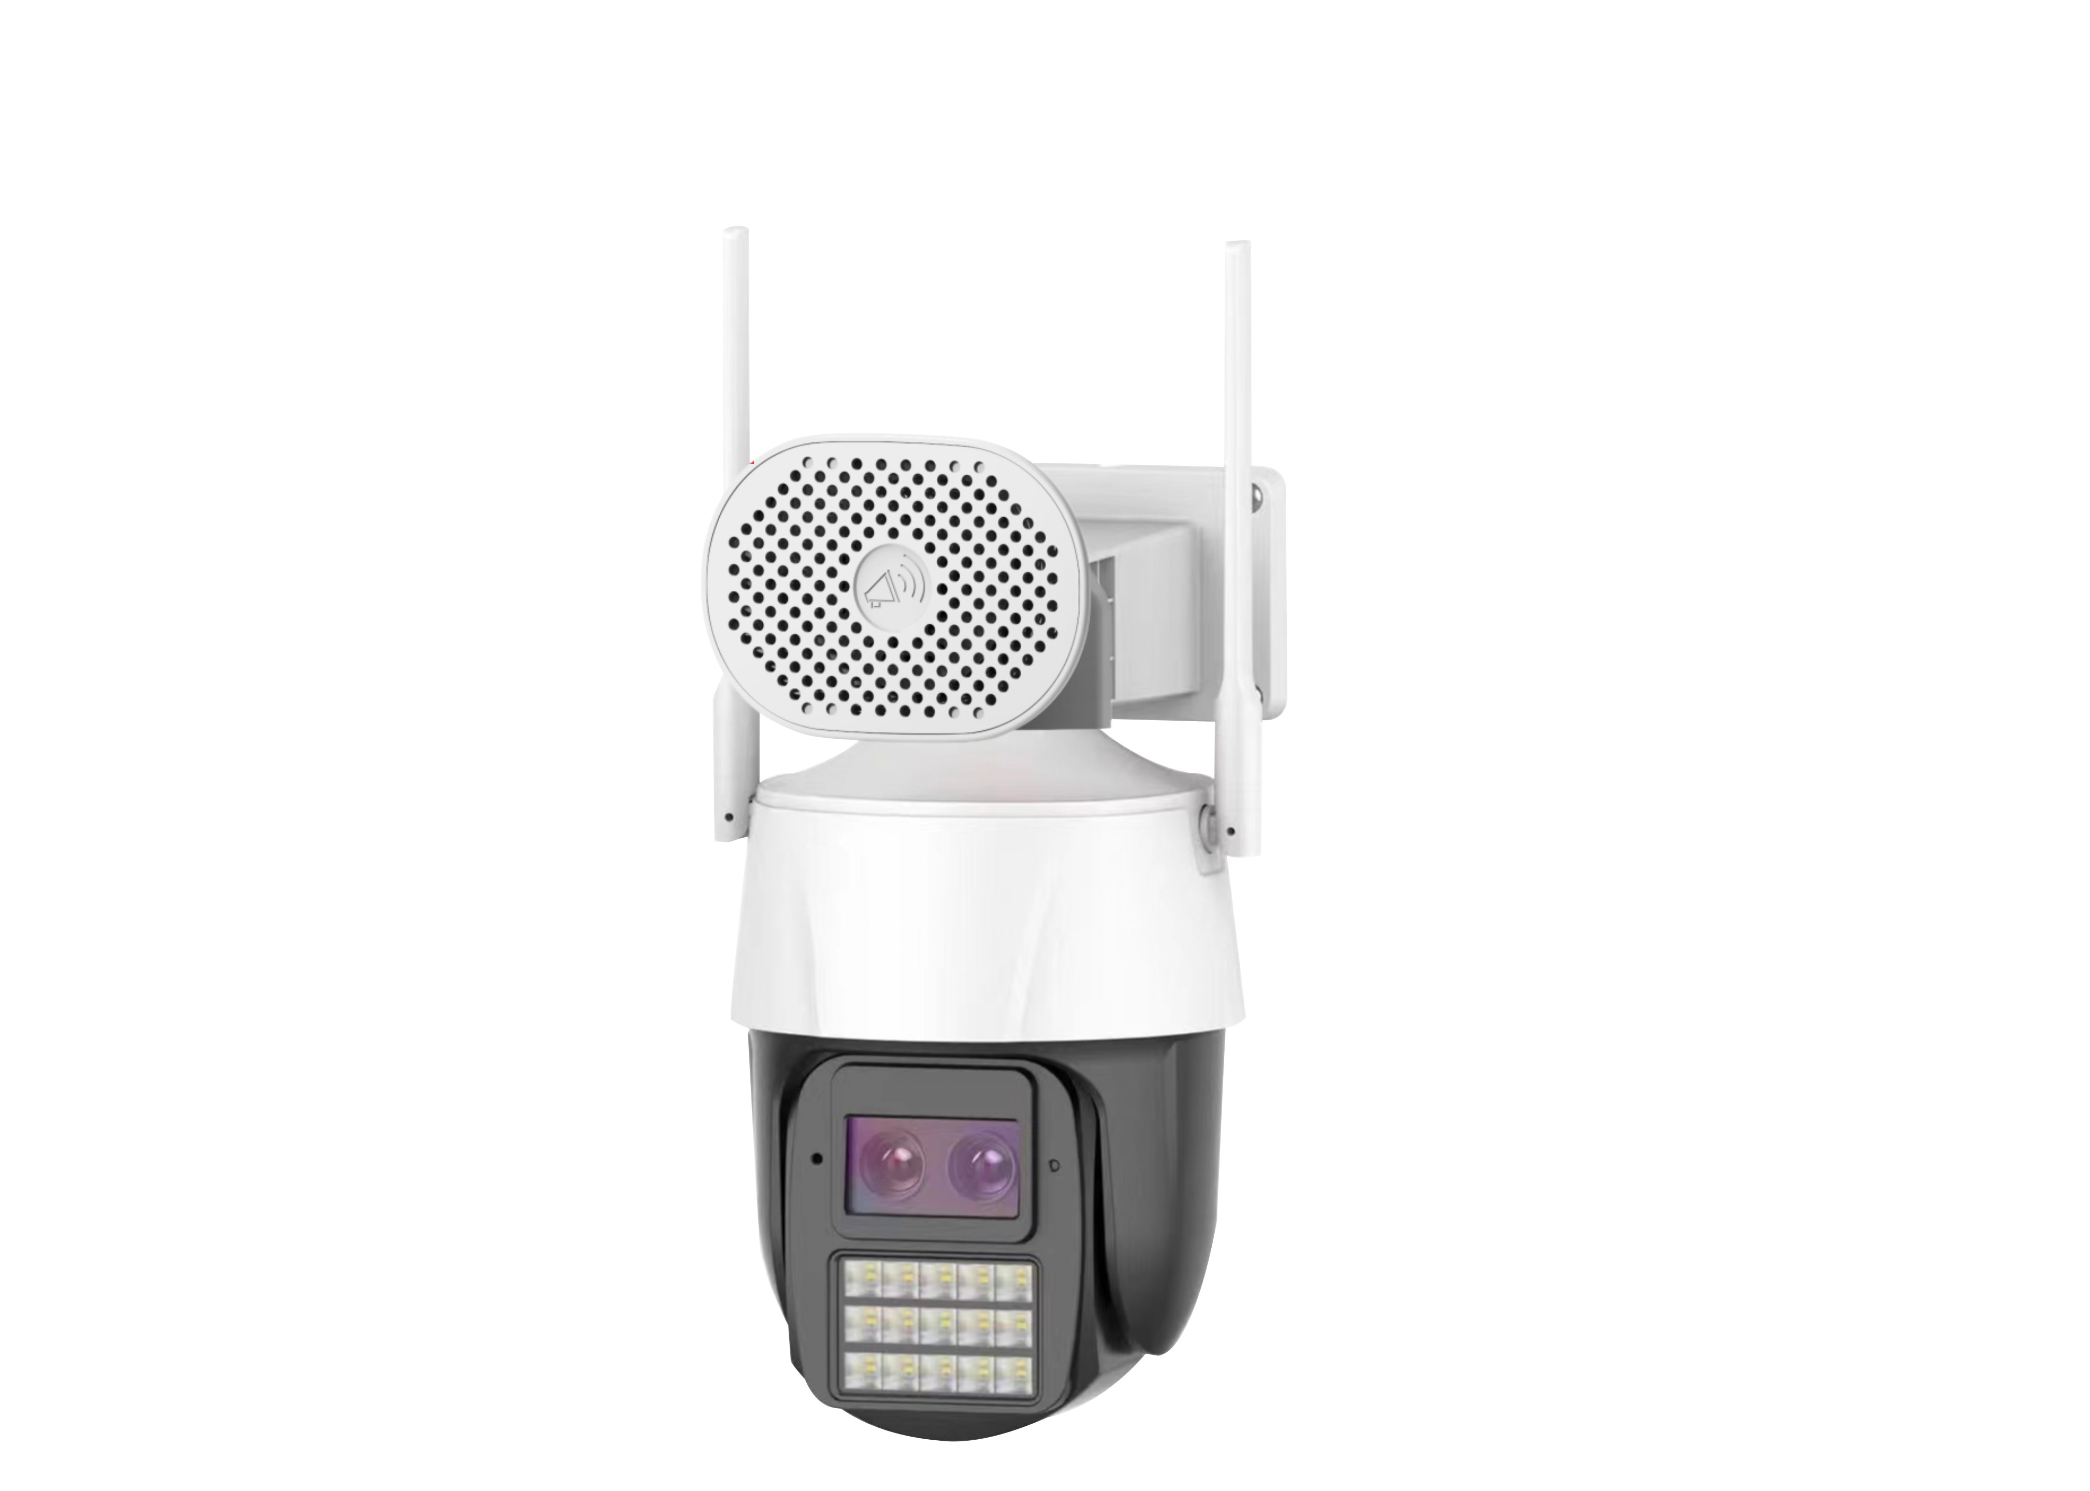
NexPro-PT6100CK-3MP · Primary

PRODUCT OVERVIEW
3MP PTZ, Wi-Fi 6, top multimedia speaker, 15-LED dual-light, 355° pan, 90° tilt, 256GB SD
Product line | CCTV & Surveillance System
Series / family | Standalone model
Exact model | NexPro-PT6100CK-3MP
Applications | Retail, Parking, Courtyard
MODEL IDENTIFICATION
Exact model | Product / variant | Resolution | PTZ | Illuminator
NexPro-PT6100CK-3MP | NexPro 3MP Wi-Fi 6 PTZ (Top Speaker, 15-LED Dual-Light) | 3MP | 355° pan / 90° tilt | 15-LED dual light
TECHNICAL SPECIFICATIONS
Parameter | Specification
Resolution | 3MP
PTZ | 355° pan / 90° tilt; 355° pan, 90° tilt
Illuminator | 15-LED dual light; 12 IR + 12×1W warm white LEDs, 15-LED dual-light full-color
Camera Type | 3MP Wi-Fi 6 Dual-Light PTZ Camera with Multimedia Speaker
Solution | Tianview TD53F61
Image Sensor | 1/2.7″ 3MP low illumination CMOS
Lens | F1.4 5MP starlight lens
Video | H.265+, 256GB SD (35 days recording)
Audio | Built-in multimedia horn speaker & microphone, two-way calls
Wireless | Wi-Fi 6, Bluetooth, RJ45, app signal rate detection
Quotation Type | Bulk project quotation
OEM/ODM | Available for selected orders
Documents | Datasheet and installation reference
Category | CCTV System
APPLICATIONS & RFQ CONFIRMATION
Typical applications | Confirm in the project RFQ
Retail  Parking  Courtyard | Confirm the exact model and required configuration.  Confirm quantity, destination, packing, branding, and documentation requirements.
Project supply: MOQ — Confirm by project quantity · Lead time — Confirm by project list · FOB port — China main ports · OEM/ODM — Available; confirm project scope
PROJECT CONFIGURATION CHECKLIST
Exact model | NexPro-PT6100CK-3MP
Application and site conditions | Confirm installation environment and operating requirements.
Quantity and model mix | Confirm forecast quantity, phase plan and required variants.
Interfaces and accessories | Confirm compatible interfaces, accessories and system integration scope.
Finish, branding and packing | Confirm only when project customization is required.
Documentation and destination | Confirm drawings, datasheets, packing documents and destination country or port.

