
CCTV & SURVEILLANCE SYSTEM

NexPro 32CH 2-Bay 4K NVR (H.265+)
  - Exact model: NexPro-NVR2232-4K
PRODUCT IMAGES
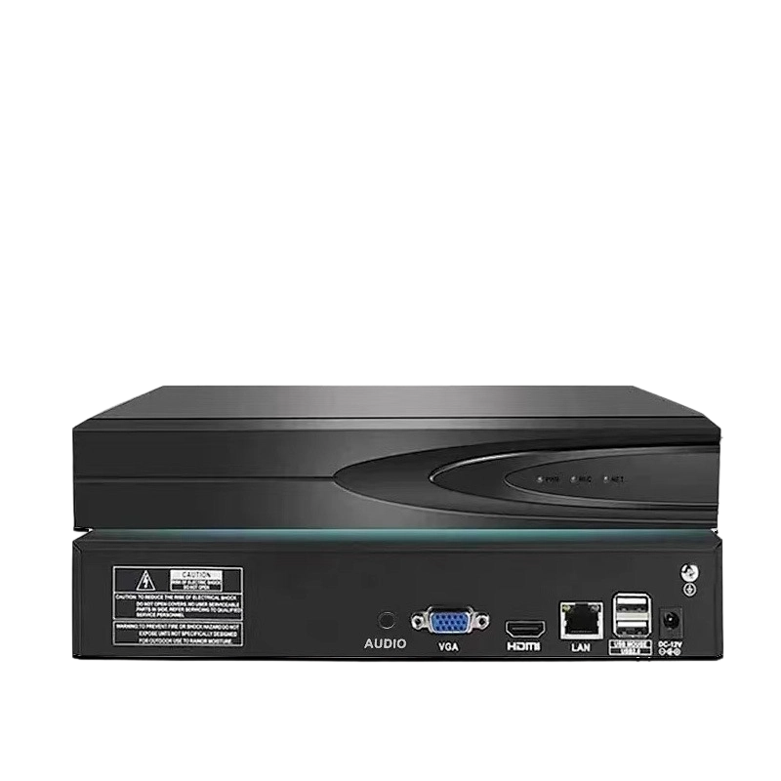
NexPro-NVR2232-4K · Primary

PRODUCT OVERVIEW
32CH 4MP/16×5MP/8×4K, 2×8TB SATA, 4CH 1080P/2×5MP/1×4K playback, 1G LAN, HDMI+VGA
Product line | CCTV & Surveillance System
Series / family | Standalone model
Exact model | NexPro-NVR2232-4K
Applications | Mid-Scale Hotel, Industrial Site, Multi-Zone Retail
MODEL IDENTIFICATION
Exact model | Product / variant | Channels | Recording | Storage
NexPro-NVR2232-4K | NexPro 32CH 2-Bay 4K NVR (H.265+) | 32CH IP | Up to 4K | 2×SATA, 36TB total
TECHNICAL SPECIFICATIONS
Parameter | Specification
Channels | 32CH IP
Recording | Up to 4K
Storage | 2×SATA, 36TB total; 2×SATA, max 18TB each  (36TB total); USB backup
Recorder Type | 32-Channel 2-Bay H.265+ Network Video Recorder
Video Input | 32CH IP, 180Mbps bandwidth, auto-search/add/record/preview
Recording Resolution | Up to 4K
Playback | 4CH 4K@30fps; Seetong Client remote playback up to 4CH
Network | LAN1 10/100/1000M + LAN2 10/100M; ONVIF, P2P, SMTP, GB28181
Cloud | Seetong Cloud, Seetong APP instantaneous preview
Quotation Type | Bulk project quotation
OEM/ODM | Available for selected orders
Documents | Datasheet and installation reference
Category | CCTV System
APPLICATIONS & RFQ CONFIRMATION
Typical applications | Confirm in the project RFQ
Mid-Scale Hotel  Industrial Site  Multi-Zone Retail | Confirm the exact model and required configuration.  Confirm quantity, destination, packing, branding, and documentation requirements.
Project supply: MOQ — Confirm by project quantity · Lead time — Confirm by project list · FOB port — China main ports · OEM/ODM — Available; confirm project scope
PROJECT CONFIGURATION CHECKLIST
Exact model | NexPro-NVR2232-4K
Application and site conditions | Confirm installation environment and operating requirements.
Quantity and model mix | Confirm forecast quantity, phase plan and required variants.
Interfaces and accessories | Confirm compatible interfaces, accessories and system integration scope.
Finish, branding and packing | Confirm only when project customization is required.
Documentation and destination | Confirm drawings, datasheets, packing documents and destination country or port.

