
CCTV & SURVEILLANCE SYSTEM

NexPro 16CH 1-Bay 5MP NVR (H.265+)
  - Exact model: NexPro-NVR1116-5MP
PRODUCT IMAGES
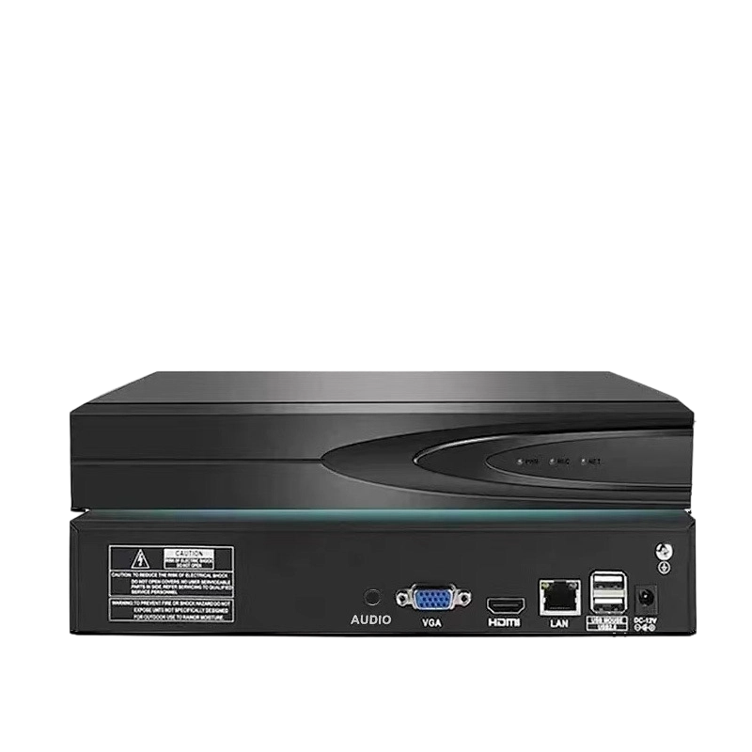
NexPro-NVR1116-5MP · Primary

PRODUCT OVERVIEW
16CH 4MP/8×5MP, 1×8TB SATA, 2CH 5MP playback, max 2K preview, mouse, Eurocom power
Product line | CCTV & Surveillance System
Series / family | Standalone model
Exact model | NexPro-NVR1116-5MP
Applications | Small Warehouse, Restaurant, Retail
MODEL IDENTIFICATION
Exact model | Product / variant | Channels | Recording | Storage
NexPro-NVR1116-5MP | NexPro 16CH 1-Bay 5MP NVR (H.265+) | 16CH IP | Up to 5MP | 1×SATA, max 14TB
TECHNICAL SPECIFICATIONS
Parameter | Specification
Channels | 16CH IP
Recording | Up to 5MP
Storage | 1×SATA, max 14TB; smart recording with buzzer alarm
Recorder Type | 16-Channel 1-Bay H.265+ Network Video Recorder
Video Input | 16CH IP, 64Mbps bandwidth, auto-search/add/record/preview
Recording Resolution | Up to 5MP
Playback | 2CH simultaneous (2×5MP)
Network | 1×RJ45 10/100M, ONVIF, P2P, GB28181
Cloud | Seetong Cloud, Seetong APP instant connection
Quotation Type | Bulk project quotation
OEM/ODM | Available for selected orders
Documents | Datasheet and installation reference
Category | CCTV System
APPLICATIONS & RFQ CONFIRMATION
Typical applications | Confirm in the project RFQ
Small Warehouse  Restaurant  Retail | Confirm the exact model and required configuration.  Confirm quantity, destination, packing, branding, and documentation requirements.
Project supply: MOQ — Confirm by project quantity · Lead time — Confirm by project list · FOB port — China main ports · OEM/ODM — Available; confirm project scope
PROJECT CONFIGURATION CHECKLIST
Exact model | NexPro-NVR1116-5MP
Application and site conditions | Confirm installation environment and operating requirements.
Quantity and model mix | Confirm forecast quantity, phase plan and required variants.
Interfaces and accessories | Confirm compatible interfaces, accessories and system integration scope.
Finish, branding and packing | Confirm only when project customization is required.
Documentation and destination | Confirm drawings, datasheets, packing documents and destination country or port.

